Bug 13183

Screenshot 1
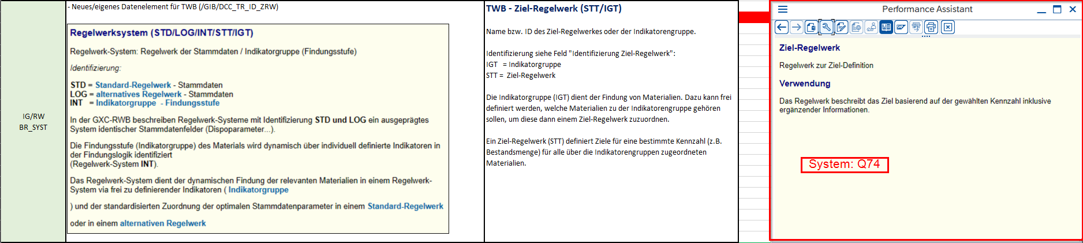

Screenshot 2
