HW 13843
FE0
E74

Programm: /GIB/DCC_BARU_MONITOR
Include: /GIB/DCC_BARU_MONITOR_FIX
Form CUST_SELECTION_GET_DATA_FIX
Include: /GIB/DCC_BARU_MONITOR_OWN_F01
Form OWN_RW_FIND
Include: /GIB/DCC_BARU_MONITOR_OWN_F02
Form OWN_RW_FIND_FORMULA_IND
Form OWN_RW_FIND_BADI_IND
*# HW 13843, CBR, 20.10.2021 - Stufe Regelwerk in Struktur /GIB/DCC_BR_MONITOR_EXT_S *## HW 13843, CBR, 20.10.2021 - Stufe Regelwerk in Struktur /GIB/DCC_BR_MONITOR_EXT_S
*# HW 13843, CBR, 21.10.2021 - Struktur /GIB/DCC_BRO01_S statt GIB/DCC_BRO01 *## HW 13843, CBR, 21.10.2021 - Struktur /GIB/DCC_BRO01_S statt GIB/DCC_BRO01
STRUKTUREN:
/GIB/DCC_BR_MONITOR_EXT_S
/GIB/DCC_BR_PARAMS_S
/GIB/DCC_BR_MONITOR_S
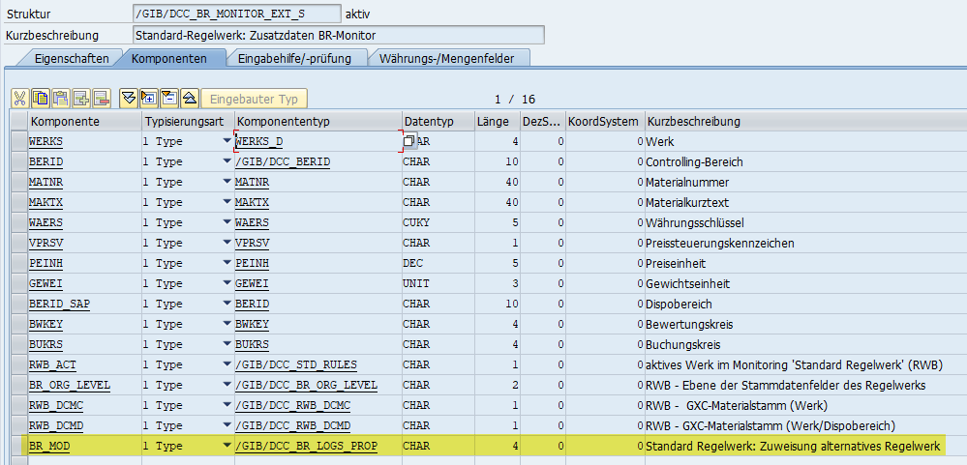
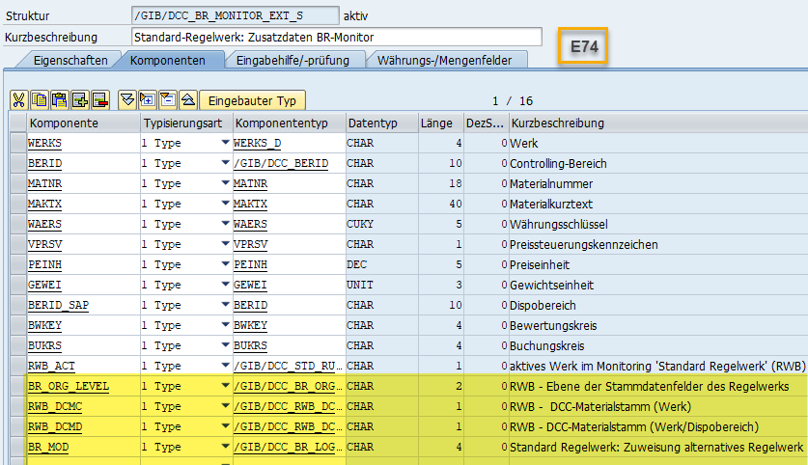
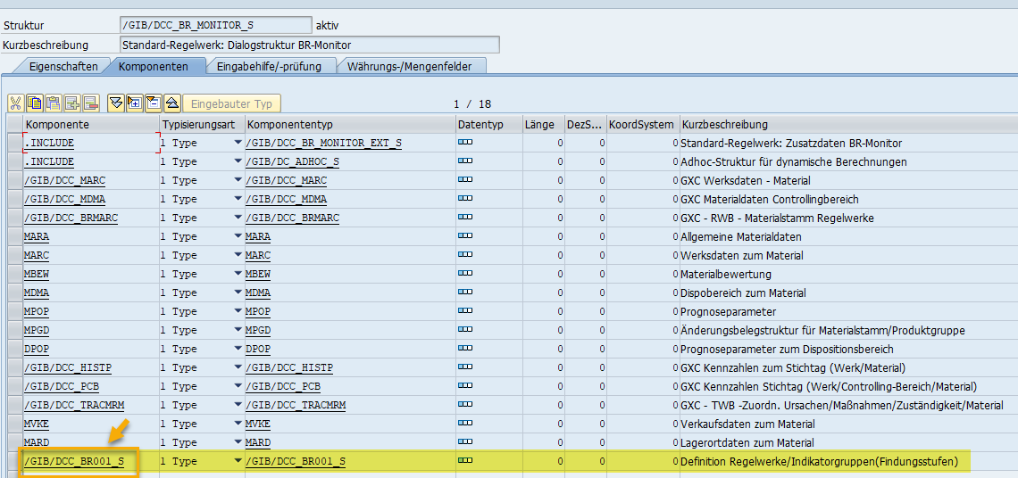
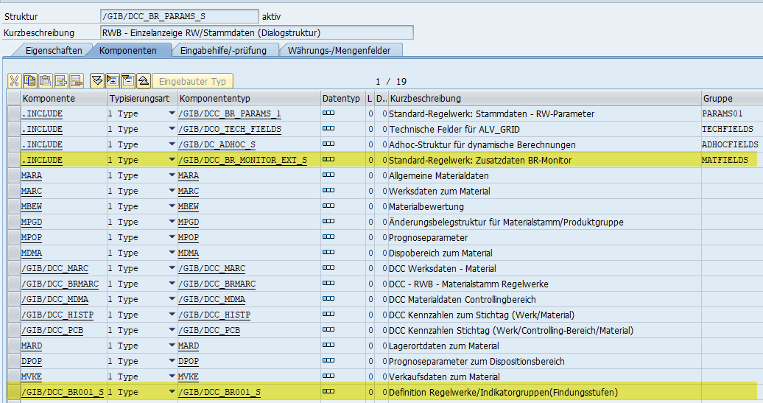
Abgleichen!!!!
