Bug 13620 - Tabellenprotokollierung aller RAC Einstellungstabellen aktivieren
Testsystem FE0:
/GIB/DC_RUACATG /GIB/DC_RAC
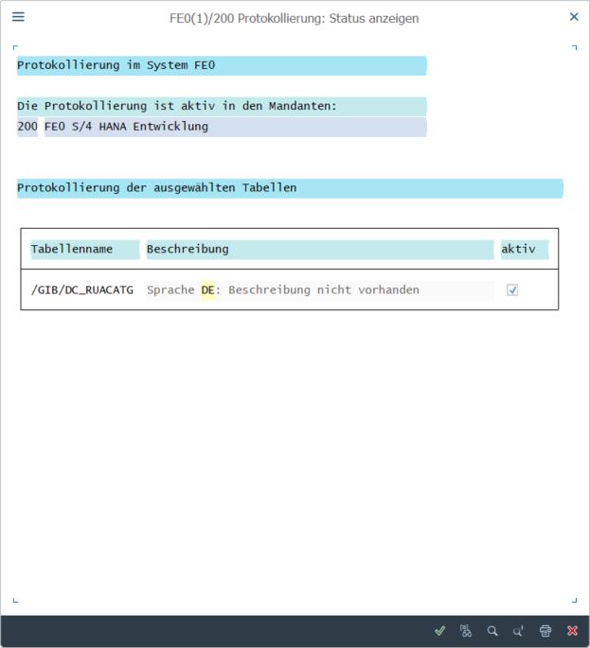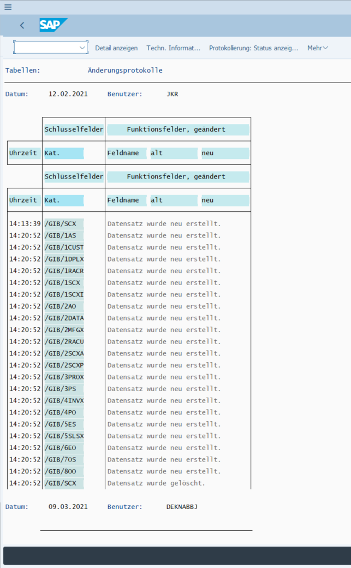
/GIB/DC_RUACATGT /GIB/DC_RAC
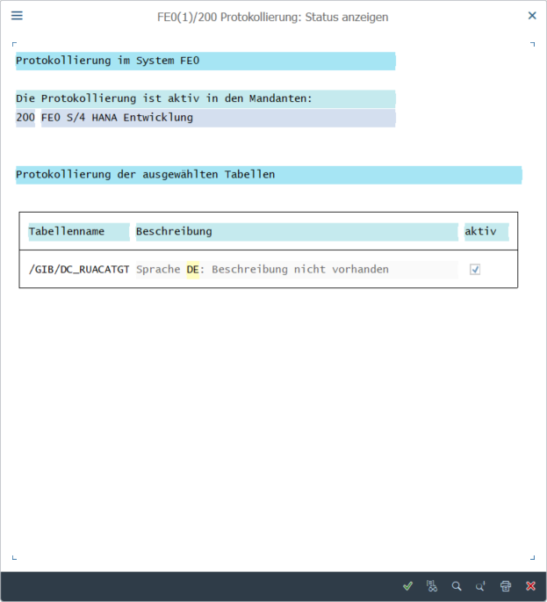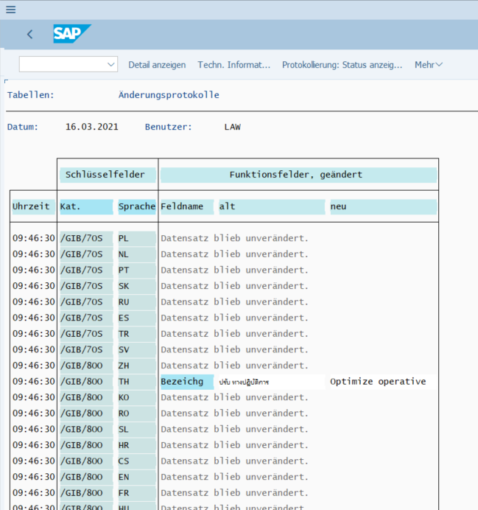
/GIB/DC_RUADEF /GIB/DC_RAC
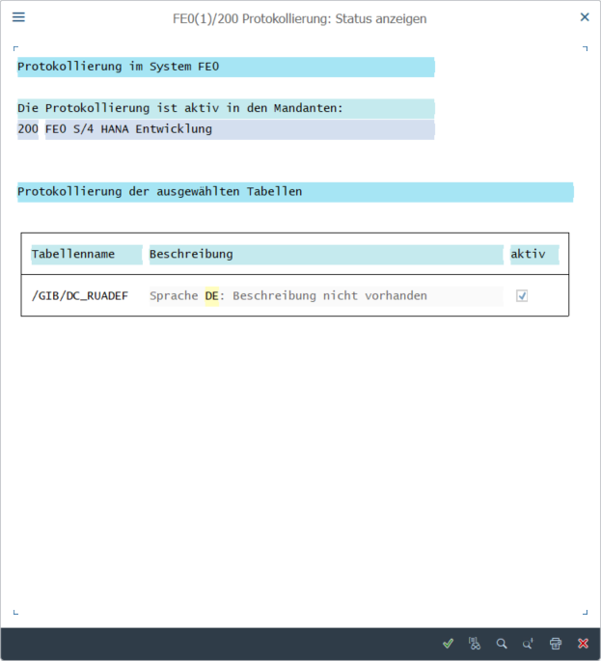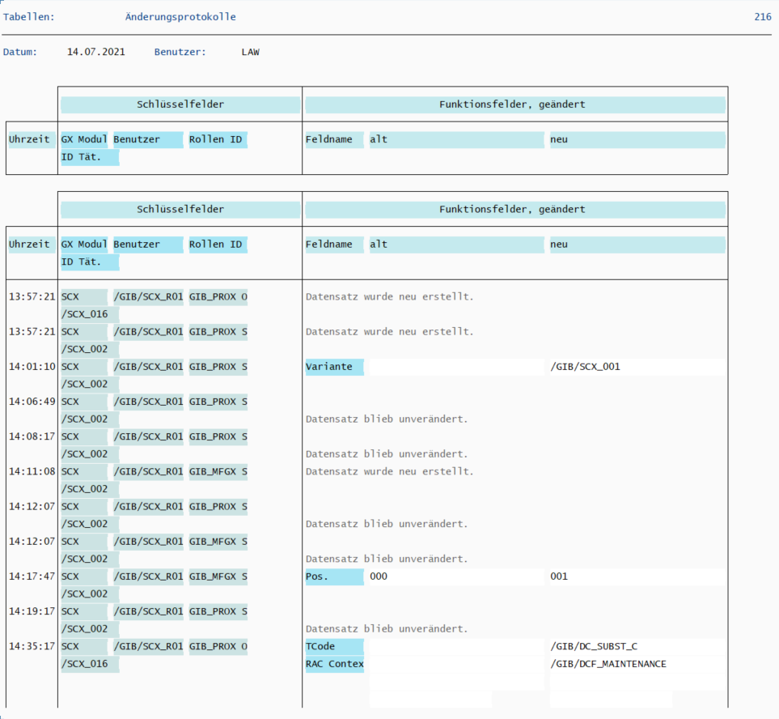
/GIB/DC_RUASORT /GIB/DC_RAC
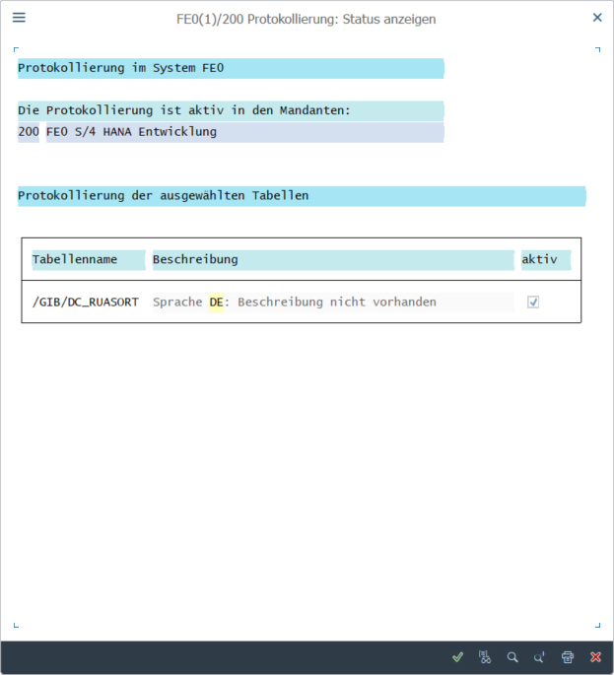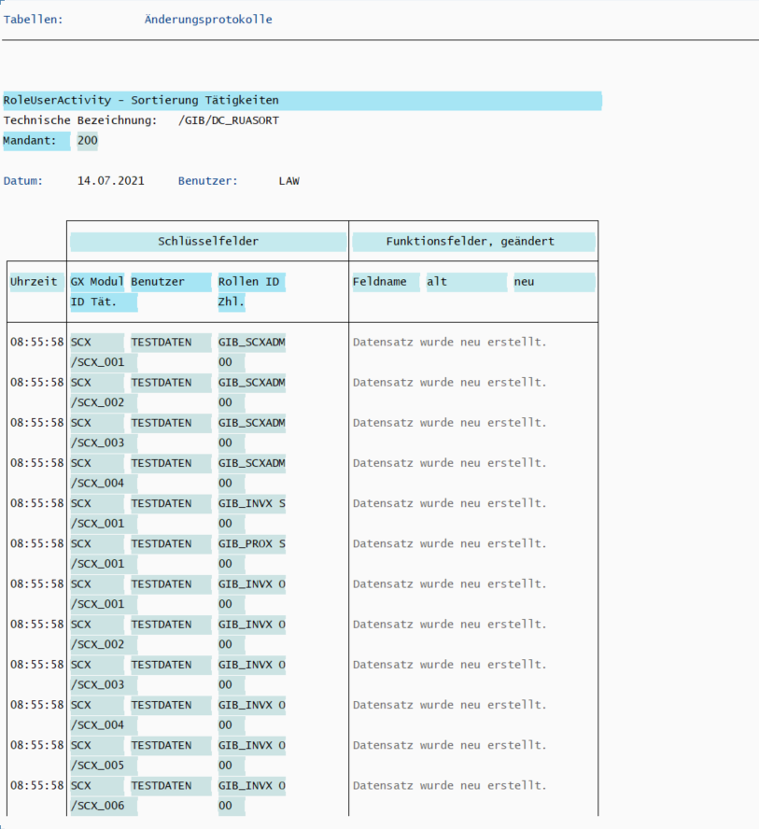
/GIB/DC_RUSR01 /GIB/DC_RAC
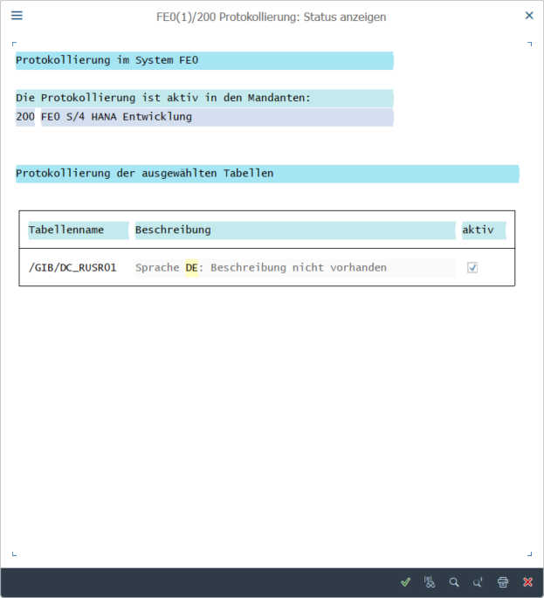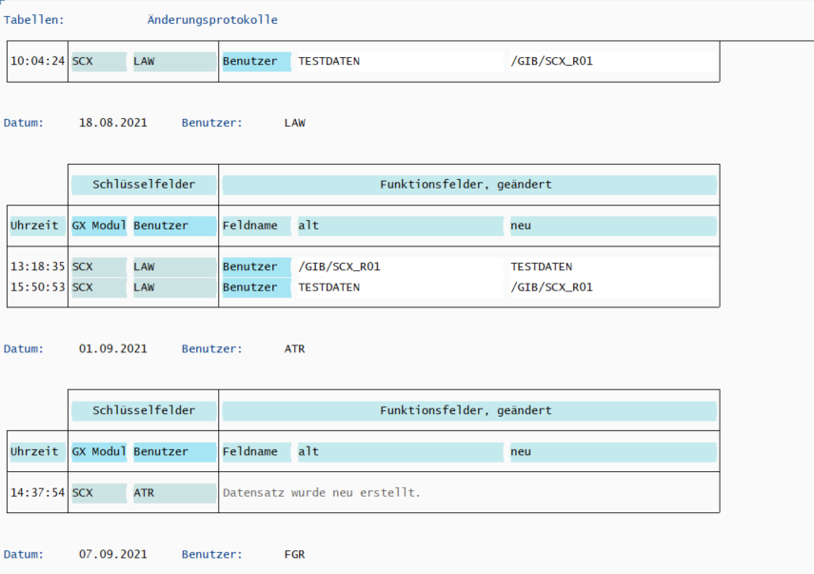
/GIB/SCX_C /GIB/SCX_RAC
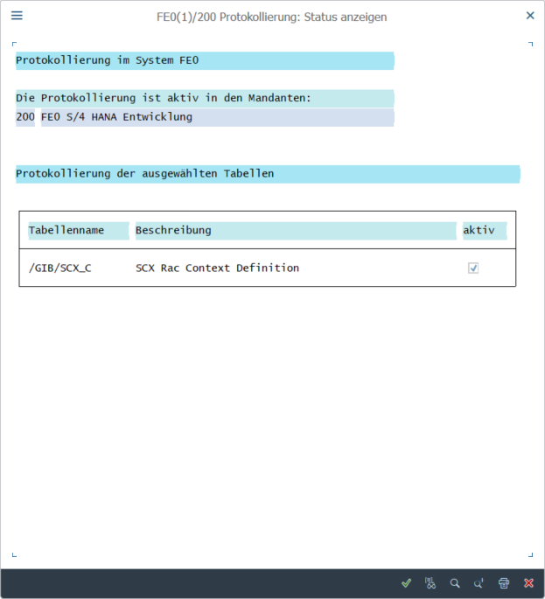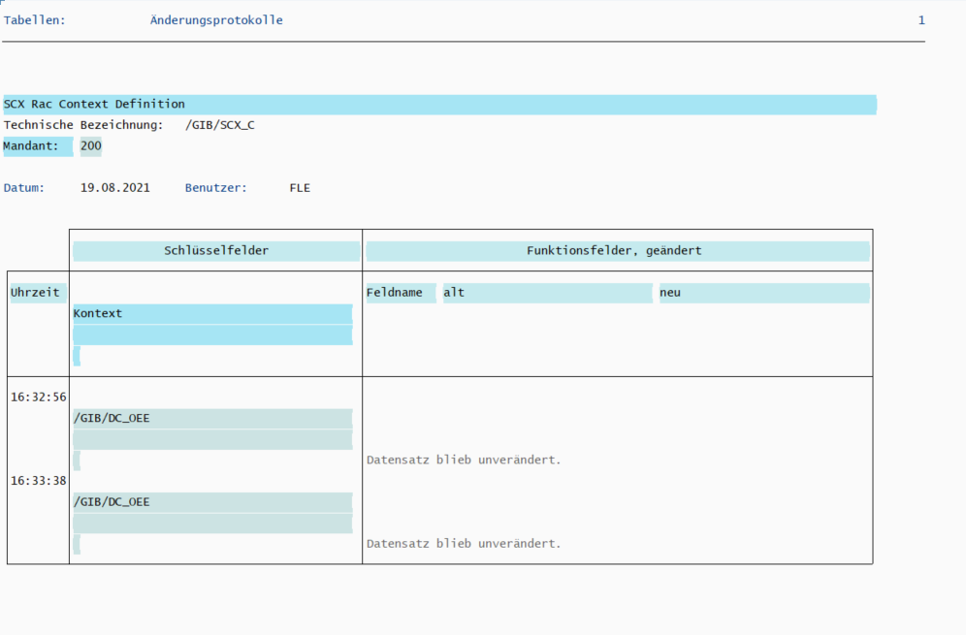
/GIB/SCX_CATTXT /GIB/SCX_RAC
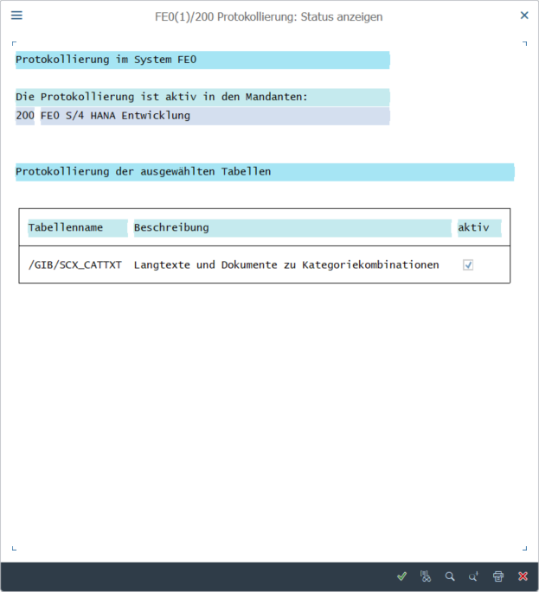
/GIB/SCX_C_T /GIB/SCX_RAC
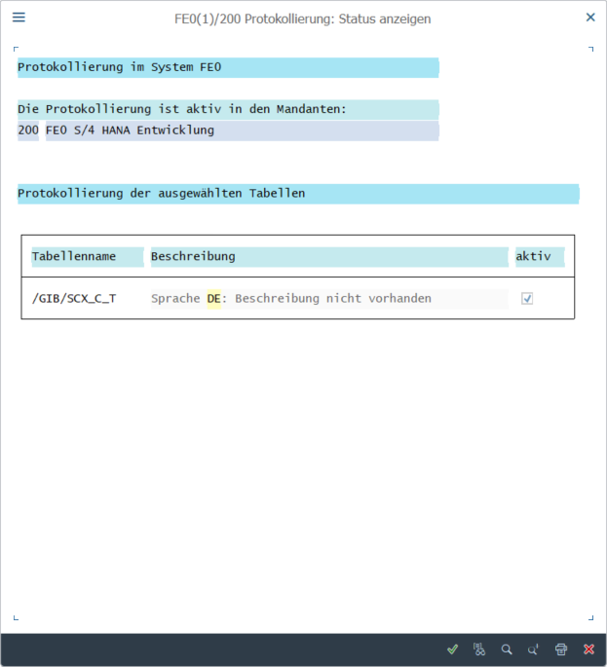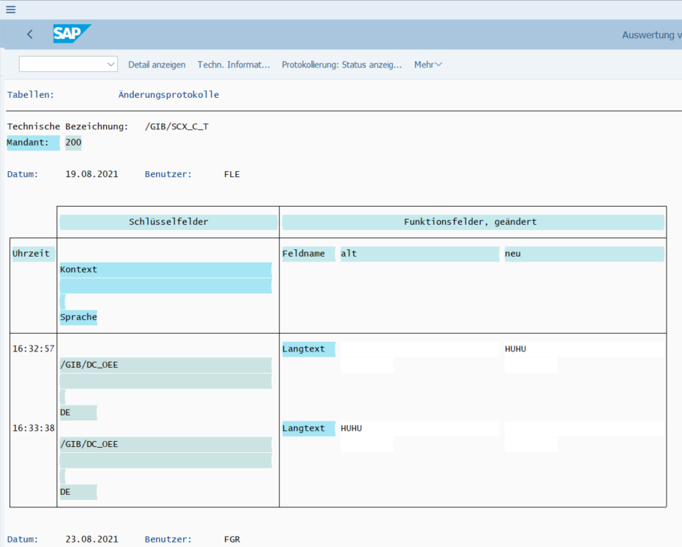
/GIB/SCX_F /GIB/SCX_RAC
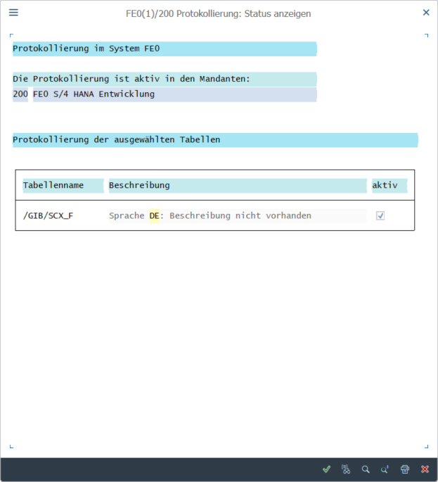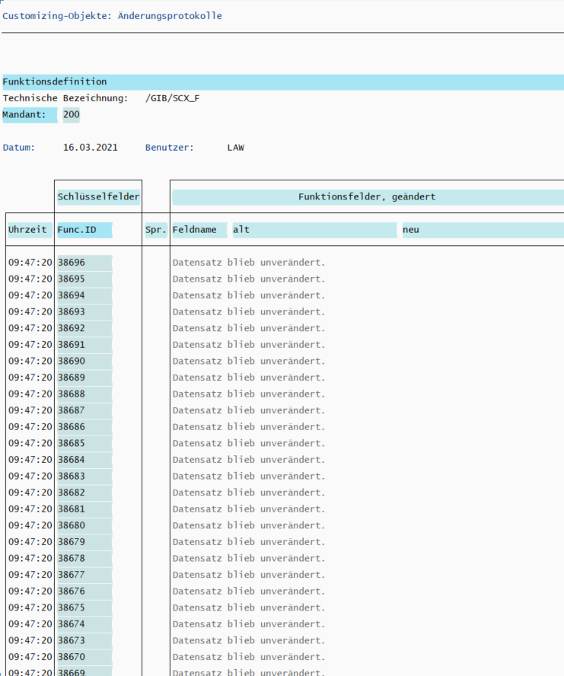
/GIB/SCX_RF /GIB/SCX_RAC
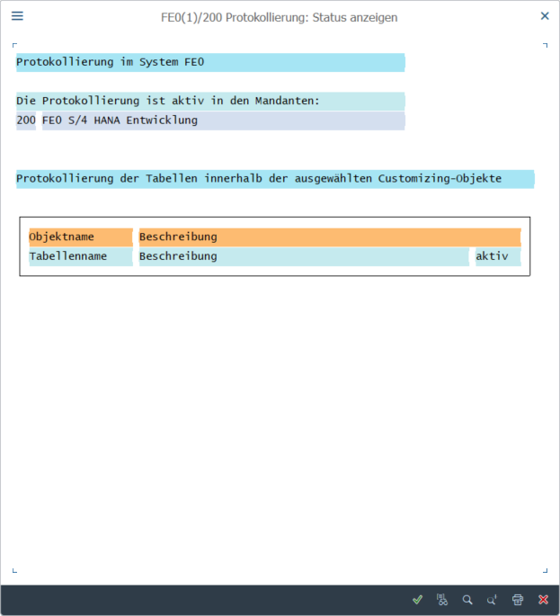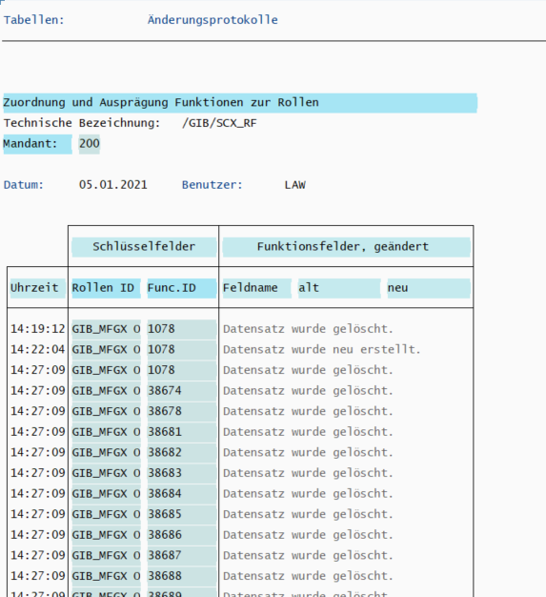
/GIB/SCX_RUAUSET /GIB/SCX_RAC
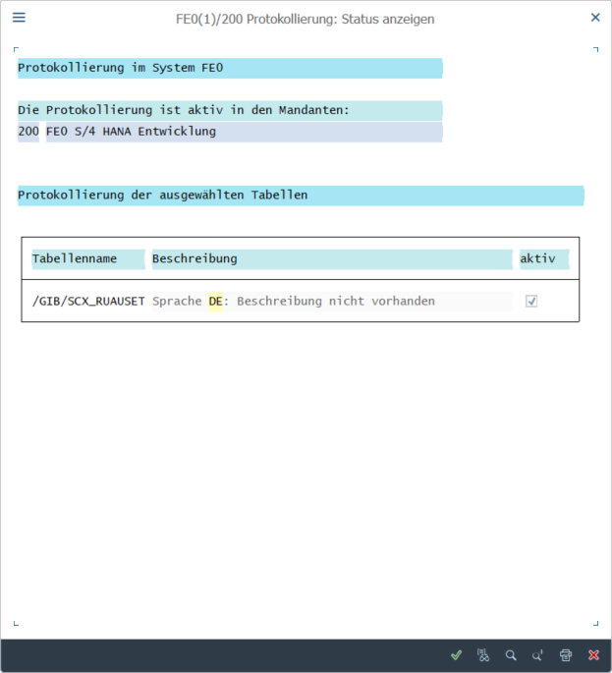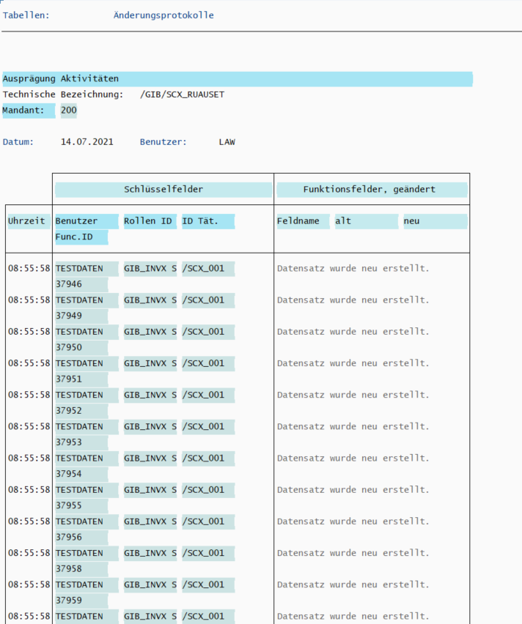
/GIB/SCX_USETS /GIB/SCX_RAC
