HW 13504 - ABC/XYZ/Produktlebenszyklus Übersicht mit AdHoc

Inhalt
Ergebnis: 2
E74 2
FE0 2
DDIC: 3
Erweiterung GRID-Struktur 3
/GIB/DCC_ABCXYZ_S – Anpassung / Erweiterung 3
Anpassungen / Erweiterungen im Programm /GIB/DCC_ABCXYZ_OVERVIEW 4
Form CUST_FIELDCAT 4
Form CUST_TOOLBAR 5
Form CUST_USER_COMMAND 6
Form CUST_SELECTION_GET_DATA 6
Form STD_SET_PF_STATUS 7
Form STD_INIT_GRID_0100 8
GUI-Status S100 9
Klasse: LCL_TBMAN_FUNCTIONS 10

Ergebnis:
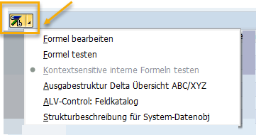

E74
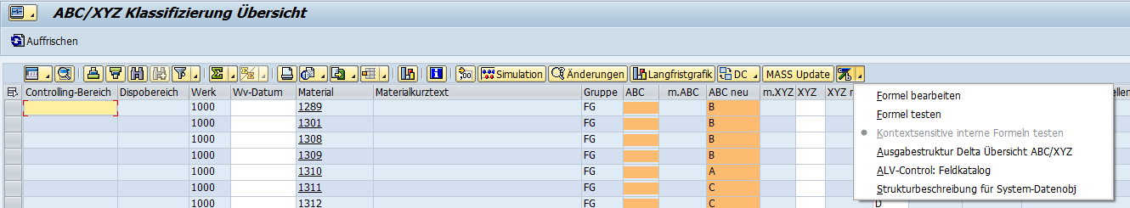

FE0
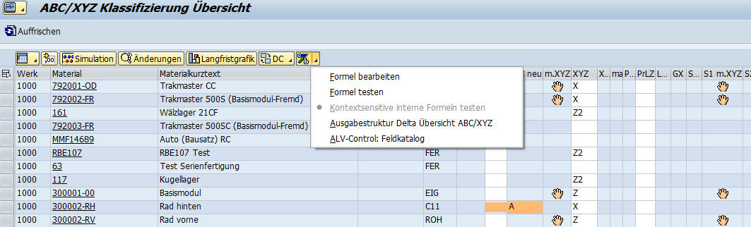

HW 13504 - AdHoc-Formel (kontextsensitiv) in Programm /GIB/DCC_ABCXYZ_OVERVIEW

DDIC:

Erweiterung GRID-Struktur

/GIB/DCC_ABCXYZ_S – Anpassung / Erweiterung
.INCLUDE | 1 Type | /GIB/DC_ADHOC_S | Adhoc-Struktur für dynamische Berechnungen | ADHOCFIELDS

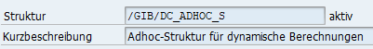
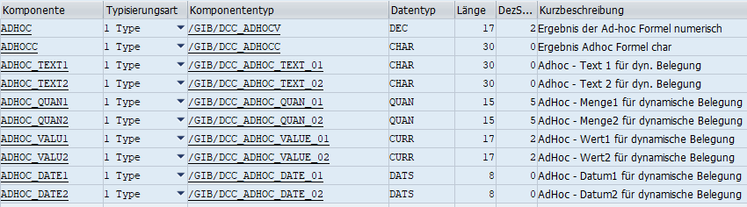
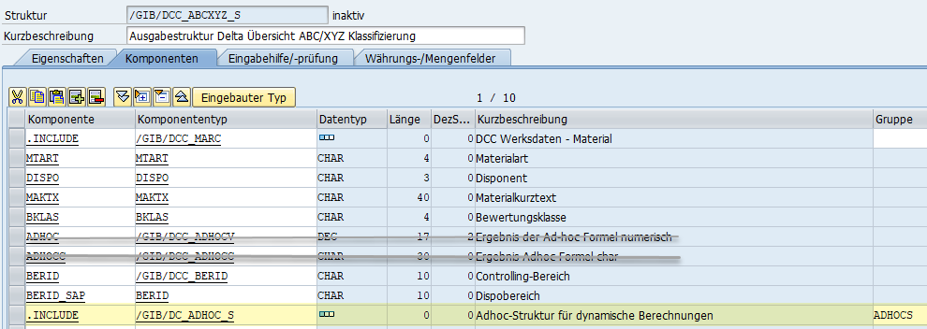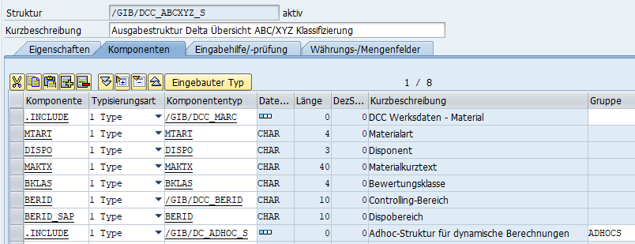

Anpassungen / Erweiterungen im Programm /GIB/DCC_ABCXYZ_OVERVIEW
*# HW 13504, CBR, 23.08.2021 - Kontextsensitive Formel (AdHoc) für Overview ABC/XYZ
*## HW 13504, CBR, 23.08.2021 - Kontextsensitive Formel (AdHoc) für Overview ABC/XYZ

Form CUST_FIELDCAT

CALL METHOD /gib/dcc_formula_mntn=>fieldcat_adhoc_internal
CHANGING
ct_fieldcat = ct_fieldcat.
*##
LOOP AT ct_fieldcat INTO lw_fieldcat.
. . .
CALL METHOD /gib/dcc_formula_mntn=>evaluate_adhoc_internal
EXPORTING
if_struc = 'LVC_S_FCAT'
if_repid = sy-repid
CHANGING
cs_dynamic = lw_fieldcat
EXCEPTIONS
no_formula = 0.
*##
MODIFY ct_fieldcat FROM lw_fieldcat.
ENDLOOP.

Form CUST_TOOLBAR
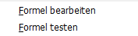 ENTFERNEN
*# Ad-hoc Formeln nur einblenden wenn eine Spalte definiert wurde
. . .
* IF sy-saprl+0(2) NE '46'.
* call METHOD /gib/dcc_formula_mntn=>TOOLBAR_ADHOC_INTERNAL
* EXPORTING if_repid = sy-repid
* CHANGING ct_toolbar = ct_toolbar_cust.
*
* CLEAR lw_toolbar_cust.
* MOVE 'ADHOC' TO lw_toolbar_cust-function.
** MOVE 'ADHOC' TO lw_toolbar_cust-subfunction.
*
* MOVE icon_bw_formula_sap TO lw_toolbar_cust-icon.
* MOVE '0' TO lw_toolbar_cust-seltype.
* MOVE 'Ad-hoc'(221) TO lw_toolbar_cust-subtext.
* MOVE 'Ad-hoc Formel bearbeiten'(222) TO lw_toolbar_cust-quickinfo.
* MOVE 1 TO lw_toolbar_cust-butn_type.
* MOVE 'B' TO lw_toolbar_cust-stype.
* APPEND lw_toolbar_cust TO ct_toolbar_cust.
* CLEAR lw_toolbar_cust.
* MOVE 'ADHOC' TO lw_toolbar_cust-function.
* MOVE 'ADHOC' TO lw_toolbar_cust-subfunction.
* MOVE icon_bw_formula_sap TO lw_toolbar_cust-icon.
* MOVE '0' TO lw_toolbar_cust-seltype.
* MOVE 'Formel bearbeiten'(226) TO lw_toolbar_cust-subtext.
* MOVE 'Ad-hoc Formel bearbeiten'(222) TO lw_toolbar_cust-quickinfo.
* MOVE 0 TO lw_toolbar_cust-butn_type.
* MOVE 'B' TO lw_toolbar_cust-stype.
* APPEND lw_toolbar_cust TO ct_toolbar_cust.
* CLEAR lw_toolbar_cust.
* MOVE 'ADHOC' TO lw_toolbar_cust-function.
* MOVE 'ADTST' TO lw_toolbar_cust-subfunction.
** MOVE icon_bw_formula_sap TO lw_toolbar_cust-icon.
* MOVE '1' TO lw_toolbar_cust-seltype.
* MOVE 'Formel testen'(224) TO lw_toolbar_cust-subtext.
* MOVE 'Ad-hoc Formel testen'(225) TO lw_toolbar_cust-quickinfo.
* MOVE 0 TO lw_toolbar_cust-butn_type.
* MOVE 'B' TO lw_toolbar_cust-stype.
* APPEND lw_toolbar_cust TO ct_toolbar_cust.
* ENDIF.
ENDFORM. " cust_toolbar

Form CUST_USER_COMMAND
. . .
WHEN OTHERS.
CALL METHOD /gib/dcc_formula_mntn=>maintain_adhoc_internal
EXPORTING
if_repid = sy-repid
if_fcode = uf_ucomm.
ENDCASE.
ENDIF.
ENDFORM. " cust_user_command

Form CUST_SELECTION_GET_DATA
*# HW 13504, CBR, 23.08.2021 - Kontextsensitive Formel (AdHoc) für Overview ABC/XYZ
FIELD-SYMBOLS: <fs_sele> TYPE tw_select_tab.
*## HW 13504, CBR, 23.08.2021 - Kontextsensitive Formel (AdHoc) für Overview ABC/XYZ
*# Übertragen der Daten in Ausgabestruktur
*# Transfer data to output structure
LOOP AT lt_select_tab INTO lw_select_tab.
. . .
CALL METHOD /gib/dcc_formula_mntn=>evaluate_adhoc_internal
EXPORTING
if_struc = '/GIB/DCC_ABCXYZ_S‘
if_repid = sy-repid
CHANGING
cs_dynamic = <fs_sele>
EXCEPTIONS
no_formula = 0.
. . .
CLEAR gw_grid_tab.
lf_index = sy-tabix.
*# Fortschrittsanzeige / Display progress
MOVE text-908 TO lf_text.
PERFORM std_progress_bar USING lf_text
lf_max
lf_index
' '.
*# Übertragung in GW_GRID_TAB / Transfer to GW_GRID_TAB
MOVE-CORRESPONDING lw_select_tab TO gw_grid_tab.

Form STD_SET_PF_STATUS
FORM std_set_pf_status .
DATA: lt_ucomm TYPE STANDARD TABLE OF sy-ucomm.
LOOP AT gt_fieldcat INTO gw_fieldcat WHERE fieldname <> 'CHECKBOX'
AND edit = 'X'.
EXIT.
ENDLOOP.
. . .
IF sy-subrc NE 0.
APPEND 'SAVE' TO lt_ucomm.
ENDIF.
* IF sy-subrc EQ 0.
* SET PF-STATUS 'S100'.
* ELSE.
* SET PF-STATUS 'S100' EXCLUDING 'SAVE'.
* ENDIF.
IF /gib/dcc_formula_mntn=>gf_adhoc_active EQ space.
APPEND 'FORMI' TO lt_ucomm.
ENDIF.
SET PF-STATUS 'S100' EXCLUDING lt_ucomm.
. . .

Form STD_INIT_GRID_0100
. . .
*# Docking Container und Splitter für Bereich oberhalb des Grids
*# erstellen. Nicht im Batch-Modus !!
*# Create docking container and splitter for the area above the grid.
*# Not to be done in batch mode.
IF sy-batch IS INITIAL.
. . .
CALL METHOD /gib/dcc_formula_mntn=>toolbar_adhoc_internal
EXPORTING
if_repid = sy-repid
CHANGING
ct_toolbar = gt_toolbar_cust.
. . .

GUI-Status S100
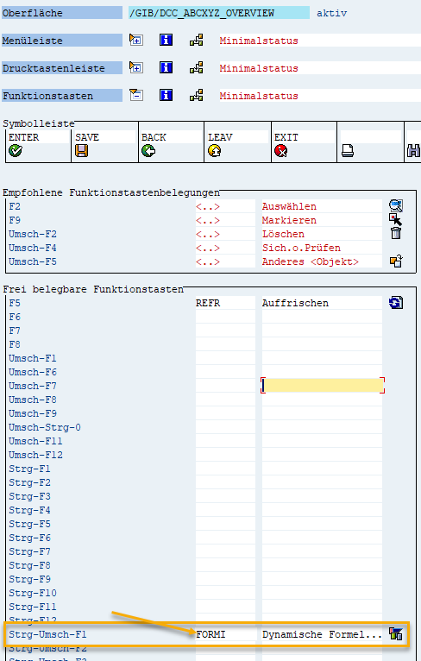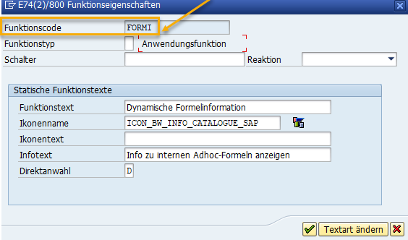

Klasse: LCL_TBMAN_FUNCTIONS

PERFORM std_toolbar IN PROGRAM /gib/dcc_abcxyz_overview
"USING 'GRID1'
CHANGING lt_dcc_toolbar.
"lt_dco_toolbar_sub.
*# HW 13504, CBR, 23.08.2021 - Kontextsensitive Formel (AdHoc) für Overview ABC/XYZ
IF sy-batch IS INITIAL.
CALL METHOD /gib/dcc_formula_mntn=>toolbar_adhoc_internal
EXPORTING
if_repid = sy-repid
CHANGING
ct_toolbar = lt_dcc_toolbar.
ENDIF.
*## HW 13504, CBR, 23.08.2021 - Kontextsensitive Formel (AdHoc) für Overview ABC/XYZ

