Bug 10488 - DCC - RWB - allgemein - Übergabe Dispoparameter via Planungsszenario (BAdI MD_MRP_PARAMETERS)
DC-Release 21.0 (PEGASUS)
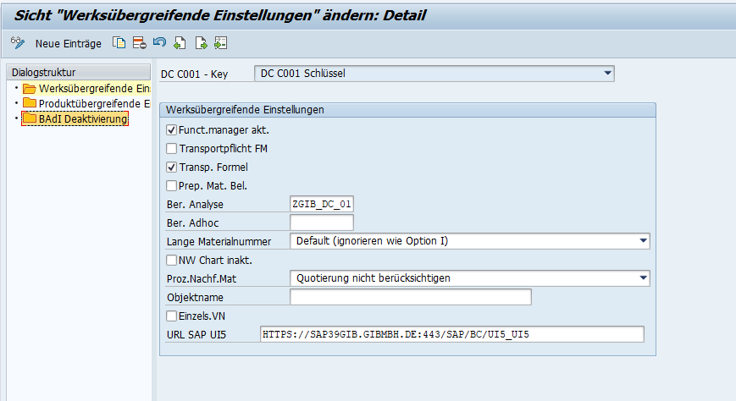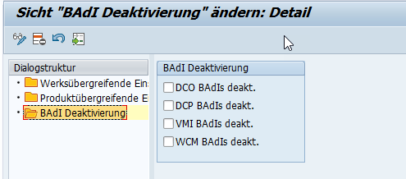
Datenelement: /GIB/DC_BADI_RWB_DEACTIVATE (RWB BAdIs deaktivieren)
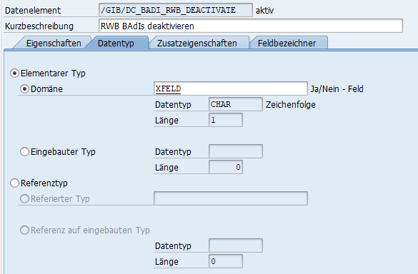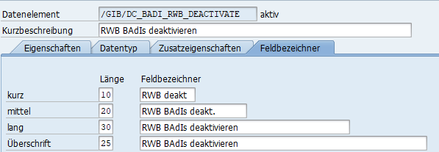
F1-Hilfe:
Tabelle: /GIB/DC_C003 (DC - Produkte - SAP-BAdI Aktivierungen)
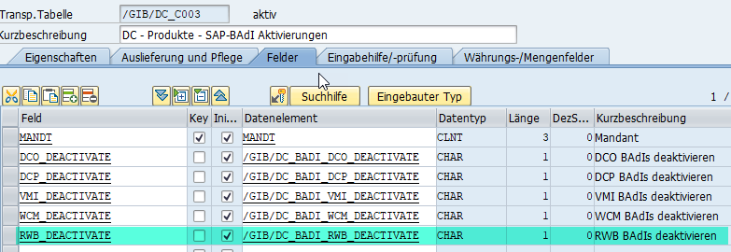
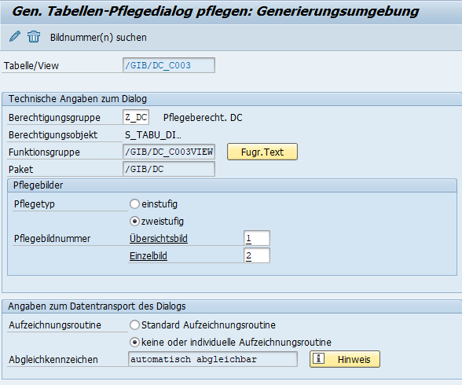
DCO-CUSTOMIZING
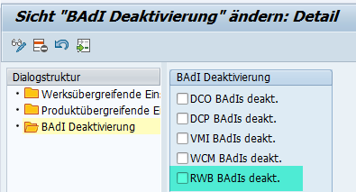
BAdI
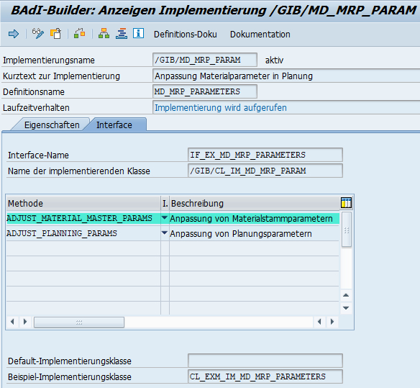
Methode: ADJUST_MATERIAL_MASTER_PARAMS
METHOD if_ex_md_mrp_parameters~adjust_material_master_params.
DATA: ls_c003 TYPE /gib/dc_c003.
FIELD-SYMBOLS: <lf_inactive> TYPE any.
FIELD-SYMBOLS: <lf_inactive_rwb> TYPE any.
SELECT SINGLE * FROM /gib/dc_c003 INTO CORRESPONDING FIELDS OF ls_c003.
*# GIB, HW 10488, CBR, 13.01.2021 - RWB: Übergabe Dispoparameter via Planungsszenario (BAdI MD_MRP_PARAMETERS)
IF ls_c003 IS NOT INITIAL.
ASSIGN COMPONENT 'RWB_DEACTIVATE' OF STRUCTURE ls_c003 TO <lf_inactive_rwb>.
IF <lf_inactive_rwb> IS NOT ASSIGNED.
RETURN.
ENDIF.
IF <lf_inactive_rwb> EQ 'X'.
RETURN.
ENDIF.
ENDIF.
*## GIB, HW 10488, CBR, 13.01.2021 - RWB: Übergabe Dispoparameter via Planungsszenario (BAdI MD_MRP_PARAMETERS)
*# GIB, HW 10488, CBR, 13.05.2019 - RWB: Übergabe Dispoparameter via Planungsszenario (BAdI MD_MRP_PARAMETERS)
TRY.
CALL METHOD ('/GIB/CL_RWB_MD_MRP_PARAMETERS')=>('MD_MRP_PARAMETERS_RWB')
EXPORTING
im_cm61x = im_cm61x
im_cm61b = im_cm61b
im_plsc = im_plsc
im_mt61d = im_mt61d
im_aufruf = im_aufruf
CHANGING
ch_mt61d_ext = ch_mt61d_ext
ch_changed = ch_changed.
CATCH cx_root.
ENDTRY.
*## GIB, HW 10488, CBR, 13.05.2019 - RWB: Übergabe Dispoparameter via Planungsszenario (BAdI MD_MRP_PARAMETERS)
*# GIB, HW 10488, CBR, 13.01.2021 - RWB: Übergabe Dispoparameter via Planungsszenario (BAdI MD_MRP_PARAMETERS)
* IF sy-subrc EQ 0.
IF ls_c003 IS NOT INITIAL.
*## GIB, HW 10488, CBR, 13.01.2021 - RWB: Übergabe Dispoparameter via Planungsszenario (BAdI MD_MRP_PARAMETERS)
ASSIGN COMPONENT 'WCM_DEACTIVATE' OF STRUCTURE ls_c003 TO <lf_inactive>.
IF <lf_inactive> IS NOT ASSIGNED.
RETURN.
ENDIF.
IF <lf_inactive> EQ 'X'.
RETURN.
ENDIF.
ENDIF.
TRY.
CALL METHOD ('/GIB/CL_WCM_MD_MRP_PARAMETERS')=>('MD_MRP_PARAMETERS')
EXPORTING
im_cm61x = im_cm61x
im_cm61b = im_cm61b
im_plsc = im_plsc
im_mt61d = im_mt61d
im_aufruf = im_aufruf
CHANGING
ch_mt61d_ext = ch_mt61d_ext
ch_changed = ch_changed.
CATCH cx_root.
ENDTRY.
ENDMETHOD.

