TA /GIB/DCO
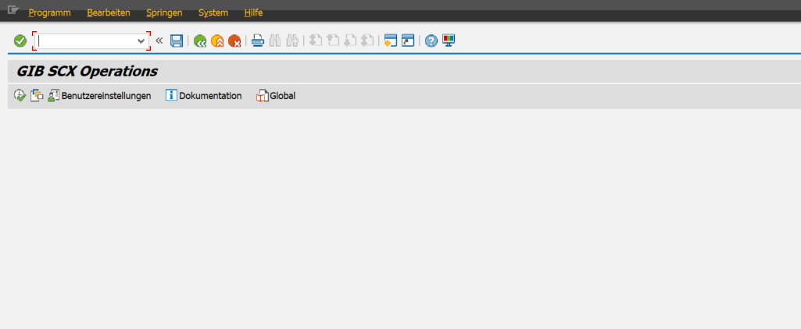
TA /GIB/DCF_PLN
