BUG: 10009 – Ermittlung der kaparelevanten Zeit für Dummies (Von- Biseingabe)
CODE context INSERT DELETE CODE context
Class | /GIB/CL_DCP_UC_HANDLER
Method | UC_DUMMY
DATA: lr_badi TYPE REF TO /gib/dcp_badi_func,
ls_template TYPE /gib/dcp_element_template_s,
ls_view TYPE /gib/dcp_view_s,
ls_main TYPE /gib/dcp_main,
lr_main TYPE REF TO /gib/dcp_main_t,
lr_exc TYPE REF TO /gib/cx_dcp,
lr_element TYPE REF TO /gib/if_dcp_element,
lr_elements TYPE REF TO /gib/dcp_elements_t,
*#HW10009 Ermittlung der kaparelevanten Zeit für Dummies Von- Bis-Eingabe ( AME 13.02.2019 )
lf_sum_duration TYPE /gib/dcp_duration_d,
lf_from_date TYPE datum,
lf_from_time TYPE /gib/dcp_plzeit.
*##HW10009 Ermittlung der kaparelevanten Zeit für Dummies Von- Bis-Eingabe ( AME 13.02.2019 )
CHECK mr_model IS BOUND.
*#HW8994 - Im Slotplanungmodus ist es möglich Elemente anzulegen (AME 29.05.2018 11:45:23)
IF mr_model->mr_settings->ms_dcp_areas-slotplan <> space.
MESSAGE s401(/gib/dcp) DISPLAY LIKE /gib/cl_dcp_msg=>co_error.
RETURN.
ENDIF.
*##HW8994 - Im Slotplanungmodus ist es möglich Elemente anzulegen (AME 29.05.2018 11:45:23)
*#HW10009 Ermittlung der kaparelevanten Zeit für Dummies (Von- Biseingabe) ( AME 12.02.2019 )
CHECK it_selected_lines IS NOT INITIAL.
LOOP AT it_selected_lines INTO ls_view.
* READ TABLE it_selected_lines INTO ls_view INDEX 1.
IF sy-tabix = 1.
lf_from_date = ls_view-pldat.
lf_from_time = ls_view-plzeit.
ENDIF.
*##HW10009 Ermittlung der kaparelevanten Zeit für Dummies (Von- Biseingabe) ( AME 12.02.2019 )
IF ls_view-settings->get_is_editable( ) EQ space.
MESSAGE s420(/gib/dcp).
RETURN.
ENDIF.
TRY.
CALL BADI mr_badi_func->decide_on_dummy
EXPORTING
is_target = ls_view.
CATCH /gib/cx_dcp_func INTO lr_exc.
MESSAGE lr_exc TYPE /gib/cl_dcp_msg=>co_status DISPLAY LIKE /gib/cl_dcp_msg=>co_error.
RETURN.
ENDTRY.
*#create the template from the selected line in the view
MOVE-CORRESPONDING ls_view TO ls_template.
IF ls_view-zart = 'Z'.
ADD ls_view-duration_d TO lf_sum_duration.
ENDIF.
ENDLOOP.
ls_template-petyp = /gib/cl_dcp_sart=>co_dummy.
ls_template-werks = ls_view-settings->mf_werks.
ls_template-area = ls_view-settings->mf_area.
ls_template-no_dialog = 'X'."create without dialog because of special dialog handling for dummyes
ls_template-anzpe = 1."only create one at a time
ls_template-peein = ls_view-unit_d.
*#HW10009 Ermittlung der kaparelevanten Zeit für Dummies (Von- Biseingabe) ( AME 12.02.2019 )
ls_template-petim = lf_sum_duration.
ls_template-pldat = lf_from_date.
ls_template-plzeit = lf_from_time.
ls_template-pedat = ls_view-pedat.
ls_template-pezeit = ls_view-pezeit.
*##HW10009 Ermittlung der kaparelevanten Zeit für Dummies (Von- Biseingabe) ( AME 12.02.2019 )
*#create a main table reference for the function
CREATE DATA lr_main.
TRY .

Dynpro anpassen im Element_Dialog
Class | /GIB/DCP_ELEMENT_DIALOG
Dynpro | 100
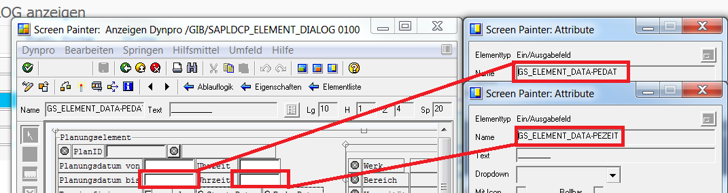

Class | /GIB/DCP_ELEMENT_DIALOG
Dynpro | 100
MODULE pbo_100 OUTPUT.
SET PF-STATUS 'S100'.
SET TITLEBAR 'T100' WITH gr_flow->mf_screen_title.
IF gr_flow->mf_first_call IS INITIAL.
gr_flow->at_screen_initialisation( gr_container ).
SET TITLEBAR 'T100' WITH gr_flow->mf_screen_title.
gr_flow->mf_first_call = abap_true.
ENDIF.
*#HW8782 - Dauer und Zeit im Block und Bundle gleichsetzen (AME 30.05.2018 12:48:05)
lcl_collection_view=>get_earliest_of_collection( IMPORTING ef_time = gs_element_data-time
ef_date = gs_element_data-date ).
*#HW8782 - Dauer und Zeit im Block und Bundle gleichsetzen (AME 30.05.2018 12:48:05)
*#HW10009 Ermittlung der kaparelevanten Zeit für Dummies ( AME 14.02.2019 )
IF sy-ucomm <> 'ENTR'.
gs_element_data-pedat = gr_data->pedat.
gs_element_data-pezeit = gr_data->pezeit.
ENDIF.
*##HW10009 Ermittlung der kaparelevanten Zeit für Dummies ( AME 14.02.2019 )
LOOP AT SCREEN.
CASE screen-group4.
WHEN 'OPE'."Operation Fields that can not be edited
IF gr_data->sart CA /gib/cl_dcp_sart=>gf_cmpstr_any_orders."no demand changes for Operations
screen-input = 0.
ENDIF.
WHEN OTHERS.
ENDCASE.
MODIFY SCREEN.
ENDLOOP.
*#HW10009 Ermittlung der kaparelevanten Zeit für Dummies ( AME 14.02.2019 )
IF gr_data->sart <> /gib/cl_dcp_sart=>co_dummy.
LOOP AT SCREEN.
IF screen-name = 'GS_ELEMENT_DATA-PEDAT'
OR screen-name = 'GS_ELEMENT_DATA-PEZEIT'
OR screen-name = 'TIME_TILL_T'
OR screen-name = 'PLDAT_TILL'.
screen-active = 0.
ENDIF.
MODIFY SCREEN.
ENDLOOP.
ENDIF.
*#HW10009 Ermittlung der kaparelevanten Zeit für Dummies ( AME 14.02.2019 )

Gui- Status für Enter anpassen (DYNPRO 100 )
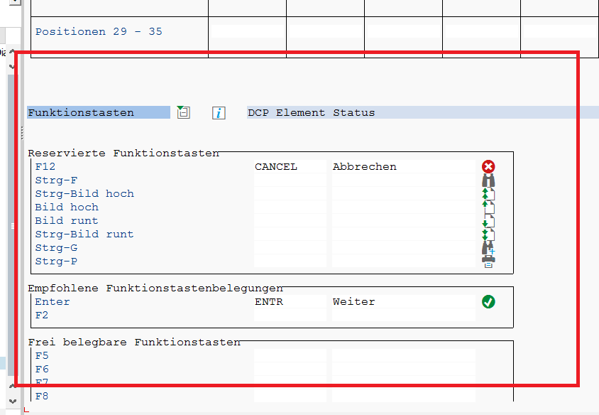
Class | /GIB/LDCP_ELEMENT_DIALOGTOP
DATA: ok_code TYPE syucomm,
gr_flow TYPE REF TO lcl_flow,
gr_data TYPE REF TO /gib/dcp_model_s,
gr_container TYPE REF TO cl_gui_container,
gs_element_data TYPE ts_element_data,
gr_element_data TYPE REF TO ts_element_data,
*#HW10009 Ermittlung der kaparelevanten Zeit für Dummies Von- Bis-Eingabe ( AME 13.02.2019 )
gf_demand_tmp TYPE /gib/dcp_duration_d.
*##HW10009 Ermittlung der kaparelevanten Zeit für Dummies Von- Bis-Eingabe ( AME 13.02.2019 )

Class | /GIB/DCP_ELEMENT_DIALOG
Local Class | lcl_flow
 | Neue Klasse anlegen
PROTECTED SECTION.
DATA: mr_element TYPE REF TO /gib/if_dcp_element,
mr_data TYPE REF TO /gib/dcp_model_s,
mr_element_data TYPE REF TO ts_element_data,
mr_collection_view TYPE REF TO lcl_collection_view.
METHODS: uc_save_to_element,
uc_toggle_element_expand_state,
uc_change_element_infotext,
uc_change_element_direction,
init_element_data,
at_pbo_screen,
at_pbo_element_data,
*#HW10009 Ermittlung der kaparelevanten Zeit für Dummies Von- Bis-Eingabe ( AME 13.02.2019 )
convert_demand IMPORTING if_unit TYPE /gib/dcp_unit_d "Methode zur Ermittlung des Bedarfs anhand der Planungszeiten
if_demand TYPE int4
RETURNING VALUE(rf_demand) TYPE /gib/dcp_duration_d,
get_new_pedat IMPORTING if_unit TYPE /gib/dcp_unit_d " Methode zur Berechnung des Planungsende anhand des neue eingegeben Bedarfs
IF_demand TYPE /gib/dcp_duration_d
RETURNING VALUE(rf_demand) TYPE int4.
*##HW10009 Ermittlung der kaparelevanten Zeit für Dummies Von- Bis-Eingabe ( AME 13.02.2019 )
ENDCLASS.

Class | /GIB/DCP_ELEMENT_DIALOG
Local Class | lcl_flow
Methode | Convert_demand
*#HW10009 Ermittlung der kaparelevanten Zeit für Dummies Von- Bis-Eingabe ( AME 13.02.2019 )
METHOD convert_demand.
CASE if_unit.
WHEN 'H'.
rf_demand = if_demand / 3600.
WHEN 'MIN'.
rf_demand = if_demand / 60.
WHEN 'S'.
rf_demand = if_demand.
WHEN 'TAG'.
rf_demand = ( if_demand / 3600 ) / 24.
WHEN 'WCH'.
rf_demand = ( ( if_demand / 3600 ) / 24 ) / 7.
WHEN 'MON'.
rf_demand = ( ( ( if_demand / 3600 ) / 24 ) / 7 ) / 4.
ENDCASE.
ENDMETHOD.
*##HW10009 Ermittlung der kaparelevanten Zeit für Dummies Von- Bis-Eingabe ( AME 13.02.2019 )

Class | /GIB/DCP_ELEMENT_DIALOG
Local Class | lcl_flow
Methode | Convert_demand
*#HW10009 Ermittlung der kaparelevanten Zeit für Dummies Von- Bis-Eingabe ( AME 13.02.2019 )
METHOD get_new_pedat.
CASE if_unit.
WHEN 'H'.
rf_demand = if_demand * 3600.
WHEN 'MIN'.
rf_demand = if_demand * 60.
WHEN 'S'.
rf_demand = if_demand.
WHEN 'TAG'.
rf_demand = ( if_demand * 3600 ) * 24.
WHEN 'WCH'.
rf_demand = ( ( if_demand * 3600 ) * 24 ) * 7.
WHEN 'MON'.
rf_demand = ( ( ( if_demand * 3600 ) * 24 ) * 7 ) * 4.
ENDCASE.
ENDMETHOD.
*##HW10009 Ermittlung der kaparelevanten Zeit für Dummies Von- Bis-Eingabe ( AME 13.02.2019 )

Class | /GIB/DCP_ELEMENT_DIALOG
Local Class | lcl_flow
Methode | /gib/if_dc_screen_flow~at_pbo
*#HW10009 Ermittlung der kaparelevanten Zeit für Dummies Von- Bis-Eingabe ( AME 13.02.2019 )
gf_demand_tmp = gs_element_data-demand.
*##HW10009 Ermittlung der kaparelevanten Zeit für Dummies Von- Bis-Eingabe ( AME 13.02.2019 )
at_pbo_screen( ).
at_pbo_element_data( ).

Class | /GIB/DCP_ELEMENT_DIALOG
Local Class | lcl_flow
Methode | /gib/if_dc_screen_flow~at_pai
METHOD /gib/if_dc_screen_flow~at_pai.
DATA: lf_demand TYPE int4.
CASE if_ucomm.
WHEN /gib/if_dc_screen_flow~co_ucomm_back OR
/gib/if_dc_screen_flow~co_ucomm_cancel OR
/gib/if_dc_screen_flow~co_ucomm_exit.
DELETE gt_elements_call_stack WHERE table_line = mr_element.
RAISE EXCEPTION TYPE /gib/cx_dcp_ui
EXPORTING
textid = /gib/cx_dcp_ui=>operation_canceled.
WHEN /gib/if_dc_screen_flow~co_ucomm_save.
*#HW10009 Ermittlung der kaparelevanten Zeit für Dummies (Von- Biseingabe) ( AME 15.02.2019 )
IF gs_element_data-date IS INITIAL OR gs_element_data-time IS INITIAL.
MESSAGE s472(/gib/dcp) DISPLAY LIKE /gib/cl_dcp_msg=>co_error.
RETURN.
ENDIF.
*##HW10009 Ermittlung der kaparelevanten Zeit für Dummies (Von- Biseingabe) ( AME 15.02.2019 )
uc_save_to_element( ).
DELETE gt_elements_call_stack WHERE table_line = mr_element.
LEAVE TO SCREEN 0.
WHEN co_uc-ek.
uc_toggle_element_expand_state( ).
WHEN co_uc-infotext.
uc_change_element_infotext( ).
WHEN co_uc-edirection.
uc_change_element_direction( ).
*#HW10009 Ermittlung der kaparelevanten Zeit für Dummies Von- Bis-Eingabe ( AME 13.02.2019 )
WHEN 'ENTR'.
CHECK gr_data->element IS BOUND.
IF gf_demand_tmp <> gs_element_data-demand.
IF gf_demand_tmp <> gs_element_data-demand.
gf_demand_tmp = GS_ELEMENT_DATA-DEMAND.
gr_data->element->set_start( /gib/cl_pit=>convert_date_time( if_date = gs_element_data-date if_time = gs_element_data-time ) ).
get_new_pedat( if_unit = gs_element_data-demand_unit if_demand = gs_element_data-demand ).
gr_data->element->set_demand( if_demand = get_new_pedat( if_unit = gs_element_data-demand_unit if_demand = gs_element_data-demand ) ).
gr_data->element->determine_end( ).
/gib/cl_pit=>convert_pit(
EXPORTING
if_pit = gr_data->element->mf_end
IMPORTING
ef_date = gs_element_data-pedat
ef_time = gs_element_data-pezeit ).
RETURN.
ENDIF.
gr_data->element->set_start( /gib/cl_pit=>convert_date_time( if_date = gs_element_data-date if_time = gs_element_data-time ) ).
gr_data->element->set_end( /gib/cl_pit=>convert_date_time( if_date = gs_element_data-pedat if_time = gs_element_data-pezeit ) ).
gr_data->element->determine_demand( ).
gs_element_data-demand = convert_demand(
EXPORTING
if_unit = gs_element_data-demand_unit
if_demand = gr_data->element->mf_demand ).
ENDIF.
*##HW10009 Ermittlung der kaparelevanten Zeit für Dummies Von- Bis-Eingabe ( AME 13.02.2019 )
ENDCASE.
ENDMETHOD.

Class | /GIB/DCP_ELEMENT_DIALOG
Local Class | lcl_flow
Methode | /gib/if_dc_screen_flow~at_pbo
*#HW10009 Ermittlung der kaparelevanten Zeit für Dummies Von- Bis-Eingabe ( AME 13.02.2019 )
gf_demand_tmp = gs_element_data-demand.
*##HW10009 Ermittlung der kaparelevanten Zeit für Dummies Von- Bis-Eingabe ( AME 13.02.2019 )
at_pbo_screen( ).
at_pbo_element_data( ).

