BUG: 9208 – Berechtigungen Werk *
CODE context INSERT DELETE CODE context

Folgende Suchhilfen anlegen:
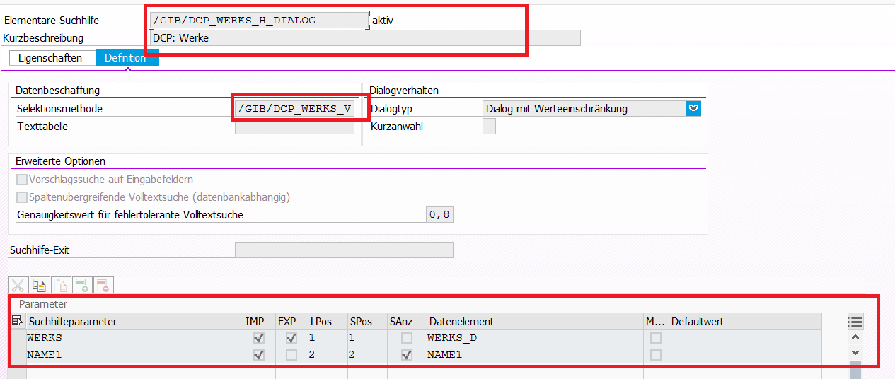

Folgende Sammelsuchhilfe anlegen:
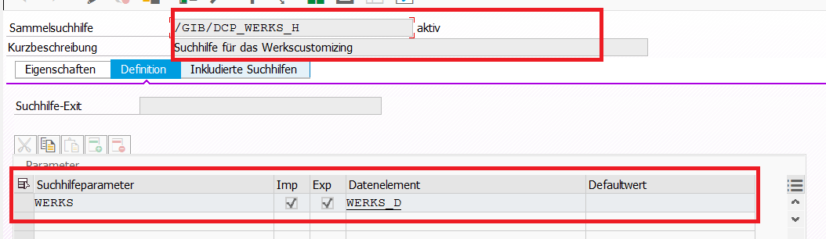

Parameterzuordnung: auf Werk identifizieren
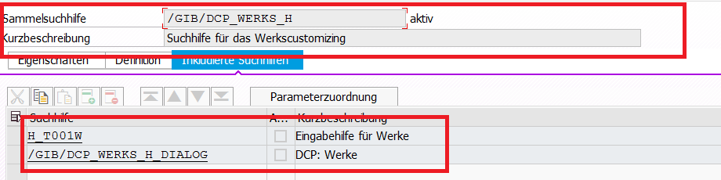

Funktionsbaustein | /GIB/DCP_POPUP_GET_WERKS_AREA
*#HW2239-Berechtigungskonzept DCP (MPL 30.05.2014 Authority Refactoring)
DATA: lt_fields TYPE TABLE OF sval,
ls_fields TYPE sval,
ls_dcp_0003 TYPE /gib/dcp_0003,
lf_return TYPE char1,
*#HW9958 Feld "WERK" in der Administration wird nicht vorbelegt
lf_werks TYPE werks_d.
*##HW9958 Feld "WERK" in der Administration wird nicht vorbelegt
FIELD-SYMBOLS: <ls_field> TYPE sval.
APPEND INITIAL LINE TO lt_fields ASSIGNING <ls_field>.
*#HW7141 - Bereichsdaten (DHO 19.07.2017 14:55:18)
IF sy-ucomm = 'CU_PLA'.
<ls_field>-tabname = '/GIB/DCP_WERKS'."'/GIB/DCP_0003'.
ELSE.
<ls_field>-tabname = '/GIB/DCP_0003'.
<ls_field>-fieldname = 'WERKS'.
ENDIF.
*##HW7141 - Bereichsdaten (DHO 19.07.2017 14:55:18)
*#HW9958 Feld "WERK" in der Administration wird nicht vorbelegt
GET PARAMETER ID 'WRK' FIELD lf_werks.
IF lf_werks IS NOT INITIAL.
ef_werks = lf_werks.
ENDIF.
*##HW9958 Feld "WERK" in der Administration wird nicht vorbelegt
<ls_field>-fieldname = 'WERKS'.
<ls_field>-value = ef_werks.
IF if_also_area IS NOT INITIAL.
APPEND INITIAL LINE TO lt_fields ASSIGNING <ls_field>.
<ls_field>-tabname = '/GIB/DCP_TIME'.
<ls_field>-fieldname = 'AREA'.
<ls_field>-value = ef_area.
ENDIF.
IF sy-ucomm = 'CU_PLA'.
CALL FUNCTION 'POPUP_GET_VALUES_DB_CHECKED'
EXPORTING
check_existence = 'X'
popup_title = ' '
* START_COLUMN = '5'
* START_ROW = '5'
IMPORTING
returncode = lf_return
TABLES
fields = lt_fields
EXCEPTIONS
error_in_fields = 1
OTHERS = 2.
ELSE.
CALL FUNCTION 'POPUP_GET_VALUES'
EXPORTING
no_value_check = 'X'
popup_title = ' '
* START_COLUMN = '5'
* START_ROW = '5'
IMPORTING
returncode = lf_return
TABLES
fields = lt_fields
EXCEPTIONS
error_in_fields = 1
OTHERS = 2.
ENDIF.
IF sy-subrc <> 0.
* Implement suitable error handling here
RAISE EXCEPTION TYPE /gib/cx_dcp_ui
EXPORTING
textid = /gib/cx_dcp_ui=>operation_canceled.
ENDIF.
*##HW7141 - Bereichsdaten (DHO 19.07.2017 14:55:18)
CASE lf_return.

