BUG: 9639 – Grafik zeigt nur Angebot auf Basis "Anzahl Tage Vorschau"
CODE context INSERT DELETE CODE context
Struktur um das Feld Monat erweitern:

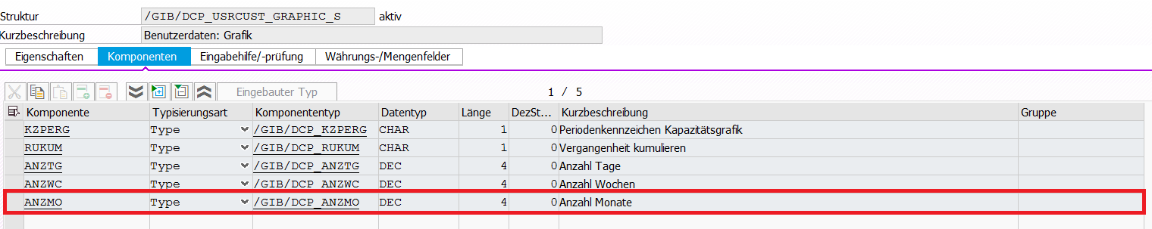

Datenelement:

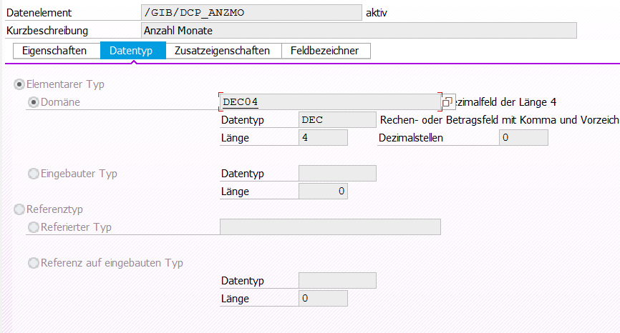

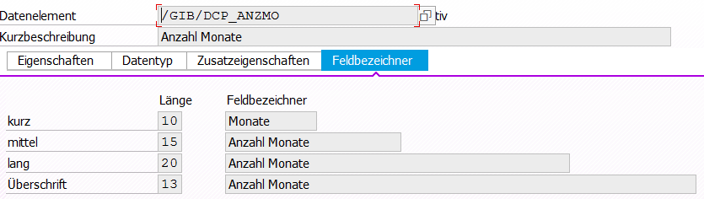

Dynpro anpassen / Monat einfügen
Func Group | /GIB/DCP_CUST_SETTINGS
Dynpro | 600
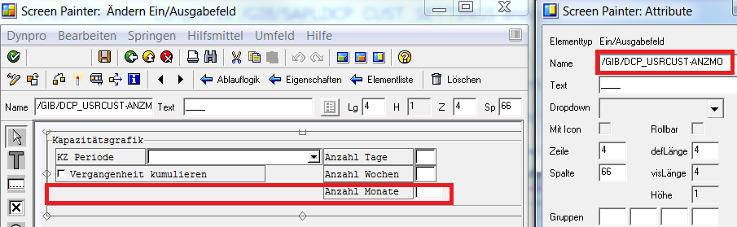

Ein und Ausblenden beeinflussen
Func Group | /GIB/DCP_CUST_SETTINGS
Dynpro | PBO 600
Unterprogramm | adjust_screen_600
*#HW9636 Grafik zeigt nur Angebot auf Basis "Anzahl Tage Vorschau" ( AME 31.01.2019 )
* LOOP AT SCREEN.
* CASE screen-group1.
* WHEN 'MIX'."ANZTG and ANZWC only appear when period type = MIX
* IF /gib/dcp_usrcust-kzperg = 'M'.
* screen-input = 1.
* screen-active = 1.
* ELSE.
* screen-input = 0.
* screen-active = 0.
* ENDIF.
* WHEN OTHERS.
* ENDCASE.
* MODIFY SCREEN.
* ENDLOOP.
LOOP AT SCREEN.
CASE /gib/dcp_usrcust-kzperg.
WHEN '1'.
IF screen-name = '/GIB/DCP_USRCUST-ANZWC'
OR screen-name = '/GIB/DCP_USRCUST-ANZMO'.
screen-active = 0.
ENDIF.
WHEN '2'.
IF screen-name = '/GIB/DCP_USRCUST-ANZTG'
OR screen-name = '/GIB/DCP_USRCUST-ANZMO'.
screen-active = 0.
ENDIF.
WHEN '3'.
IF screen-name = '/GIB/DCP_USRCUST-ANZTG'
OR screen-name = '/GIB/DCP_USRCUST-ANZWC'.
screen-active = 0.
ENDIF.
WHEN 'MIX'.
WHEN SPACE.
IF screen-name = '/GIB/DCP_USRCUST-ANZTG'
OR screen-name = '/GIB/DCP_USRCUST-ANZWC'
OR screen-name = '/GIB/DCP_USRCUST-ANZMO'.
screen-active = 0.
ENDIF.
ENDCASE.
MODIFY SCREEN.
ENDLOOP.
*#HW9636 Grafik zeigt nur Angebot auf Basis "Anzahl Tage Vorschau" ( AME 31.01.2019 )

Class | /GIB/CL_DCP_C_GRAPH
Method | PREPARE_GRAPHIC_DATA
DATA: lt_data TYPE /gib/dcp_model_t,"table with unplanned data for graphic
lt_slices TYPE /gib/dcp_slice_t,"table with capacity data for graphic
lf_start_date TYPE sydatum,
lf_end_date TYPE sydatum,
lt_capacity TYPE tt_collect_data,
lt_unplanned TYPE tt_collect_data,
lt_unplanned_avpl TYPE tt_collect_data,
lt_planned TYPE tt_collect_data,
ls_graph_data TYPE /gib/dcp_graf_angebot_s,
lt_periods TYPE TABLE OF REF TO /gib/if_dc_calendar_period,
lt_weeks TYPE TABLE OF REF TO /gib/if_dc_calendar_period,
*#HW9639 Grafik zeigt nur Angebot auf Basis "Anzahl Tage Vorschau"
lt_month TYPE TABLE OF REF TO /gib/if_dc_calendar_period.
*##HW9639 Grafik zeigt nur Angebot auf Basis "Anzahl Tage Vorschau"

*#get the user cust settings
DATA(ls_user_cust) = /gib/cl_dcp_settings=>gs_usrcust.
gather_unplanned_data( IMPORTING et_unplanned_data = lt_data ).
collect_unplanned( EXPORTING it_unplanned = lt_data
if_time_unit_out = ls_user_cust-zeinh
IMPORTING et_collected_unplanned = lt_unplanned
et_collected_unp_avpl = lt_unplanned_avpl
CHANGING cf_min_date = lf_start_date
cf_max_date = lf_end_date ).
CLEAR lt_data.
gather_planned_data( IMPORTING et_planned_data = lt_data ).
collect_planned( EXPORTING it_planned = lt_data
if_time_unit_out = ls_user_cust-zeinh
IMPORTING et_collected_planned = lt_planned
CHANGING cf_min_date = lf_start_date
cf_max_date = lf_end_date ).
*#only gahter capacity from today forward
gather_capacity_data( EXPORTING if_min_date = sy-datum
if_max_date = lf_end_date
IMPORTING et_capacity_slice = lt_slices ).
collect_capacity( EXPORTING it_capacity = lt_slices
if_time_unit_out = ls_user_cust-zeinh
IMPORTING et_collected_capacity = lt_capacity ).
*#If the cumulate past data is set then all the past date will
*#be cumulated in current date and start date for the graphic
*#will be set tu current date
IF ls_user_cust-rukum = 'X'.
cumulate_past_data( CHANGING ct_collect_data = lt_unplanned ).
cumulate_past_data( CHANGING ct_collect_data = lt_unplanned_avpl ).
cumulate_past_data( CHANGING ct_collect_data = lt_planned ).
cumulate_past_data( CHANGING ct_collect_data = lt_capacity ).
lf_start_date = sy-datum.
ENDIF.
READ TABLE lt_capacity INTO DATA(ls_collect) INDEX lines( lt_capacity ).
IF lf_end_date < ls_collect-datum.
lf_end_date = ls_collect-datum.
ENDIF.
DATA(lr_calendar) = NEW /gib/cl_dc_calendar( if_start_date = lf_start_date
if_end_date = lf_end_date ).
"Build the Periods in:
CASE ls_user_cust-kzperg.
WHEN '1'."Days
LOOP AT lr_calendar->mt_calendar INTO DATA(ls_calendar).
DATA(lr_period) = lr_calendar->get_day( ls_calendar-date ).
APPEND lr_period TO lt_periods.
*#get the index of the current date
IF ls_calendar-date = sy-datlo.
ef_index_offset = sy-tabix.
ENDIF.
ENDLOOP.
WHEN '2'."Weeks
LOOP AT lr_calendar->mt_calendar INTO ls_calendar.
lr_period = lr_calendar->get_week( ls_calendar-week ).
COLLECT lr_period INTO lt_periods.
ENDLOOP.
WHEN '3'."Months
LOOP AT lr_calendar->mt_calendar INTO ls_calendar.
lr_period = lr_calendar->get_month( ls_calendar-month ).
COLLECT lr_period INTO lt_periods.
ENDLOOP.
WHEN 'M'."Mix
IF ls_user_cust-anztg IS INITIAL.
ls_user_cust-anztg = 5."default
ENDIF.
IF ls_user_cust-anzwc IS INITIAL.
ls_user_cust-anzwc = 5."default
ENDIF.
*#HW9639 Grafik zeigt nur Angebot auf Basis "Anzahl Tage Vorschau"
IF ls_user_cust-anzmo IS INITIAL.
ls_user_cust-anzmo = 2."default
ENDIF.
*##HW9639 Grafik zeigt nur Angebot auf Basis "Anzahl Tage Vorschau"

LOOP AT lr_calendar->mt_calendar INTO ls_calendar FROM 1 TO ls_user_cust-anztg.
lr_period = lr_calendar->get_day( ls_calendar-date ).
APPEND lr_period TO lt_periods.
*#get the index of the current date
IF ls_calendar-date = sy-datlo.
ef_index_offset = sy-tabix.
ENDIF.
ENDLOOP.
DATA(lf_date) = ls_calendar-date.
"build the necesary week periods
LOOP AT lr_calendar->mt_calendar INTO ls_calendar WHERE date GT lf_date.
lr_period = lr_calendar->get_week( ls_calendar-week ).
COLLECT lr_period INTO lt_weeks.
IF lines( lt_weeks ) = ls_user_cust-anzwc.
EXIT.
ENDIF.
ENDLOOP.
APPEND LINES OF lt_weeks TO lt_periods.
*#HW9639 Grafik zeigt nur Angebot auf Basis "Anzahl Tage Vorschau"
** lf_date = ls_calendar-date.
** "everything else in months
** LOOP AT lr_calendar->mt_calendar INTO ls_calendar WHERE date GT lf_date.
** lr_period = lr_calendar->get_month( ls_calendar-month ).
** COLLECT lr_period INTO lt_periods.
** ENDLOOP.
LOOP AT lr_calendar->mt_calendar INTO ls_calendar WHERE date GT lf_date.
lr_period = lr_calendar->get_month( ls_calendar-month ).
COLLECT lr_period INTO lt_month.
IF lines( lt_month ) = ls_user_cust-anzmo.
EXIT.
ENDIF.
ENDLOOP.
APPEND LINES OF lt_month TO lt_periods.
*##HW9639 Grafik zeigt nur Angebot auf Basis "Anzahl Tage Vorschau"
ENDCASE.

Class | /GIB/CL_DCP_C_GRAPH
Method | GATHER_COLLECTION_DATA
*#HW9448 - Grafik-Kapazitätsbedarf (MPL 23.07.2018)
DATA: ls_usrcust TYPE /gib/dcp_usrcust,
ls_usrcust_old TYPE /gib/dcp_usrcust,
lr_element TYPE REF TO /gib/if_dcp_element,
lf_expand_state TYPE flag,
lr_data TYPE REF TO /gib/dcp_model_t.
*#HW9639 Grafik zeigt nur Angebot auf Basis "Anzahl Tage Vorschau" ( AME 30.01.2019 )
* ir_settings->get_usrcust( IMPORTING es_usrcust = ls_usrcust_old )."remember the user settings
select single * FROM /GIB/DCP_USRCUST into CORRESPONDING FIELDS OF ls_usrcust_old WHERE uname = sy-uname.
*##HW9639 Grafik zeigt nur Angebot auf Basis "Anzahl Tage Vorschau" ( AME 30.01.2019 )
ls_usrcust = ls_usrcust_old.
*#set the dipslay settings to allways have the day change
ls_usrcust-kzohft = 'X'."Feiertage ausblenden
ls_usrcust-kzohka = 'X'. "Arbeitszeit ausblenden
ls_usrcust-kzohat = 'X'."Ausfallzeiten ausblenden
ls_usrcust-kzohpa = 'X'."Pausenzeiten ausblenden
ls_usrcust-kzschw = 'X'."Schichtwechsel ausblenden
ls_usrcust-daychange = ' '."Tageswechsel ausblenden
ls_usrcust-weekchange = 'X'."Wochenwechsel ausblenden
ls_usrcust-monchange = 'X'."Monatswechsel ausblenden
ls_usrcust-int_start = 'X'."intervall-start ausblenden
ls_usrcust-int_end = 'X'."Intervall-Ende ausblenden
ls_usrcust-freekum = 'X'."Freie Zeiten summieren
ls_usrcust-auskum = 'X'."Nichtarbeitszeiten zusammenfassen
ls_usrcust-auzkum = 'X'."Ausfallzeiten zusammenfassen
ir_settings->set_usrcust( ls_usrcust-data ).
LOOP AT ir_collection->mt_elements INTO lr_element.
lf_expand_state = lr_element->mf_expand_state."remember the expand state
lr_element->set_expand_state( 'X' )." to display the element expanded
CREATE DATA lr_data.
lr_element->write( lr_data ).
"remove capacity lines
DELETE lr_data->* WHERE zart IS NOT INITIAL.
APPEND LINES OF lr_data->* TO et_data."ET_DATA can have data from previous calls!!!
lr_element->set_expand_state( lf_expand_state )."in order to set it back at the end
ENDLOOP.
ir_settings->set_usrcust( ls_usrcust_old-data )."so

Folgende Methode anlegen:

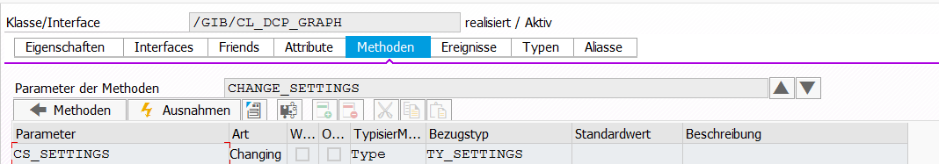

Class | /GIB/CL_DCP_GRAPH
Method | Change_settings
*#HW9639 Grafik zeigt nur Angebot auf Basis "Anzahl Tage Vorschau" ( AME 30.01.2019 )
method CHANGE_SETTINGS.
DATA: lf_cust_day TYPE datum,
lf_usrcust TYPE /GIB/DCP_USRCUST.
select single kzperg anztg anzwc anzmo FROM /GIB/DCP_USRCUST into CORRESPONDING FIELDS OF lf_usrcust
WHERE UNAME = sy-uname.
CASE lf_usrcust-kzperg.
WHEN '1'. " Tagesdarstellung
IF lf_usrcust-anztg IS NOT INITIAL.
CS_SETTINGS-steps = lf_usrcust-anztg.
ENDIF.
WHEN '2'. " Wochendarstellung
IF lf_usrcust-anztg IS NOT INITIAL.
CS_SETTINGS-steps = lf_usrcust-anzwc.
ENDIF.
WHEN '3'. " Monatsdarstellung
IF lf_usrcust-anztg IS NOT INITIAL.
CS_SETTINGS-steps = lf_usrcust-anzmo.
ENDIF.
WHEN 'M'.
DATA(lf_period_mix) = lf_usrcust-anzmo + lf_usrcust-anzwc + lf_usrcust-anztg.
IF lf_period_mix IS NOT INITIAL.
CS_SETTINGS-steps = lf_period_mix.
ENDIF.
ENDCASE.
endmethod.
*##9639 Grafik zeigt nur Angebot auf Basis "Anzahl Tage Vorschau" ( AME 30.01.2019 )

Class | /GIB/CL_DCP_GRAPH
Method | LOAD_GRAPH_XML
DATA: lf_key TYPE /gib/dc_cl-srtfd,
lf_data TYPE xstring,
lt_data TYPE w3htmltabtype.
DATA: lt_data_dummy TYPE STANDARD TABLE OF char1,
lr_data TYPE REF TO data.
*# Wie werden die Einstellungen abgelegt
lf_key = get_key_name( ).
IF NOT lf_key IS INITIAL.
TRY.
IMPORT xml_customizing = lt_data
settings = ms_settings
FROM DATABASE /gib/dc_cl(gr)
ID lf_key
IGNORING CONVERSION ERRORS
ACCEPTING PADDING
ACCEPTING TRUNCATION.
CATCH cx_root.
CLEAR: lt_data." ms_settings.
ENDTRY.
ENDIF.
*#HW9639 Grafik zeigt nur Angebot auf Basis "Anzahl Tage Vorschau" ( AME 30.01.2019 )
change_settings( CHANGING cs_settings = ms_settings ). " Change periods
*##9639 Grafik zeigt nur Angebot auf Basis "Anzahl Tage Vorschau" ( AME 30.01.2019 )
*# nur unter Windows kommt man wieder an die Graph-Daten
IF lt_data IS INITIAL AND mr_chart_control->activex NE space.
*# keine gespeicherten Daten vorhanden

Class | /GIB/CL_DCP_GRAPH
Method | CREATE_GRAPH
*# Graph aus Daten erzeugen
DATA: lr_ixml_doc TYPE REF TO if_ixml_document,
lr_ostream TYPE REF TO if_ixml_ostream,
lr_element TYPE REF TO if_ixml_element,
lr_encoding TYPE REF TO if_ixml_encoding,
lr_categories TYPE REF TO if_ixml_element,
lr_series TYPE REF TO if_ixml_element,
lr_chartdata TYPE REF TO if_ixml_element,
lr_point TYPE REF TO if_ixml_element,
lf_string TYPE string,
lf_count TYPE sytabix,
lf_point_type TYPE string,
lf_char TYPE char128,
lr_xstr TYPE xstring,
lf_master TYPE xfeld,
* lf_type TYPE char1,
lt_category TYPE TABLE OF string,
lf_datetime TYPE string.
*# 12.08.11 ABA Gantgrafik Anzahl Rubriken
DATA: lf_start_gantt TYPE sy-tabix,
lf_step_gantt TYPE sy-tabix.
*## 12.08.11 ABA Gantgrafik Anzahl Rubriken
FIELD-SYMBOLS: <lt_data> TYPE STANDARD TABLE,
<fs_data> TYPE ANY,
<fs_from> TYPE ANY,
<fs_curr> TYPE waers,
<fs_fcat> TYPE lvc_s_fcat.
*#HW9639 Grafik zeigt nur Angebot auf Basis "Anzahl Tage Vorschau" ( AME 30.01.2019 )
change_settings( CHANGING cs_settings = ms_settings ). " Change periods
*##9639 Grafik zeigt nur Angebot auf Basis "Anzahl Tage Vorschau" ( AME 30.01.2019 )
IF ms_chart_layout-pres_type GE 100.
* or ms_chart_layout-pres_type = '100' .
"GFW_PRESTYPE_TIME_AXIS
lf_point_type = 'time'. "#EC*

Class | /GIB/CL_DCP_UC_HANDLER
Method | UC_GRAPH
*# local declarations
DATA: lt_setarea TYPE /gib/dcp_setarea_t,
ls_setarea TYPE /gib/dcp_setarea,
lr_scl TYPE REF TO /gib/if_dc_scl,
*#HW9314 - DCP glob. Toolbar - Button "Anzeigen / Ändern" reagiert nicht (AME 13.06.2018 14:25:17)
ls_models TYPE ts_model,
*#HW9639 Grafik zeigt nur Angebot auf Basis "Anzahl Tage Vorschau"
lr_msg TYPE REF TO /gib/cl_dcp_msg.
IF /gib/cl_dcp_settings=>gs_usrcust-kzperg IS INITIAL.
CREATE OBJECT lr_msg.
lr_msg->set(
EXPORTING
mid = '/GIB/DCP' " (abweichende) Nachrichtenklasse
num = 464
typ = 'E' " Messagetyp ( niemals ' '!)
no_duplicate = 'X' ). " Keine doppelte Meldungsnummern
lr_msg->show( ).
RETURN.
ENDIF.
*##HW9639 Grafik zeigt nur Angebot auf Basis "Anzahl Tage Vorschau"

Class | /GIB/CL_DCP_UC_HANDLER
Method | UC_GRAPH_SUM
*#--------------------------------------------------------------------*
*# local declarations
DATA: lt_setarea TYPE /gib/dcp_setarea_t,
ls_setarea TYPE /gib/dcp_setarea,
lt_alt_areas TYPE /gib/dcp_alt_areas_t,
*#HW9314 - DCP glob. Toolbar - Button "Anzeigen / Ändern" reagiert nicht (AME 13.06.2018 14:25:17)
ls_models TYPE ts_model,
*##HW9314 - DCP glob. Toolbar - Button "Anzeigen / Ändern" reagiert nicht (AME 13.06.2018 14:25:17)
*#HW9639 Grafik zeigt nur Angebot auf Basis "Anzahl Tage Vorschau"
lr_msg TYPE REF TO /gib/cl_dcp_msg.
IF /gib/cl_dcp_settings=>gs_usrcust-kzperg IS INITIAL.
CREATE OBJECT lr_msg.
lr_msg->set(
EXPORTING
mid = '/GIB/DCP' " (abweichende) Nachrichtenklasse
num = 464
typ = 'E' " Messagetyp ( niemals ' '!)
no_duplicate = 'X' ). " Keine doppelte Meldungsnummern
lr_msg->show( ).
RETURN.
ENDIF.
*##HW9639 Grafik zeigt nur Angebot auf Basis "Anzahl Tage Vorschau"
FIELD-SYMBOLS: <lf_area> TYPE /gib/dcp_area.

Folgende Nachricht anlegen:

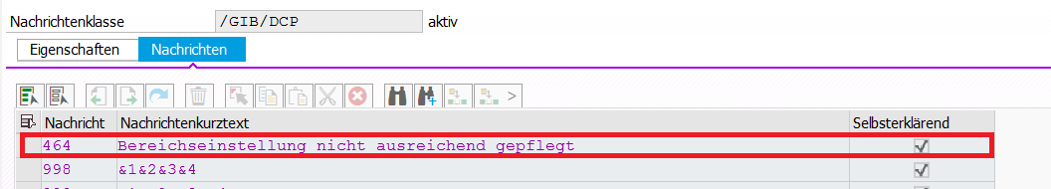

Func Group | /GIB/DCP_CUST_SETTINGS
DYNPRO 100 | PAI_100 lcl_flow_0100=>pai( ).
Method | process_user_command
*#HW9636
DATA: lr_msg TYPE REF TO /GIB/CL_DCP_MSG,
lt_msg TYPE MSG_TAB_TYPE.
CREATE OBJECT lr_msg.
*##HW9636
save_ok = ok_code100.
CLEAR: ok_code100.
CASE save_ok.
WHEN 'SAVE'.
*#HW9085 - Persönliche Einstellungen: Grundeinstellungen können nicht übernommen werden (AME 03.04.2018 11:02:33)
IF /gib/dcp_usrcust-zeinh IS INITIAL.
MESSAGE e055(00).
* Füllen Sie alle Mußfelder aus
RETURN.
ENDIF.
IF /gib/cl_services=>is_time_unit( /gib/dcp_usrcust-zeinh ) IS INITIAL.
MESSAGE i301(/gib/dcp) WITH /gib/dcp_usrcust-zeinh.
CLEAR: /gib/dcp_usrcust-zeinh, ok_code100.
RETURN.
ENDIF.
*##HW9085 - Persönliche Einstellungen: Grundeinstellungen können nicht übernommen werden (AME 03.04.2018 11:02:33)
*#HW9636 - Grafik zeigt nur Angebot auf Basis "Anzahl Tage Vorschau" ( AME 11.02.2019 )
IF /gib/dcp_usrcust-anztg > 360.
lr_msg->set(
EXPORTING
mid = '/GIB/DCP' " (abweichende) Nachrichtenklasse
num = 466 " Messagenummer
typ = /GIB/CL_DCP_MSG=>co_error
).
ENDIF.
IF /gib/dcp_usrcust-anzwc > 52.
lr_msg->set(
EXPORTING
mid = '/GIB/DCP' " (abweichende) Nachrichtenklasse
num = 467 " Messagenummer
typ = /GIB/CL_DCP_MSG=>co_error
).
ENDIF.
IF /gib/dcp_usrcust-anzmo > 12.
lr_msg->set(
EXPORTING
mid = '/GIB/DCP' " (abweichende) Nachrichtenklasse
num = 468 " Messagenummer
typ = /GIB/CL_DCP_MSG=>co_error " Messagetyp ( niemals ' '!)
).
ENDIF.
lt_msg = lr_msg->get_msg_tab( ).
IF lt_msg IS NOT INITIAL.
lr_msg->show( ).
RETURN.
ENDIF.
*##HW9636 - Grafik zeigt nur Angebot auf Basis "Anzahl Tage Vorschau" ( AME 11.02.2019 )
IF gf_kzezkap = '2'.
* Auftragskomprimierung einschalten
/gib/dcp_usrcust-kzcomp = gw_user_cust-kzcomp.
"Ausfallzeiten summiere

