BUG: 9998 – Selektion in der Übersicht
CODE context INSERT DELETE CODE context
Klasse | /GIB/CL_DCP_SEL_PARAMETERS
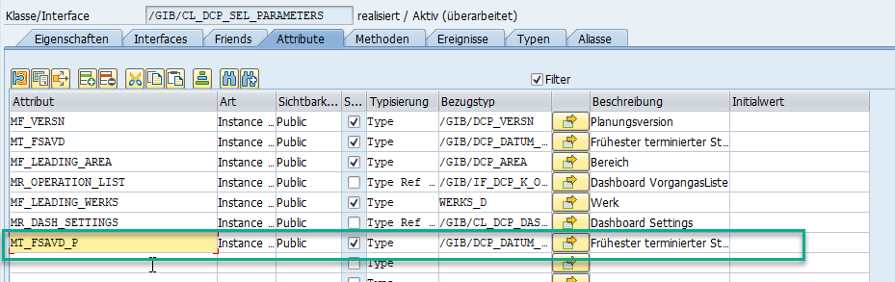

Klasse | /GIB/CL_DCP_M_OVERVIEW
Methode | READ_DCP_OVERVIEW
CLEAR et_overview.
READ TABLE mr_parameters->mt_kzpla WITH KEY low = /gib/cl_dcp_tyco=>co_planned TRANSPORTING NO FIELDS.
IF sy-subrc = 0.
SELECT * FROM /gib/dcp_main
APPENDING CORRESPONDING FIELDS OF TABLE et_overview
WHERE werks = ms_id-werks
AND area = ms_id-area
AND versn = ms_id-versn
AND kzpla = /gib/cl_dcp_tyco=>co_planned
*#HW9998 Selektion in der Übersicht (ABA 19.12.2018)
* AND pldat IN mr_parameters->mt_bidat.
AND pldat IN mr_parameters->mt_bidat
and fsavd in mr_parameters->mt_fsavd_p.
*##HW9998 Selektion in der Übersicht (ABA 19.12.2018)
ENDIF.

Klasse | /GIB/CL_DCP_SEL_METADATA
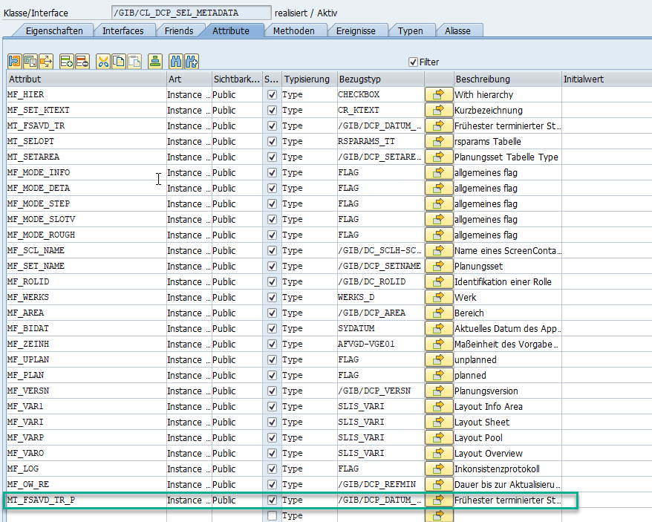

Klasse | /GIB/CL_DCP_SEL_METADATA
Methode | INIT_METADATA
APPEND ls_fsavd_sr TO lt_plan_tr.
ENDIF.
ENDLOOP.
*#HW9998 Selektion in der Übersicht (ABA 19.12.2018)
* IF lt_uplan_tr IS NOT INITIAL
* AND lt_plan_tr IS INITIAL.
* mt_fsavd_tr = lt_uplan_tr.
* ELSEIF lt_plan_tr IS NOT INITIAL
* AND lt_uplan_tr IS INITIAL.
* mt_fsavd_tr = lt_plan_tr.
* ELSE.
* APPEND LINES OF lt_uplan_tr TO mt_fsavd_tr.
* APPEND LINES OF lt_uplan_tr TO mt_fsavd_tr.
*
* ENDIF.
IF lt_uplan_tr IS NOT INITIAL.
mt_fsavd_tr = lt_uplan_tr.
endif.
IF lt_plan_tr IS NOT INITIAL.
mt_fsavd_tr_P = lt_plan_tr.
ENDIF.
*##HW9998 Selektion in der Übersicht (ABA 19.12.2018)
ENDIF.

Klasse | /GIB/CL_DCP_SEL_PARAMETERS
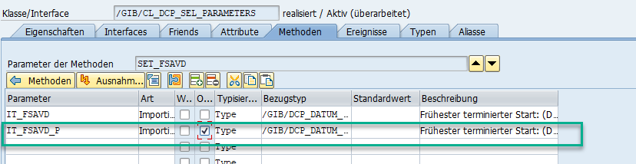

Klasse | /GIB/CL_DCP_SEL_PARAMETERS
Methode | SET_FSAVD
mt_fsavd = it_fsavd.
*#HW9998 Selektion in der Übersicht (ABA 19.12.2018)
mt_fsavd_P = it_fsavd_p.
*##HW9998 Selektion in der Übersicht (ABA 19.12.2018)

Klasse | /GIB/CL_DCP_GUI_SERVICES
Methode | CREATE_OVERVIEW
CREATE OBJECT lr_parameters.
lr_parameters->mf_ow_re = ir_metadata->mf_ow_re.
lr_parameters->mf_varo = ir_metadata->mf_varo.
lr_parameters->set_versn( ir_metadata->mf_versn ).
*#HW9998 Selektion in der Übersicht (ABA 19.12.2018)
* lr_parameters->set_fsavd( ir_metadata->mt_fsavd_tr ).
lr_parameters->set_fsavd( exporting it_fsavd = ir_metadata->mt_fsavd_tr
it_fsavd_p = ir_metadata->mt_fsavd_tr_p ).
*##HW9998 Selektion in der Übersicht (ABA 19.12.2018)
lr_parameters->set_bidat( ir_metadata->mf_bidat ).

