BUG: 9676 – Auflösen Infohierarchie zeigt nicht alle Arbeitsplätze

Class: | /GIB/CL_DCP_HIERARCHY
Private Section
private section.
types:
tt_objid TYPE TABLE OF cr_objid .
class-data:
gt_hierarchy TYPE TABLE OF REF TO /gib/cl_dcp_hierarchy .
data MT_CHILDREN type /GIB/IF_DCP_OBJID=>TT_OBJID .
*#HW9676 - Hierarchie auflösen (SLI 25.09.2018 16:40:48)
* data:
* mt_nodes TYPE TABLE OF REF TO /gib/cl_dcp_arbid_node .
**
*##HW9676 - Hierarchie auflösen (SLI 25.09.2018 16:40:48)
methods ADD_NODE_CHILDREN
importing
!IR_NODE type ref to /GIB/CL_DCP_ARBID_NODE .
methods BUILD_WORKCENTERS .
methods BUILD_CHILDREN .
methods GET_NODE_CHILDREN_IDS
importing
• • •

Class: | /GIB/CL_DCP_HIERARCHY
Public Section
public section.
interfaces /GIB/IF_DCP_DESCRIPTION .
interfaces /GIB/IF_DCP_OBJID .
aliases MF_HIERID
for /GIB/IF_DCP_OBJID~MF_OBJID .
aliases GET_CHILDREN
for /GIB/IF_DCP_OBJID~GET_CHILDREN .
aliases GET_DESCRIPTION
for /GIB/IF_DCP_DESCRIPTION~GET .
aliases GET_ICON
for /GIB/IF_DCP_DESCRIPTION~GET_ICON .
aliases GET_LONG_DESCRIPTION
for /GIB/IF_DCP_DESCRIPTION~GET_LONG .
aliases GET_SUBTREE
for /GIB/IF_DCP_OBJID~GET_SUBTREE .
data MS_CRHH type CRHH read-only .
data:
mt_hierarchy_structure TYPE TABLE OF rcr06_a read-only .
data MF_DESCRIPTION type CR_KTEXT read-only .
data MR_WERKS type ref to /GIB/CL_DCP_WERKS read-only .
class /GIB/CL_DCP_ARBID definition load .
data MT_WORKCENTERS type /GIB/CL_DCP_ARBID=>TT_ARBID read-only .
*#HW9676 - Hierarchie auflösen (SLI 25.09.2018 16:40:48)
data:
mt_nodes TYPE TABLE OF REF TO /gib/cl_dcp_arbid_node .
*##HW9676 - Hierarchie auflösen (SLI 25.09.2018 16:40:48)
class-methods GET_INSTANCE_WITH_KEY
importing
!IF_HNAME type CR_HNAME
!IF_WERKS type WERKS_D
returning
value(RR_HIERARCHY) type ref to /GIB/CL_DCP_HIERARCHY .
• • •

Function module: | /GIB/DCP_HIERARCHY_ALT
*# Lesen der Hierarchie-Stammdaten
SELECT SINGLE objid FROM crhh INTO CORRESPONDING FIELDS OF lw_crhh "#EC CI_NOORDER - AME - 09.11.2017
WHERE werks = if_werks
AND name = if_name_hy. "#EC *
IF sy-subrc <> 0.
EXIT.
ENDIF.
*#HW9676 - Infohierarchie (SLI 25.09.2018 14:40:37)
IF if_kzinfo IS INITIAL.
*##HW9676 - Infohierarchie (SLI 25.09.2018 14:40:37)
*# Lesen der gesamten Hierarchie
CALL FUNCTION 'CR_HIERARCHY_DISOLVE'
EXPORTING
objid_hy = lw_crhh-objid
TABLES
t_struc = lt_struc
EXCEPTIONS
hierarchy_not_found = 1
object_not_in_hierarchy = 2
OTHERS = 3.
IF sy-subrc <> 0.
EXIT.
ENDIF.
lw_alt-objid = lw_struc-objid.
lw_alt-objty = lw_struc-objty.
SELECT SINGLE arbpl FROM crhd INTO lw_alt-arbpl
WHERE objty = 'A'
AND objid = lw_alt-objid.
SELECT SINGLE ktext FROM crtx INTO lw_alt-ktext
WHERE objty = 'A'
AND objid = lw_alt-objid
AND spras = sy-langu.
APPEND lw_alt TO et_alt.
lf_objid_wrk = lw_struc-objid_up.
ELSE.
EXIT.
ENDIF.
ENDDO.
ENDIF.
SORT et_alt BY arbpl.
*#HW9676 - Infohierarchie (SLI 25.09.2018 14:40:37)
ELSE.
DATA: lr_arbid TYPE REF TO /gib/cl_dcp_arbid.
DATA(lr_hier) = /gib/cl_dcp_hierarchy=>get_instance_with_key( if_hname = if_name_hy
if_werks = if_werks ).
READ TABLE lr_hier->mt_nodes INTO DATA(lr_node)
WITH KEY table_line->/gib/if_dcp_objid~mf_objid = lw_crhd-objid.
IF sy-subrc EQ 0.
lr_node->get_subtree( IMPORTING et_subtree = DATA(lt_subtree) ).
LOOP AT lt_subtree INTO DATA(lr_objid).
TRY.
lr_arbid ?= lr_objid.
CLEAR: lw_alt.
lw_alt-werks = lr_arbid->mr_werks->mf_werks.
lw_alt-objid = lr_arbid->ms_crhd-objid.
lw_alt-objty = lr_arbid->ms_crhd-objty.
lw_alt-arbpl = lr_arbid->mf_arbpl.
lw_alt-ktext = lr_arbid->mf_description.
APPEND lw_alt TO et_alt.
CATCH cx_sy_move_cast_error.
ENDTRY.
ENDLOOP.
ENDIF.
ENDIF.
*##HW9676 - Infohierarchie (SLI 25.09.2018 14:40:37)
ENDFUNCTION. "#EC CI_VALPAR
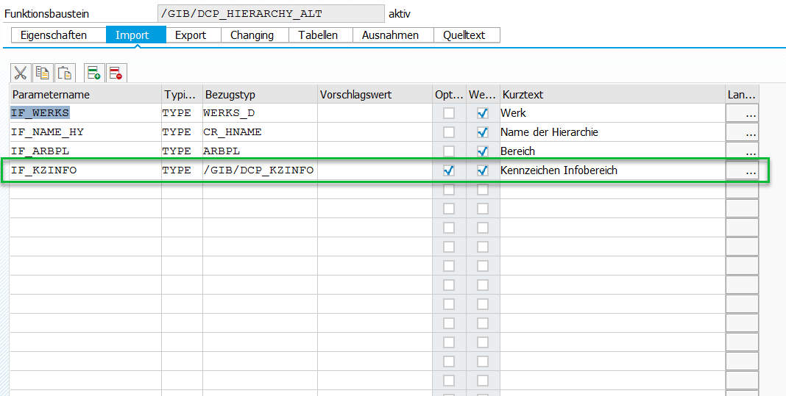
• • •

Class: | /GIB/CL_DCP_SETTINGS
Method: | FIND_ALTERNATIVES
METHOD find_alternatives.
*#HW4132 - DCP und DCPN Infobereiche werden über Hierarchie zum einplanen angeboten (MPL 24.07.2014)
*#HW4137 - Zweischrittverfahren (MPL 29.07.2014)
DATA: lt_workstations TYPE /gib/dcp_area_alt_tt,
ls_workstation TYPE /gib/dcp_area_alt,
lr_settings TYPE REF TO /gib/cl_dcp_settings.
CHECK ir_settings->mf_alternative_hierarchy IS NOT INITIAL.
CALL FUNCTION '/GIB/DCP_HIERARCHY_ALT'
EXPORTING
if_werks = ir_settings->mf_werks
if_arbpl = ir_settings->mf_area
if_name_hy = ir_settings->mf_alternative_hierarchy
*#HW9676 - Auflösen infohierarchie (SLI 26.09.2018 08:05:23)
if_kzinfo = ir_settings->ms_dcp_areas-kzinfo
*##HW9676 - Auflösen infohierarchie (SLI 26.09.2018 08:05:23)
IMPORTING
et_alt = lt_workstations
EXCEPTIONS
area_not_found = 1
OTHERS = 2.
CHECK sy-subrc = 0.
• • •

Class: | /GIB/CL_DCP_ARBID_NODE
Method: | SET_CHILDREN
METHOD set_children.
*#HW9676 - Hierarchie auflösen (SLI 25.09.2018 16:42:21)
APPEND LINES OF it_children TO mt_children.
*##HW9676 - Hierarchie auflösen (SLI 25.09.2018 16:42:21)
ENDMETHOD.
• • •

