BUG: 9391 – Erweiterung /GIB/DCP_MAIN - Zuordnung Dummys -> Terminserie
CODE context INSERT DELETE CODE context
Structure | /GIB/DCP_E_PROPERTIES_S
Add TSERID tot he structure

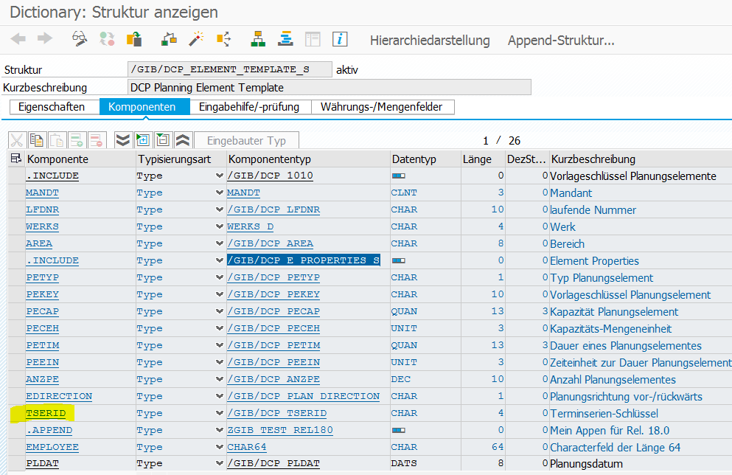

Class | /GIB/CL_DCP_TERMS
Method | build_series  BUILD_SERIES_BCKWD  BUILD_SERIES_INTVL
METHOD build_series.
DATA: ls_tser TYPE /gib/dcp_tser_s,
lf_days TYPE char10,
lf_offset TYPE char10,
lf_date TYPE sy-datum,
lf_week_count TYPE char10,
lf_week_inter TYPE char10,
lr_exc TYPE REF TO /gib/cx_dcp,
lt_main TYPE /gib/dcp_main_t,
ls_template TYPE /gib/dcp_element_template_s.

FIELD-SYMBOLS: <ls_main> TYPE /gib/dcp_main.

READ TABLE mr_settings->mt_tser WITH KEY tserid = ms_event-tserid INTO ls_tser.
*#no further proccesing if a event series does not exist
*#HW 8564 - Terminserie ohne Intervall (ABA 31.01.2018)
CHECK sy-subrc EQ 0.
IF ls_tser-iveinh IS INITIAL OR ls_tser-intva IS INITIAL.
MESSAGE i164(/gib/dcp) DISPLAY LIKE 'W'.
EXIT.
ENDIF.
*#HW 8564 - Terminserie ohne Intervall (ABA 31.01.2018)

CREATE DATA mr_series.

*# BUILD EVENT SERIES PATTERN
ls_template-no_dialog = abap_true.
ls_template-werks = mr_settings->mf_werks.
ls_template-area = mr_settings->mf_area.
*#HW9391
ls_template-tserid = ms_event-tserid. "Key of the event series #DCP 19.0 (DHO)
*##HW9391
ls_template-anzpe = 1."Number of elements to be created
ls_template-petyp = ms_event-petyp."Planning element Type
ls_template-petim = ms_event-evkzl."Duration
ls_template-peein = ms_event-eveinh."Duration Unit
ls_template-plzeit = ls_tser-strzt."Start Time of Element
ls_template-petxt = ls_tser-tsrtx."Event Series Text

*#Build the actual Event Series
lf_days = mf_date_to - mf_date_from.

DO.
IF lf_offset GT lf_days.
EXIT.
ENDIF.

CLEAR: lf_date.
lf_date = mf_date_from + lf_offset.

FUNCTION | /GIB/DCP_ELEMENT_CREATE
LOCAL CLASS | LCL_FLOW
METHOD | set_template
METHOD set_template.
mr_template = ir_template.

*#do some default settings
IF mr_template->pldat IS INITIAL.
mr_template->pldat = sy-datum.
ENDIF.
IF mr_template->pedat IS INITIAL.
mr_template->pedat = sy-datum.
ENDIF.
IF mr_template->anzpe IS INITIAL.
mr_template->anzpe = 1.
ENDIF.
IF mr_template->peein IS INITIAL.
mr_template->peein = 'S'.
ENDIF.
IF mr_template->petyp IS INITIAL.
mr_template->petyp = mf_sart.
ENDIF.

*#HWxxxx - (MPL 10.11.2017)
MOVE-CORRESPONDING mr_template->* TO /gib/dcp_e_properties_s.
*##HWxxxx - (MPL 10.11.2017)
ENDMETHOD.
METHOD create_new_elements.
*#HW7979 - Anlage Dummy Aufträge (DHO 11.09.2017 10:49:19)
DATA: ls_main TYPE /gib/dcp_main,
lf_unit_out TYPE t006-msehi VALUE 'S'.

CLEAR: mt_new_elements.

*#HWxxxx - (MPL 10.11.2017)
*#Also set the Element Properties Structure for Client Screens
MOVE-CORRESPONDING /gib/dcp_e_properties_s TO mr_template->*.
*##HWxxxx - (MPL 10.11.2017)

*#element demand is allways in seconds
/gib/cl_services=>conversion_time(
EXPORTING
if_value_in = mr_template->petim
if_unit_in = mr_template->peein
CHANGING
ef_unit_out = lf_unit_out
ef_value_out = ls_main-duration_orig ).

DO mr_template->anzpe TIMES.

MOVE-CORRESPONDING mr_template->* TO ls_main.
ls_main-pltext = mr_template->petxt.
ls_main-sart = mr_template->petyp.
ls_main-plnid = /gib/cl_dcp_main_no=>new( mr_template->petyp ).
ls_main-elementid = /gib/cl_dcp_element=>get_elementid( ls_main ).
*#HW9391 (DHO)
ls_main-erdat = sy-datum.
ls_main-erzeit = sy-uzeit.
ls_main-ernam = sy-uname.
ls_main-tserid = mr_template->tserid.
*##HW9391 (DHO)
APPEND ls_main TO mt_new_elements.

ENDDO.

ENDMETHOD.

Auf M37

FUNCTION | /GIB/DCP_ELEMENT_CREATE
LOCAL CLASS | LCL_FLOW
METHOD | set_template
METHOD set_template.
mr_template = ir_template.

*#do some default settings
IF mr_template->pldat IS INITIAL.
mr_template->pldat = sy-datum.
ENDIF.
IF mr_template->pedat IS INITIAL.
mr_template->pedat = sy-datum.
ENDIF.
IF mr_template->anzpe IS INITIAL.
mr_template->anzpe = 1.
ENDIF.
IF mr_template->peein IS INITIAL.
mr_template->peein = 'S'.
ENDIF.
IF mr_template->petyp IS INITIAL.
mr_template->petyp = mf_sart.
ENDIF.

*#HWxxxx - (MPL 10.11.2017)
MOVE-CORRESPONDING mr_template->* TO /gib/dcp_e_properties_s.
*##HWxxxx - (MPL 10.11.2017)
ENDMETHOD.
METHOD create_new_elements.
*#HW7979 - Anlage Dummy Aufträge (DHO 11.09.2017 10:49:19)
DATA: ls_main TYPE /gib/dcp_main,
lf_unit_out TYPE t006-msehi VALUE 'S'.

CLEAR: mt_new_elements.

*#HWxxxx - (MPL 10.11.2017)
*#Also set the Element Properties Structure for Client Screens
MOVE-CORRESPONDING /gib/dcp_e_properties_s TO mr_template->*.
*##HWxxxx - (MPL 10.11.2017)

*#element demand is allways in seconds
/gib/cl_services=>conversion_time(
EXPORTING
if_value_in = mr_template->petim
if_unit_in = mr_template->peein
CHANGING
ef_unit_out = lf_unit_out
ef_value_out = ls_main-duration_orig ).

DO mr_template->anzpe TIMES.

MOVE-CORRESPONDING mr_template->* TO ls_main.
ls_main-pltext = mr_template->petxt.
ls_main-sart = mr_template->petyp.
ls_main-plnid = /gib/cl_dcp_main_no=>new( mr_template->petyp ).
ls_main-elementid = /gib/cl_dcp_element=>get_elementid( ls_main ).
*#HW9391 (DHO)
ls_main-erdat = sy-datum.
ls_main-erzeit = sy-uzeit.
ls_main-ernam = sy-uname.
*##HW9391 (DHO)
APPEND ls_main TO mt_new_elements.

ENDDO.

ENDMETHOD.

