BUG: 8598 – Dashboard Selektionsbild
CODE context INSERT DELETE CODE context
Folgende Konstante in der folgenden Klasse anlegen:
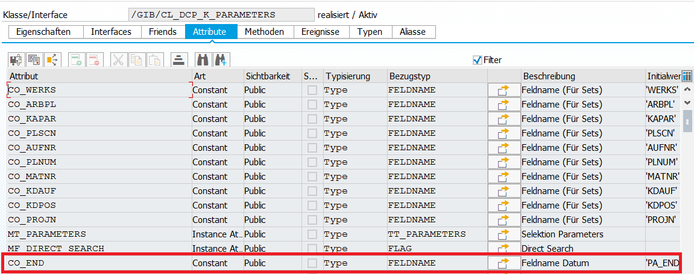
Folgendes Instanzattribut in der folgenden Klasse anlegen:
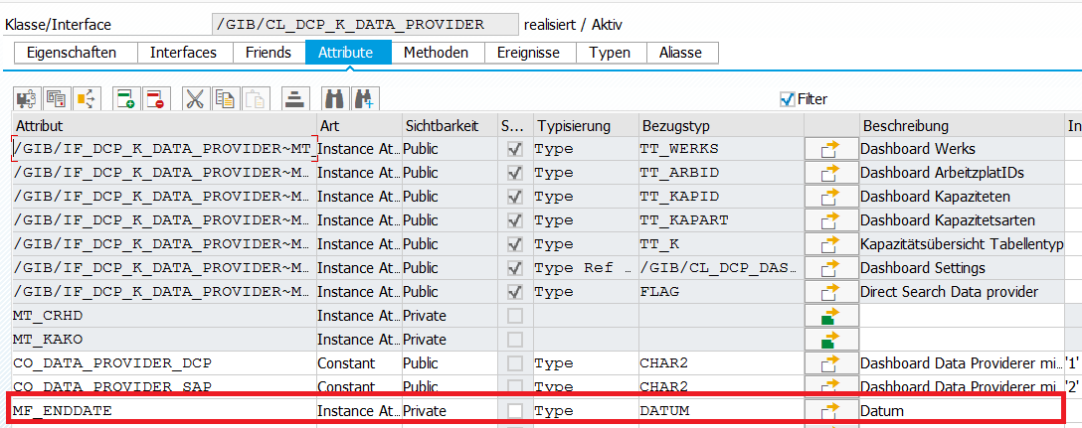

Class | /GIB/CL_DCP_K_DATA_PROVIDER
Method | /GIB/IF_DCP_K_DATA_PROVIDER~SELECT_DATA
METHOD /gib/if_dcp_k_data_provider~select_data.
DATA: lr_k TYPE REF TO /gib/cl_dcp_k,
lr_day TYPE REF TO /gib/cl_dcp_k_period_day,
*#HW8117 - ATC (DHO 08.12.2017 09:10:36)
* lt_arbpl_r TYPE TABLE OF range_c8,
* lt_werks_r TYPE TABLE OF range_c4,
lt_arbpl_r TYPE TABLE OF range_c35,
lt_werks_r TYPE TABLE OF range_c35,
*#HW8117 - ATC (DHO 08.12.2017 09:10:36)
lt_kapid_data TYPE /gib/dcp_kapid_data_t.
FIELD-SYMBOLS: <ls_kapid_data> TYPE /gib/dcp_kapid_data_s,
<ls_parameter> TYPE cyxranges,
*#HW8117 - ATC (DHO 08.12.2017 09:10:36)
* <ls_arbpl_r> TYPE range_c8,
* <ls_werks_r> TYPE range_c4,
<ls_werks_r> TYPE range_c35,
<ls_arbpl_r> TYPE range_c35,
*##HW8117 - ATC (DHO 08.12.2017 09:10:36)
<ls_day_data> TYPE /gib/dcp_k_day_data_s.
*#buffer workcenter information
LOOP AT ir_parameters->mt_parameters ASSIGNING <ls_parameter>.
CASE <ls_parameter>-feld.
WHEN ir_parameters->co_werks.
APPEND INITIAL LINE TO lt_werks_r ASSIGNING <ls_werks_r>.
MOVE-CORRESPONDING <ls_parameter> TO <ls_werks_r>. "#EC CI_FLDEXT_OK - ATC 11.12.2017 (DHO)
WHEN ir_parameters->co_arbpl.
APPEND INITIAL LINE TO lt_arbpl_r ASSIGNING <ls_arbpl_r>.
MOVE-CORRESPONDING <ls_parameter> TO <ls_arbpl_r>. "#EC CI_FLDEXT_OK - ATC 11.12.2017 (DHO)

*#HW8598 - Dashboard Selektionsbild (AME 20.02.2018 15:29:12)
WHEN ir_parameters->co_end.
IF mf_enddate IS INITIAL.
mf_enddate = <ls_parameter>-low.
ENDIF.
*##HW8598 - Dashboard Selektionsbild (AME 20.02.2018 15:29:12)
WHEN OTHERS.
ENDCASE.
ENDLOOP.
*#check if a direct search was asked:-> AUFNR,PLNUM,MATNR,KDAUF
mf_direct_search = ir_parameters->mf_direct_search.
*#update the kako and crhd data
CALL FUNCTION 'CR_WORKCENTER_PRE_READ'
EXPORTING
cap_all = 'X'
* CAP_AVAIL = 'space'
* CAP_BAS = ' '
* VIEW_RCR01 = ' '
* NO_TEXTS = ' '
TABLES
* TARBID =
* THROID =
range_arbpl = lt_arbpl_r
range_werks = lt_werks_r
EXCEPTIONS
wrong_selection = 1
OTHERS = 2.
IF sy-subrc <> 0.
CASE sy-subrc.
WHEN 1.
MESSAGE ID sy-msgid TYPE sy-msgty NUMBER sy-msgno
WITH sy-msgv1 sy-msgv2 sy-msgv3 sy-msgv4.
WHEN OTHERS.
ENDCASE.
ENDIF.
*# abstact select of data
select( EXPORTING ir_parameters = ir_parameters
IMPORTING et_kapid_data = lt_kapid_data ).
*#fill the K's and K day periods
LOOP AT lt_kapid_data ASSIGNING <ls_kapid_data>.
lr_k = get_k( if_kapid = <ls_kapid_data>-kapid
if_arbid = <ls_kapid_data>-arbid ).
LOOP AT <ls_kapid_data>-day_data ASSIGNING <ls_day_data>.
lr_day ?= lr_k->get_day( <ls_day_data>-day ).
*#HW8598 - Dashboard Selektionsbild (AME 20.02.2018 15:29:12)
"Lösche alle Datensätze, welche nach dem eingegebenen Datum existieren
IF mf_enddate < <ls_day_data>-day.
IF mf_enddate IS NOT INITIAL.
DELETE <ls_kapid_data>-day_data WHERE day = <ls_day_data>-day.
ENDIF.
ENDIF.
*##HW8598 - Dashboard Selektionsbild (AME 20.02.2018 15:29:12)
CHECK lr_day IS BOUND.
*#HW8598 - Dashboard Selektionsbild (AME 20.02.2018 15:29:12)
IF <ls_day_data> IS ASSIGNED.
*##HW8598 - Dashboard Selektionsbild (AME 20.02.2018 15:29:12)
lr_day->set_data( <ls_day_data> ).
*#HW8598 - Dashboard Selektionsbild (AME 20.02.2018 15:29:12)
ENDIF.
*##HW8598 - Dashboard Selektionsbild (AME 20.02.2018 15:29:12)
ENDLOOP.
ENDLOOP.
*#will update MT_WERKS/MT_ARBID/MT_KAPID/MT_KAPART
collect_info_from_k( ).
ENDMETHOD.

Program | /GIB/DCP_DASHBOARDN
Include | /GIB/DCP_DASHBOARDN_LCL045
Local Class | lcl_screen_flow
Method | Constructor
DATA: lr_parameters TYPE REF TO /gib/cl_dcp_k_parameters,
*#HW8598 - Dashboard Selektionsbild (AME 20.02.2018 15:39:33)
ls_params TYPE cyxranges.
*##HW8598 - Dashboard Selektionsbild (AME 20.02.2018 15:39:33) *#set the main screen title
/gib/if_dc_screen_flow~mf_screen_title = 'DCP Dashboard'(020).
*#interpret selection
mr_selection = ir_selection.
*#save a settings instance
mr_settings = ir_settings.
* lt_params = mr_selection->get_parameters( ).
*#create the concrete data provider( DCP or SAP )
CASE 'X'.
WHEN pa_dcp.
mr_dp ?= /gib/cl_dcp_k_data_provider=>factory( if_type = /gib/cl_dcp_k_data_provider=>co_data_provider_dcp
ir_settings = mr_settings ).
WHEN pa_cm01.
mr_dp ?= /gib/cl_dcp_k_data_provider=>factory( ir_settings = mr_settings ).
ENDCASE.
*#ask the data provider for the data
lr_parameters = mr_selection->get_parameters( ).
*#HW8598 - Dashboard Selektionsbild (AME 20.02.2018 15:39:33)
IF lr_parameters IS BOUND.
ls_params-feld = /GIB/CL_DCP_K_PARAMETERS=>co_end.
ls_params-low = pa_end.
ls_params-sign = 'I'.
ls_params-option = 'EQ'.
APPEND ls_params TO lr_parameters->mt_parameters.
ENDIF.
*##HW8598 - Dashboard Selektionsbild (AME 20.02.2018 15:39:33)
mr_dp->select_data( lr_parameters ).
*#listen to settings
SET HANDLER on_settings_changed FOR mr_settings.
SET HANDLER on_display_form_changed FOR mr_settings.
SET HANDLER on_period_type_changed FOR mr_settings.
ENDMETHOD.

