BUG: 7135 – Werkslayouts und Benutzerlayouts werden nicht übernommen
CODE context INSERT DELETE CODE context
Im Include: /GIB/DCP_MAIN_TOP
folgende globale Variablen anlegen:
DATA: gf_werks TYPE werks_d,
gs_time TYPE /gib/dcp_time.

Program | /GIB/DCP_MAIN
Include | /GIB/DCP_MAIN_LCL_002
Local Class | lcl_selection_screen_handler
CLASS lcl_selection_screen_handler DEFINITION.
PUBLIC SECTION.
TYPE-POOLS: vrm.
DATA:
mt_selopt TYPE /gib/dcp_seltab_t READ-ONLY,
mr_metadata TYPE REF TO /gib/cl_dcp_sel_metadata READ-ONLY,
*#HW7135 - Werksdaten übernehmen (AME 16.11.2017 13:25:16)
ms_dcp_time TYPE /gib/dcp_time.
*##HW7135 - Werksdaten übernehmen (AME 16.11.2017 13:25:16)
DATA: mf_plausi_error TYPE flag.
*#DCP 740 MPL
CLASS-DATA: gs_sp TYPE /gib/dcp_sp READ-ONLY,
gf_load_report TYPE sy-repid READ-ONLY.
*#HW7135 - Werksdaten übernehmen (AME 16.11.2017 13:25:16)
DATA: mf_vari TYPE /gib/dcp_varii READ-ONLY,
mf_varip TYPE /gib/dcp_varip READ-ONLY,
mf_variu TYPE /gib/dcp_variu READ-ONLY.
*##HW7135 - Werksdaten übernehmen (AME 16.11.2017 13:25:16)
CLASS-METHODS: class_constructor.

METHODS:
get_metadata RETURNING VALUE(rr_metadata) TYPE REF TO /gib/cl_dcp_sel_metadata,
initialization,
at_selection_screen_output,
at_selection_screen,
start_of_selection,
end_of_selection.
PRIVATE SECTION.

Program | /GIB/DCP_MAIN
Include | /GIB/DCP_MAIN_LCL_002
Local Class | lcl_selection_screen_handler
Method | at_selection_screen
*# by adding additional subscreens the event is also triggered for these
CHECK sy-dynnr = 1000.
*#HW7135 - Werksdaten übernehmen (AME 16.11.2017 13:25:16)
DATA: lf_werks TYPE werks_d,
ls_time TYPE /gib/dcp_time.
IF sy-ucomm = 'ENTER'.
GET PARAMETER ID 'WRK' FIELD lf_werks.
ENDIF.
IF lf_werks IS NOT INITIAL.
SELECT SINGLE varip varii variu FROM /gib/dcp_time INTO CORRESPONDING FIELDS OF ls_time
WHERE werks = lf_werks
AND area = space.
IF sy-subrc = 0.
IF ls_time-varip IS NOT INITIAL.
mf_varip = ls_time-varip.
ELSE.
CLEAR: mf_varip.
ENDIF.
IF ls_time-varii IS NOT INITIAL.
mf_vari = ls_time-varii.
ELSE.
CLEAR: mf_vari.
ENDIF.
IF ls_time-variu IS NOT INITIAL.
mf_variu = ls_time-variu.
ELSE.
CLEAR: mf_variu.
ENDIF.
ENDIF.
else.
if mf_varip IS NOT INITIAL or mf_vari IS NOT INITIAL OR MF_variu IS NOT INITIAL.
CLEAR: mf_varip, mf_vari, mf_variu.
endif.
ENDIF.
*##HW7135 - Werksdaten übernehmen (AME 16.11.2017 13:25:16) * ENDIF.
*#Variante speichern
CALL FUNCTION '/GIB/DC_VARIANT_SET_MODE'.
me->handle_user_command( EXPORTING if_ucomm = sy-ucomm ).

Program | /GIB/DCP_MAIN
Include | /GIB/DCP_MAIN_EVENTS
INITIALIZATION.
*# Info-Icon auf Button im Selection Screen
MOVE '@0S@' TO pinfo(4).
"SLI 7<.50
* IF sy-uname = 'SLI'.
* sel_text = zsli_test_text=>get_custom_text( ).
* ELSE.
sel_text = text-006.
* ENDIF.
*#HW5979 - Layout des Vorrat - Vorb13elegung zum USER und oder Werk (AME 14.11.2017 15:18:19)
*#HW6642 UBA 17.10.2016 Vorbelegung Layout ungeplant
pa_varp = /gib/cl_dcp_settings=>gs_user-variu.
*##HW6642
pa_var1 = /gib/cl_dcp_settings=>gs_user-varii.
pa_vari = /gib/cl_dcp_settings=>gs_user-varip.
*#HW7135 - Werksdaten übernehmen (AME 08.11.2017 13:25:16)
GET PARAMETER ID 'WRK' FIELD gf_werks.
* ENDIF.
IF gf_werks IS NOT INITIAL.
SELECT SINGLE varip varii variu FROM /gib/dcp_time INTO CORRESPONDING FIELDS OF gs_time
WHERE werks = gf_werks
AND area = space.
IF sy-subrc = 0.
IF pa_varp IS INITIAL.
pa_varp = gs_time-variu.
ELSEIF /gib/cl_dcp_settings=>gs_user-variu IS NOT INITIAL.
else.
CLEAR: pa_varp.
ENDIF.
IF pa_vari IS INITIAL.
pa_vari = gs_time-varip.
ELSEIF /gib/cl_dcp_settings=>gs_user-varip IS NOT INITIAL.
else.
CLEAR: pa_vari.
ENDIF.
IF pa_var1 IS INITIAL.
pa_var1 = gs_time-varii.
ELSEIF /gib/cl_dcp_settings=>gs_user-varii IS NOT INITIAL.
else.
CLEAR: pa_var1.
ENDIF.
ENDIF.
else.
if pa_var1 IS NOT INITIAL or pa_vari IS NOT INITIAL OR pa_varp IS NOT INITIAL.
CLEAR: pa_var1, pa_vari, pa_varp.
endif.
endif.
*#HW7135 - Werksdaten übernehmen (AME 08.12.2017 13:25:16)
* ENDIF.
*##HW5979 - Layout des Vorrat - Vorbelegung zum USER und oder Werk (AME 14.11.2017 15:18:19)
CREATE OBJECT gr_selection_screen_handler.
gr_selection_screen_handler->initialization( ).
CLEAR: gf_repid, gf_variant, gf_subrc.
gf_repid = sy-repid.
CONCATENATE 'U_' sy-uname INTO gf_variant.
CONDENSE gf_variant.
CLEAR gf_subrc.
CALL FUNCTION 'RS_VARIANT_EXISTS'
EXPORTING
report = gf_repid
variant = gf_variant
IMPORTING
r_c = gf_subrc.
IF gf_subrc = 0.
CALL FUNCTION 'RS_COVERPAGE_SELECTIONS' "#EC CI_SUBRC
EXPORTING
report = gf_repid
variant = gf_variant
TABLES
infotab = gt_info
EXCEPTIONS
OTHERS = 3.
ENDIF.
*##HW7700 - Benutzerspezifische Varianten (SLI 05.07.2017 11:25:33)
*#---------------------------------------------------------------------*
*# Aktionen vor Ausgabe Selektionsmaske
*# Actions before output selektion screen
*#---------------------------------------------------------------------*
AT SELECTION-SCREEN OUTPUT.
gr_selection_screen_handler->at_selection_screen_output( ).
*#---------------------------------------------------------------------*
*# Feldspezifische Matchcodes
*# Matchcodes for fields
*#---------------------------------------------------------------------*
*AT SELECTION-SCREEN ON VALUE-REQUEST FOR pa_vari.
*AT SELECTION-SCREEN ON VALUE-REQUEST FOR pa_var1.
*#---------------------------------------------------------------------*
*# Selektionsbildverarbeitung
*# Processing selection screen
*#---------------------------------------------------------------------*
AT SELECTION-SCREEN.
gr_selection_screen_handler->at_selection_screen( ).
*#HW7135 - Werksdaten übernehmen (AME 16.11.2017 13:25:16)
IF gf_subrc <> 0.
IF /gib/cl_dcp_settings=>gs_user-variu IS INITIAL.
pa_varp = gr_selection_screen_handler->mf_variu.
ENDIF.
IF /gib/cl_dcp_settings=>gs_user-varip IS INITIAL.
pa_vari = gr_selection_screen_handler->mf_varip.
ENDIF.
IF /gib/cl_dcp_settings=>gs_user-varii IS INITIAL.
pa_var1 = gr_selection_screen_handler->mf_vari.
ENDIF.
ENDIF.
*##HW7135 - Werksdaten übernehmen (AME 16.11.2017 13:25:16)
*#---------------------------------------------------------------------*
*# Verarbeitung entsprechend Selektion
*# Processing accordant selection
*#---------------------------------------------------------------------* ENDIF.
ENDIF.
*##HW7135 - Werksdaten übernehmen (AME 16.11.2017 13:25:16)

Neue Spalte für DCP_USER anlegen für den ungeplanten Bereich
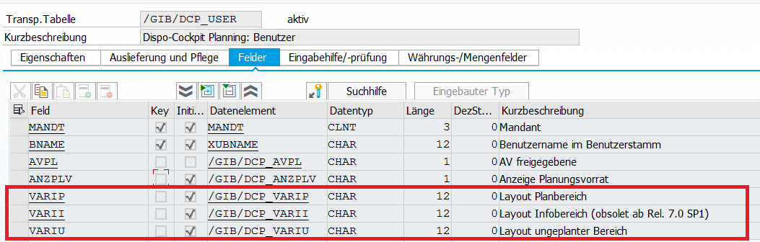
Neue Spalte für DCP_TIME anlegen für den ungeplanten Bereich
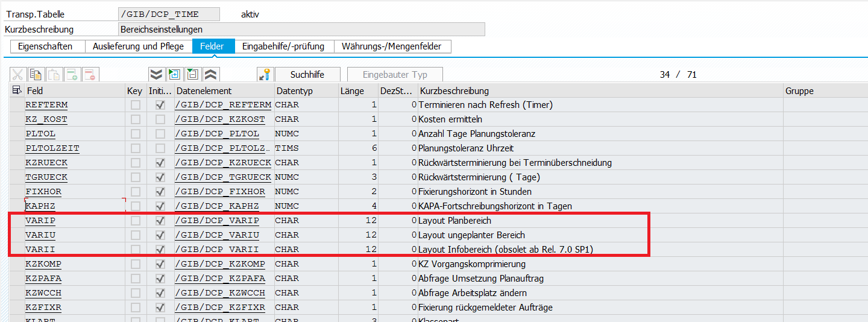

Pflege-View anpassen (ungeplanten Bereich einfügen) : /GIB/DCP_V002
und anschließend Tabellenpflegegenerator ausführen.
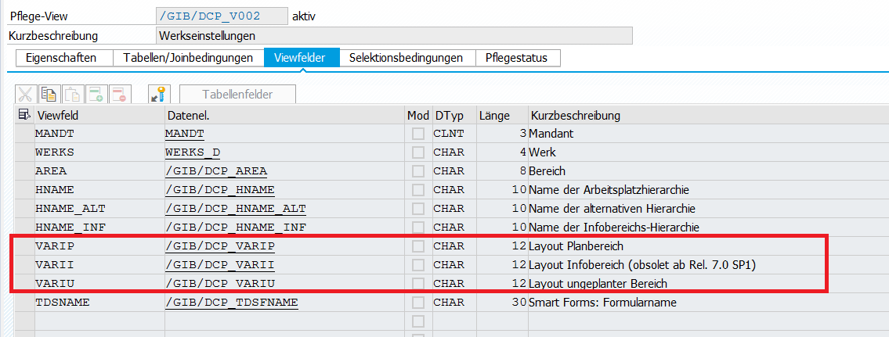
Pflege-View anpassen (ungeplanten Bereich einfügen) : /GIB/DCP_V011
