BUG: 8247 – Fertigungsversionswechsel übergibt falschen Arbeitsplatz an das BaDI
Class: | /GIB/CL_DCP_M_SHEET
Local class: | LCL_VERID
Method: | CHANGE_VERIDS
TRY .
LOOP AT mt_operations INTO ls_operation.
lr_verid->* = ls_operation-verid_new.
ls_operation-element->do_action( if_action = /gib/cl_dcp_e_operation=>co_do_change_order_verid
ir_data = lr_verid
*#HW8247 - Fertigungsversionswechsel (SLI 21.11.2017 11:45:53)
ir_object = mr_settings
*##HW8247 - Fertigungsversionswechsel (SLI 21.11.2017 11:45:53)
ir_protocol = lr_msg ).
APPEND ls_operation TO lt_processed.
*#HW7857 – Fertigungsversionwechsel Protokoll(MPL 01.08.2017)
*#if the MSG object contains error messages then the proccessing must be
*#aborted
IF lr_msg->has_type( lr_msg->co_error ) IS NOT INITIAL OR
lr_msg->has_type( lr_msg->co_abend ) IS NOT INITIAL.
rollback_verids( lt_processed ).
• • •

Class: | /GIB/CL_DCP_E_OPERATION
Method: | /GIB/IF_DCP_ACTION~DO
WHEN co_do_order_amount_dialog.
do_order_amount_dialog( ).
WHEN co_do_change_order_verid.
do_change_order_verid( ir_new_verid = ir_data
*#HW8247 - Fertigungsversionswechsel (SLI 21.11.2017 11:50:14)
ir_new_settings = ir_object
*##HW8247 - Fertigungsversionswechsel (SLI 21.11.2017 11:50:14)
ir_protocol = ir_protocol ).
WHEN co_do_print_order.
do_print_order( ir_protocol ).
WHEN co_do_free_order.
do_free_order( ir_protocol ).
*#HW7642 – Model Refresh (MPL 11.06.2017)
WHEN co_do_refresh_operation_data.
do_refresh_operation_data( ).
• • •

Class: | /GIB/CL_DCP_E_OPERATION
Method: | DO_CHANGE_ORDER_VERID
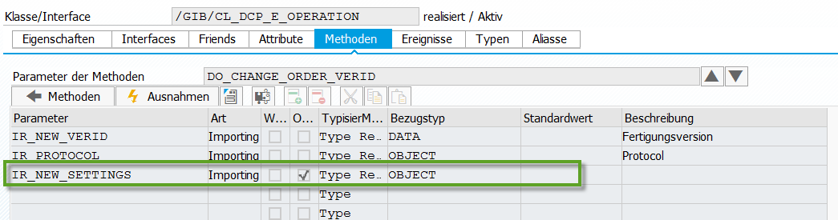
METHOD do_change_order_verid.
DATA: ls_main TYPE /gib/dcp_main,
lr_verid TYPE REF TO verid,
lr_exc TYPE REF TO /gib/cx_dcp,
lr_protocol TYPE REF TO /gib/cl_dcp_msg,
lt_bapireturn TYPE bapiret2_t.
*#HW8247 - Fertigungsversionswechsel (SLI 21.11.2017 11:51:58)
DATA: lr_settings TYPE REF TO /gib/cl_dcp_settings.
*##HW8247 - Fertigungsversionswechsel (SLI 21.11.2017 11:51:58)
*#HW7857 – Fertigungsversionwechsel Protokoll(MPL 01.08.2017)
* TRY.
*##HW7857 – Fertigungsversionwechsel Protokoll(MPL 01.08.2017)
*#evaluate the verid object
IF ir_new_verid IS BOUND.
ELSE.
CREATE OBJECT lr_protocol.
ENDIF.
*#HW8247 - Fertigungsversionswechsel (SLI 21.11.2017 11:54:01)
IF ir_new_settings IS NOT BOUND.
lr_settings = mr_data->settings.
ELSE.
lr_settings ?= ir_new_settings.
ENDIF.
*##HW8247 - Fertigungsversionswechsel (SLI 21.11.2017 11:54:01)
/gib/cl_dcp_order_services=>change_version( EXPORTING
if_plnid = mr_data->plnid
if_order_type = mr_data->sart
if_new_verid = lr_verid->*
*#HW8247 - Fertigungsversionswechsel (SLI 21.11.2017 11:54:15)
* if_werks = mr_data->werks
* if_area = mr_data->area
**
if_werks = lr_settings->mf_werks
if_area = lr_settings->mf_area
*##HW8247 - Fertigungsversionswechsel (SLI 21.11.2017 11:54:15)
if_matnr = mr_data->matnr
if_display_bapireturn = space
IMPORTING
et_bapireturn = lt_bapireturn ).
lr_protocol->add_bapiret2_tab( lt_bapireturn ).
*#at a change of version the the entire Order will be changed:
*#-the APLZL will chanage;
*#-posibly the VORNR will change;
*#-posibly the ARBPL will change;
*#the DO_UPDATE_ORDER_ELEMENTS will proccess all these changes and resolve the situation for
*#all the active ELEMENTS of the ORDER
• • •

