Bug 8108 - DCP Materialbeschränkung - Änderung der Selektion nicht möglich
Program | /GIB/DCP_SET_MAT_DISPATCH_SO
Edit the GUI Status and add the following return code
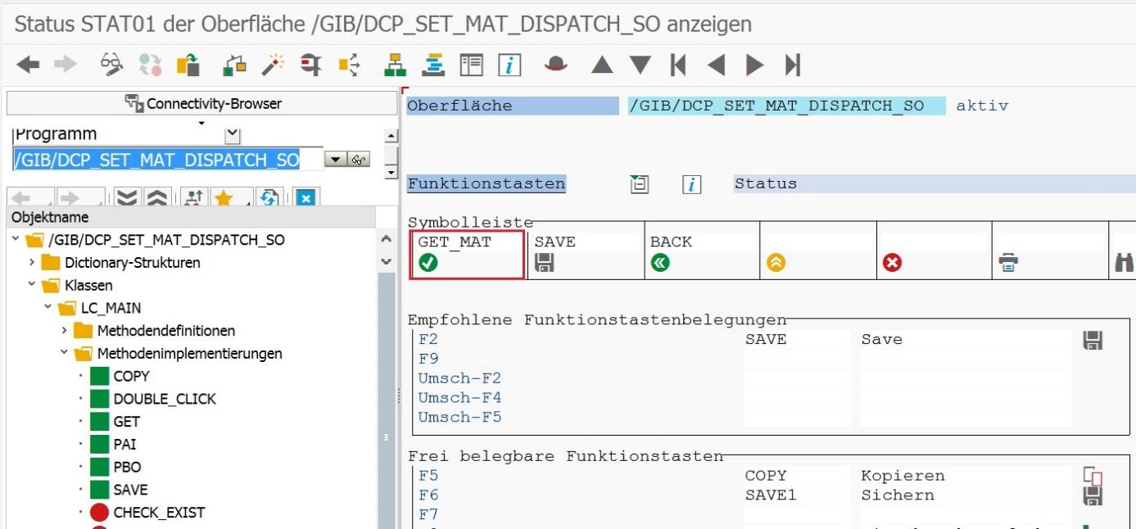

Program | /GIB/DCP_SET_MAT_DISPATCH_SO
*----------------------------------------------------------------*
*# Report : /GIB/DCP_SET_MAT_DISPATCH_SO
*# Modul : DCP
*# Autor : Gabriel Suciu (GSU)
*# gib mbH Siegen
*# Datum : ab 23.04.2014
*# Doku :
*# Bug : 3875 - Material In-/Exclusion List per Area
*#----------------------------------------------------------------*
*# Programmbeschreibung:
*# Maintain range table for material at werk and area level
*# Ranges are saved in DB table /GIB/DCP_MATNRSO
*#
REPORT /gib/dcp_set_mat_dispatch_so.
TABLES : mara,/gib/dcp_matnrso.
DATA : gr_docking TYPE REF TO cl_gui_docking_container,
gr_alv TYPE REF TO cl_gui_alv_grid,
gt_matnrso TYPE TABLE OF /gib/dcp_matnrso,
*#HW8108 - Materialbeschränkung (DHO 02.11.2017 13:19:40)
gt_matnrso_tmp TYPE TABLE OF /gib/dcp_matnrso.
*##HW8108 - Materialbeschränkung (DHO 02.11.2017 13:19:40)
DATA : gf_werks TYPE werks_d,
gf_area TYPE /gib/dcp_area,
gt_matnr_r TYPE RANGE OF matnr.
SELECTION-SCREEN BEGIN OF BLOCK b1 WITH FRAME.
PARAMETERS : pa_werks TYPE werks_d MEMORY ID wrk,
pa_area TYPE /gib/dcp_area MEMORY ID /gib/dcp_area.
SELECT-OPTIONS : so_matnr FOR mara-matnr.
SELECTION-SCREEN END OF BLOCK b1.
SELECTION-SCREEN BEGIN OF BLOCK b2 WITH FRAME TITLE text-t01.
PARAMETERS : pa_areac TYPE /gib/dcp_area.
SELECTION-SCREEN END OF BLOCK b2.
INCLUDE /gib/dcp_set_mat_disp_so_c01.
AT SELECTION-SCREEN OUTPUT.
lc_main=>pbo( ).
AT SELECTION-SCREEN.
lc_main=>pai( ).

Add a new method CHECK_WERKS () in lcl_main
Program | /GIB/DCP_SET_MAT_DISPATCH_SO
Include | /GIB/DCP_SET_MAT_DISP_SO_C01
Local class | LC_MAIN
Method | CHECK_WERKS
CLASS lc_main DEFINITION.
PUBLIC SECTION.
CLASS-METHODS : pbo,
pai,
copy,
save,
get IMPORTING if_werks TYPE werks_d
if_area TYPE /gib/dcp_area,
double_click FOR EVENT double_click
OF cl_gui_alv_grid
IMPORTING e_row
e_column
es_row_no.
PROTECTED SECTION.
PRIVATE SECTION.
CLASS-METHODS : check_exist IMPORTING if_area TYPE /gib/dcp_area
RETURNING VALUE(rf_answer) TYPE char1,
get_data,
*#HW8108 - Mat.beschr. (DHO 03.11.2017 09:23:31)
check_werks IMPORTING if_werks TYPE werks_d
EXPORTING ef_exists TYPE abap_bool.
*##HW8108 - Mat.beschr. (DHO 03.11.2017 09:23:31)
ENDCLASS. "lc_main DEFINITION

*----------------------------------------------------------------------*
* CLASS class IMPLEMENTATION
*----------------------------------------------------------------------*
*
*----------------------------------------------------------------------*
CLASS lc_main IMPLEMENTATION.
[...]
*#HW8108 - Mat.beschr. (DHO 03.11.2017 09:23:31)
METHOD check_werks.
DATA lf_werks TYPE werks_d.
SELECT SINGLE werks
FROM /gib/dcp_0003 INTO lf_werks
WHERE werks = if_werks.
IF sy-subrc IS INITIAL.
ef_exists = 'X'.
ELSE.
ef_exists = ''.
ENDIF.
ENDMETHOD.
*#HW8108 - Mat.beschr. (DHO 03.11.2017 09:23:31)

Program | /GIB/DCP_SET_MAT_DISPATCH_SO
Include | /GIB/DCP_SET_MAT_DISP_SO_C01
Local class | LC_MAIN
Method | PBO
DATA: lt_exclude TYPE TABLE OF syucomm.
* SET pf-STATUS 'STAT01'.
* APPEND 'ONLI' TO lt_exclude.
CALL FUNCTION 'RS_SET_SELSCREEN_STATUS'
EXPORTING
p_status = 'STAT01' "SY-PFKEY
* p_program = '/GIB/DCP_SET_MAT_DISP_SO'
TABLES
p_exclude = lt_exclude.
*# Create docking
IF gr_docking IS INITIAL.
CREATE OBJECT gr_docking
EXPORTING
side = cl_gui_docking_container=>dock_at_right
extension = 700
* caption = 'Test'(001)
EXCEPTIONS
OTHERS = 1.
IF sy-subrc <> 0.
ENDIF.
*# Create ALV
CREATE OBJECT gr_alv
EXPORTING
i_parent = gr_docking
EXCEPTIONS
OTHERS = 1.
get_data( ).
DATA : ls_layout TYPE lvc_s_layo,
lt_sort TYPE lvc_t_sort,
ls_sort TYPE lvc_s_sort.
ls_sort-fieldname = 'WERKS'.
APPEND ls_sort TO lt_sort.
ls_sort-fieldname = 'AREA'.
APPEND ls_sort TO lt_sort.
ls_layout-cwidth_opt = 'X'.
gr_alv->set_table_for_first_display(
EXPORTING
i_structure_name = '/GIB/DCP_MATNRSO'
is_layout = ls_layout
CHANGING
it_outtab = gt_matnrso
it_sort = lt_sort
EXCEPTIONS
OTHERS = 1 ).
SET HANDLER lc_main=>double_click FOR gr_alv.
ELSE.

*#HW8108 - Mat-beschr. (DHO 02.11.2017 11:50:53)
IF gt_matnrso_tmp IS INITIAL.
gr_alv->refresh_table_display( ).
ELSE.
gr_alv->set_table_for_first_display(
EXPORTING
i_structure_name = '/GIB/DCP_MATNRSO'
is_layout = ls_layout
CHANGING
it_outtab = gt_matnrso_tmp
it_sort = lt_sort
EXCEPTIONS
OTHERS = 1 ).
SET HANDLER lc_main=>double_click FOR gr_alv.
gr_alv->refresh_table_display( ).
ENDIF.
*##HW8108 - Mat-beschr. (DHO 02.11.2017 11:50:53)
ENDIF.
ENDMETHOD. "pbo

Program | /GIB/DCP_SET_MAT_DISPATCH_SO
Include | /GIB/DCP_SET_MAT_DISP_SO_C01
Local class | LC_MAIN
Method | GET
METHOD get.
*# Fill material select options with saved data in DB
*# for current werk and area
DATA : lt_mat TYPE TABLE OF /gib/dcp_matnrso,
ls_matnr LIKE LINE OF so_matnr.
FIELD-SYMBOLS : <ls_mat> TYPE /gib/dcp_matnrso.
*#HW8108 - Materialbes. (DHO 02.11.2017 13:23:28)
CLEAR gt_matnrso_tmp.
*IF if_werks IS INITIAL OR if_area IS INITIAL.
IF if_werks IS INITIAL.
* MESSAGE i032(/gib/dcp).
MESSAGE i030(/gib/dcp) DISPLAY LIKE 'E'.
RETURN.
ENDIF.
check_werks(
EXPORTING
if_werks = if_werks
IMPORTING
ef_exists = lf_exists ).
IF lf_exists IS NOT INITIAL.
IF if_werks IS NOT INITIAL
AND if_area IS NOT INITIAL.
SELECT * FROM /gib/dcp_matnrso
INTO TABLE lt_mat
WHERE werks = if_werks
AND area = if_area.
ELSEIF if_werks IS NOT INITIAL
AND if_area IS INITIAL.
SELECT * FROM /gib/dcp_matnrso
INTO TABLE lt_mat
WHERE werks = if_werks.
* AND area = if_area.
ENDIF.
ELSE.
MESSAGE i025(/gib/dcp) WITH if_werks DISPLAY LIKE 'E'.
CLEAR gt_matnrso.
RETURN.
ENDIF.
*##HW8108 - Materialbesch. (DHO 02.11.2017 13:20:22)
CLEAR so_matnr[].
*#HW8108 - Materialbesch. (DHO 02.11.2017 13:20:22)
IF lt_mat IS NOT INITIAL.
gt_matnrso_tmp = lt_mat.
ELSE.
MESSAGE s059(/gib/dcp) DISPLAY LIKE 'W'.
CLEAR gt_matnrso.
ENDIF.
* LOOP AT lt_mat ASSIGNING <ls_mat>.
* ls_matnr-sign = <ls_mat>-sign.
* ls_matnr-option = <ls_mat>-options.
* ls_matnr-low = <ls_mat>-low.
* ls_matnr-high = <ls_mat>-high.
* APPEND ls_matnr TO so_matnr.
* ENDLOOP.
*##HW8108 - Materialbesch. (DHO 02.11.2017 13:20:22)
ENDMETHOD. "get

