Bug 8102 - Dashboard(Kapaanpassung)

Function | /GIB/DCP_SET_ANGEBOT
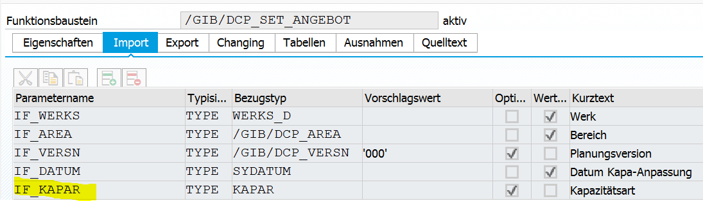

add an new import parameter and in the function this coding

FUNCTION /gib/dcp_set_angebot.
*"----------------------------------------------------------------------
*"*"Lokale Schnittstelle:
*" IMPORTING
*" VALUE(IF_WERKS) TYPE WERKS_D
*" VALUE(IF_AREA) TYPE /GIB/DCP_AREA
*" REFERENCE(IF_VERSN) TYPE /GIB/DCP_VERSN DEFAULT '000'
*" VALUE(IF_DATUM) TYPE SYDATUM
*" REFERENCE(IF_KAPAR) TYPE KAPAR OPTIONAL
*"----------------------------------------------------------------------
DATA: lr_settings TYPE REF TO /gib/cl_dcp_settings.
CLEAR: /gib/dcp_zraum_s-datumv,
/gib/dcp_zraum_s-datumb,
/gib/dcp_zraum_s-kapar,
gt_zraum_tc,
gf_cursor_field,
gf_cursor_line,
tc_zraum-lines.
IF /gib/cl_dcp_authority=>check_area(
if_werks = if_werks
if_arbpl = if_area
if_actvt = /gib/cl_dcp_authority=>co_actvt_maintain_areacust ) IS INITIAL.
*# do not change of available capacity if no authority for maintain area customizing
MESSAGE s306(/gib/dcp).
RETURN.
ENDIF.
lr_settings = /gib/cl_dcp_settings=>get_instance( if_werks = if_werks
if_area = if_area ).

*#HW8102 - Dashboard Kapaanpassung (DHO 23.10.2017 14:56:42)
IF if_kapar IS NOT INITIAL.
/gib/dcp_zraum_s-kapar = if_kapar.
ELSE.
/gib/dcp_zraum_s-kapar = lr_settings->ms_dcp_areas-kapart.
ENDIF.
*##HW8102 - Dashboard Kapaanpassung (DHO 23.10.2017 14:56:42)
IF /gib/dcp_zraum_s-kapar IS INITIAL.
EXIT.
[...]

Program | /GIB/DCP_DASHBOARDN
Local class | lcl_h_mfunc
Method | Call_capacity_change
METHOD call_capacity_change.
DATA: lr_k TYPE REF TO /gib/cl_dcp_k,
ls_areas TYPE /gib/dcp_areas,
*#HW8102 - Kapaanpassung Dashboard (DHO 23.10.2017 12:10:35)
ls_wtsc TYPE /gib/dcp_wtsc.
*##HW8102 - Kapaanpassung Dashboard (DHO 23.10.2017 12:10:35)
TRY.
lr_k ?= ir_period->get_k( ).
SELECT SINGLE * FROM /gib/dcp_areas INTO ls_areas
WHERE werks = lr_k->mr_arbid->ms_crhd-werks
AND area = lr_k->mr_arbid->ms_crhd-arbpl
AND kapart = lr_k->mr_kapart->mf_kapart
AND kapasap = space.
IF sy-subrc = 0.
IF ir_period->mf_from_date = ir_period->mf_to_date.
CALL FUNCTION '/GIB/DCP_SET_ANGEBOT'
EXPORTING
if_werks = lr_k->mr_arbid->mr_werks->mf_werks
if_area = lr_k->mr_arbid->mf_arbpl
if_datum = ir_period->mf_from_date.
ELSE.
CALL FUNCTION '/GIB/DCP_CALL_CUST'
EXPORTING
if_werks = lr_k->mr_arbid->mr_werks->mf_werks
if_area = lr_k->mr_arbid->mf_arbpl
if_modus = '1'
if_submod = '01'.
ENDIF.
ELSE.
*#HW8102 - Kapaanpassung Dashboard (DHO 23.10.2017 12:10:35)
SELECT SINGLE *
FROM /gib/dcp_wtsc
INTO ls_wtsc
WHERE kapar = lr_k->mr_kapart->mf_kapart.
*IF ir_period->mf_from_date = ir_period->mf_to_date.
IF ls_wtsc-wpkey IS NOT INITIAL.
CALL FUNCTION '/GIB/DCP_SET_ANGEBOT'
EXPORTING
if_werks = lr_k->mr_arbid->mr_werks->mf_werks
if_area = lr_k->mr_arbid->mf_arbpl
if_datum = ir_period->mf_from_date
if_kapar = lr_k->mr_kapart->mf_kapart.
ELSE.
CALL FUNCTION '/GIB/DCP_CHANGE_CAPACITY'
EXPORTING
if_werks = lr_k->mr_arbid->ms_crhd-werks
if_arbpl = lr_k->mr_arbid->ms_crhd-arbpl.
ENDIF.
*##HW8102 - Kapaanpassung Dashboard (DHO 23.10.2017 12:10:35)
ENDIF.
lr_k->refresh( ).
* mr_aggregation->raise_aggregation_changed( ).
CATCH cx_sy_move_cast_error.
MESSAGE s001(/gib/dcp_dash).
ENDTRY.
ENDMETHOD.

Function group | /GIB/DCP_ANGEBOT
include | /GIB/LDCP_ANGEBOTTOP
Local class (definition) | lcl_duration_service
*----------------------------------------------------------------------*
* CLASS lcl_duration_service DEFINITION
*----------------------------------------------------------------------*
*
*----------------------------------------------------------------------*
CLASS lcl_duration_service DEFINITION.
PUBLIC SECTION.
CLASS-METHODS:
get_plantime IMPORTING if_werks TYPE werks_d
if_area TYPE /gib/dcp_area
if_start_date TYPE sydatum
*#HW8102 - Kapaanpassung Dashboard (DHO 23.10.2017 15:37:47)
if_kapar TYPE kapar OPTIONAL
*##HW8102 - Kapaanpassung Dashboard (DHO 23.10.2017 15:37:47)
RETURNING VALUE(rt_plantime) TYPE /gib/dcp_plantime_t.
ENDCLASS. "lcl_duration_service DEFINITION
Local class (implmentation
METHOD get_plantime.
*#HW4514 - DCPN: Dashboard Korrekturen (MPL 08.12.2014)
DATA: lr_settings TYPE REF TO /gib/cl_dcp_settings,
lr_capacity TYPE REF TO /gib/if_dcp_capacity,
lt_slices TYPE /gib/dcp_slice_t,
lf_ezkap TYPE /gib/dcp_ezkap,
lf_start_date TYPE sy-datum,
lf_pit TYPE int4.
FIELD-SYMBOLS: <ls_slice> TYPE /gib/dcp_slice_s,
<ls_plantime> TYPE /gib/dcp_plantime_s.
lf_start_date = if_start_date.
IF lf_start_date IS INITIAL.
lf_start_date = sy-datum.
ENDIF.
*# Get DCP settings
lr_settings = /gib/cl_dcp_settings=>get_instance( if_werks = if_werks
if_area = if_area ).
*# Create Capacity for the area
lr_capacity = /gib/cl_dcp_capacity=>factory( if_ezkap = lf_ezkap
ir_settings = lr_settings
*#HW8102 - Kapaanpassung Dashboard (DHO 23.10.2017 15:37:47)
if_kapar = if_kapar ).
*ä#HW8102 - Kapaanpassung Dashboard (DHO 23.10.2017 15:37:47)
*# set the start interval for the capacity
lf_pit = /gib/cl_pit=>convert_date_time( if_date = lf_start_date
if_time = '000000' ).
lr_capacity->set_start( lf_pit ).

Function group | /GIB/DCP_ANGEBOT
Function | /GIB/DCP_SET_ANGEBOT
Include | /GIB/LDCP_ANGEBOTF01
form | get_zraum_prop_0100
FORM get_zraum_prop_0100 .
DATA: lw_wtsc TYPE /gib/dcp_wtsc_hv,
lw_wtsc2 TYPE /gib/dcp_wtsc_hv,
lt_wtsc TYPE TABLE OF /gib/dcp_wtsc_hv,
lw_wpsp TYPE /gib/dcp_wpsp,
lw_zraum TYPE /gib/dcp_week2_s,
lw_zraum2 TYPE /gib/dcp_week2_s,
lt_zraum TYPE TABLE OF /gib/dcp_week2_s,
lf_datum TYPE sy-datum,
lf_tabix TYPE sy-subrc,
lf_daynr TYPE hrvsched-daynr.
DATA: lt_wkextra TYPE STANDARD TABLE OF /gib/dcp_wkextra,
lw_wkextra TYPE /gib/dcp_wkextra.
DATA: lt_plantime TYPE /gib/dcp_plantime_t.
DATA: lw_plantime TYPE /gib/dcp_plantime_s.
DATA: lf_tag TYPE hrvsched-daynr.
DATA: lt_zraum_all TYPE TABLE OF /gib/dcp_week2_s,
lw_zraum_all TYPE /gib/dcp_week2_s,
lt_check_output TYPE STANDARD TABLE OF /gib/dcp_week2_s,
lw_check_output TYPE /gib/dcp_week2_s,
lf_check_count TYPE i.
IF /gib/dcp_zraum_s-datumv > /gib/dcp_zraum_s-datumb AND
NOT /gib/dcp_zraum_s-datumb IS INITIAL.
MESSAGE e021(/gib/dcp)
WITH /gib/dcp_zraum_s-datumv
/gib/dcp_zraum_s-datumb.
ENDIF.
CLEAR: gt_zraum_tc.

lt_plantime = lcl_duration_service=>get_plantime( if_werks = /gib/dcp_werks_s-werks
if_area = /gib/dcp_area_s-area
if_start_date = /gib/dcp_zraum_s-datumv
*#HW8102 - Dashboard Kapaanpassung (DHO 23.10.2017 15:41:42)
if_kapar = /gib/dcp_zraum_s-kapar
*##HW8102 - Dashboard Kapaanpassung (DHO 23.10.2017 15:41:42)
).
gf_datumb = /gib/dcp_zraum_s-datumb.
IF gf_datumb IS INITIAL.
gf_datumb = /gib/dcp_zraum_s-datumv.
[...]

Class | /GIB/CL_DCP_CAPACITY
Method | READ_AVAILABLE_CAPACITY
METHOD read_available_capacity .
DATA: lf_snapshot TYPE flag,
lf_anzhl TYPE kapanzahl.
FIELD-SYMBOLS: <ls_slice> TYPE /gib/dcp_slice_s.
IF mf_versn IS NOT INITIAL.
SELECT SINGLE flg_snap FROM /gib/dcp_0026
INTO lf_snapshot
WHERE versn = mf_versn.
ENDIF.
IF lf_snapshot = abap_true.
read_slices_from_snapshot( ).
ELSEIF mr_settings->ms_dcp_areas-kapasap IS INITIAL AND
*#HW8102 Dashboard Kapaangebot
* mr_settings->get_wpkey( sy-datum ) IS NOT INITIAL.
mr_settings->get_wpkey( if_date = sy-datum
if_kapar = mf_kapar ) IS NOT INITIAL.
*##HW8102 Dashboard Kapaangebot
read_slices_from_dcp( ).
ELSE.
read_slices_from_sap( ).
ENDIF.
*#when working with single capacities the available time that that hase a number of single
*#capacities lower then the current single capacity must be set as no working time
IF mf_ezkap IS NOT INITIAL AND mr_settings->ms_dcp_areas-kzezkap = '1'.
lf_anzhl = mf_ezkap.
LOOP AT mt_slices ASSIGNING <ls_slice> WHERE zart EQ /gib/if_dcp_capacity=>co_timetype_avail
AND anzhl LT lf_anzhl.
<ls_slice>-zart = /gib/if_dcp_capacity=>co_timetype_nowrk.
ENDLOOP.
ENDIF.
ensure_integrity( CHANGING ct_slices = mt_slices ).
ENDMETHOD.

Class | /GIB/CL_DCP_SETTINGS
Method | GET_NUMBER_OF_CAPACITIES
METHOD get_number_of_capacities.
DATA: lt_wkextra TYPE /gib/dcp_wkextra_t,
ls_wkextra TYPE /gib/dcp_wkextra,
lt_wtsc TYPE /gib/dcp_wtsc_t,
ls_wtsc TYPE /gib/dcp_wtsc,
ls_wpsp TYPE /gib/dcp_wpsp,
lf_ezkap TYPE /gib/dcp_ezkap,
lf_date TYPE sydatum.
*#No planning of single capacities in customizing
IF ms_dcp_areas-kzezkap IS INITIAL.
rf_kapanzahl = 1.
RETURN.
ENDIF.
*#Info Areas do not take into consideration single capacity planning
IF ms_dcp_areas-kzinfo EQ 'X'.
rf_kapanzahl = 1.
RETURN.
ENDIF.
*#HW7199 - Vert. Ezkap. Kapa SAP (SLI 21.09.2017 11:36:20)
IF ms_dcp_areas-kapasap IS INITIAL.
*##HW7199 - Vert. Ezkap. Kapa SAP (SLI 21.09.2017 11:36:20)
*#Search the biggest number of capacities in the weekplan but only
*#from the current weekplan onwards
lt_wtsc = mt_wtsc.
*#HW8102 Dashboard Kapaangebot
delete lt_wtsc WHERE kapar <> ms_dcp_areas-kapart.
*##HW8102 Dashboard Kapaangebot

Class | /GIB/CL_DCP_SETTINGS
Method | GET_WPKEY
Add importparameter if_kapar

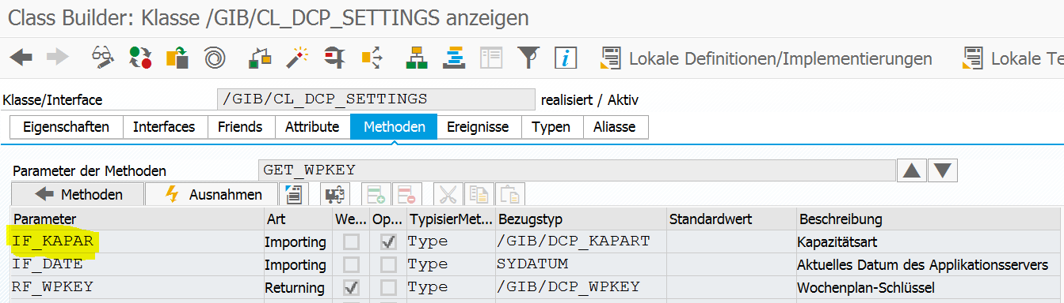

METHOD get_wpkey.
*#MPL 14.05.2014 calculate the correct week plan key for a specific date
FIELD-SYMBOLS: <ls_wtsc> TYPE /gib/dcp_wtsc.
*#HW8102 Dashboard Kapaangebot
DATA: lf_kapar TYPE /gib/dcp_kapart.
IF lf_kapar IS INITIAL.
lf_kapar = ms_dcp_areas-kapart.
ENDIF.
* LOOP AT mt_wtsc ASSIGNING <ls_wtsc> WHERE datab <= if_date.
LOOP AT mt_wtsc ASSIGNING <ls_wtsc> WHERE kapar = if_kapar
AND datab <= if_date.
*##HW8102 Dashboard Kapaangebot
EXIT.
ENDLOOP.
IF sy-subrc EQ 0.
rf_wpkey = <ls_wtsc>-wpkey.
ENDIF.
*##MPL 14.05.2014
ENDMETHOD.

Class | /GIB/CL_DCP_SETTINGS
Method | READ_WTSC
METHOD read_wtsc.
CLEAR mt_wtsc.
*#HW8102 Dashboard Kapaangebot
**# Select Assignment weekly schedule keys - werks/area/kapart/from date
* SELECT * FROM /gib/dcp_wtsc INTO TABLE mt_wtsc
* WHERE werks = mf_werks
* AND area = mf_area
* AND kapar = ms_dcp_areas-kapart.
* SORT mt_wtsc BY datab DESCENDING.
*# Select Assignment weekly schedule keys - werks/area/kapart/from date
SELECT * FROM /gib/dcp_wtsc INTO TABLE mt_wtsc
WHERE werks = mf_werks
AND area = mf_area.
SORT mt_wtsc BY datab kapar DESCENDING.
*##HW8102 Dashboard Kapaangebot
ENDMETHOD.

