Bug 8044 - Materialbeschränkung wird nicht durchgeführt

BAdI /GIB/DCP_BADI_DISPATCH
Interface /GIB/IF_BADI_DISPATCH
Method MOVE_IN_DECIDE

Ändern der Signatur
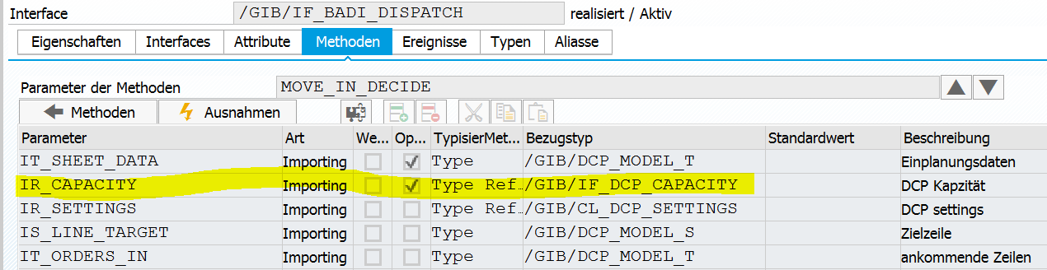

BAdI /GIB/DCP_BADI_DISPATCH
Interface /GIB/IF_BADI_DISPATCH
Method BEFORE_DISPATCH

Ändern der Signatur
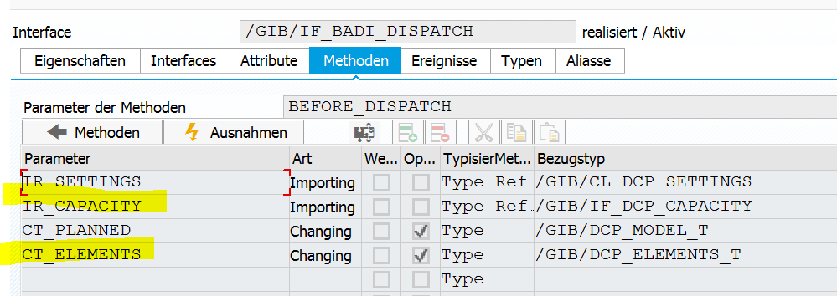

Class /GIB/CL_DCP_M_SHEET
Einfügen Attribut mr_badi_dispatch
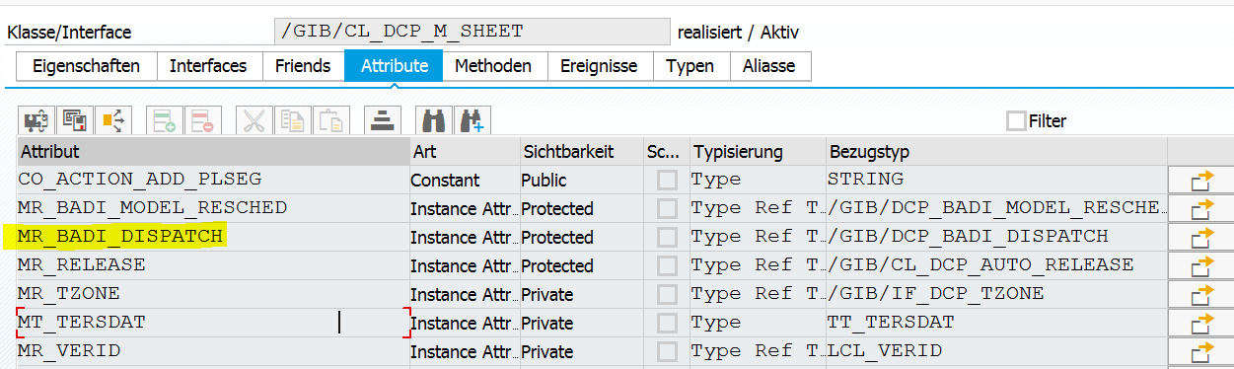

Class /GIB/CL_DCP_M_SHEET
Method constructor
[...]
*#create an autorelease object(customizing in area settings)
CREATE OBJECT mr_release
EXPORTING
ir_m_sheet = me.
GET BADI mr_badi_model_resched
FILTERS
werks = ms_id-werks
area = ms_id-area.
*#HW8044 - SCI (DHO 27.09.2017 12:42:45)
GET BADI mr_badi_dispatch
FILTERS
werks = ms_id-werks
area = ms_id-area.
*##HW8044 - SCI (DHO 27.09.2017 12:42:45)
CREATE OBJECT mr_verid_log
EXPORTING
mid = /gib/cl_dcp_tyco=>co_message_id
title = 'Fertigungsversionswechsel Protokoll'(001).
CREATE OBJECT mr_verid
EXPORTING
ir_settings = mr_settings
ir_log = mr_verid_log.
[...]

Class /GIB/CL_DCP_M_SHEET
Method /GIB/IF_DCP_ELEMENT_COLLECTION~DISPATCH
Redfinition in M_SHEET anlegen
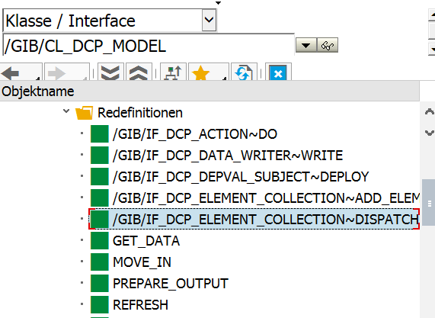

method /GIB/IF_DCP_ELEMENT_COLLECTION~DISPATCH.
*#HW8044 - Mat.beschr. funktioniert nicht (DHO 27.09.2017 13:23:48)
CALL BADI mr_badi_dispatch->before_dispatch
EXPORTING
ir_settings = mr_settings
ir_capacity = mr_capacity
CHANGING
ct_elements = mt_elements.
super->/gib/if_dcp_element_collection~dispatch( ).
*##HW8044 - Mat.beschr. funktioniert nicht (DHO 27.09.2017 13:23:48)
ENDMETHOD.

Class /GIB/CL_DCP_M_SHEET
Method MOVE_IN_DECIDE

METHOD move_in_decide.
DATA: ls_data TYPE /gib/dcp_model_s.
*#HW8044 - SCI (DHO 27.09.2017 12:42:45)
CALL BADI mr_badi_dispatch->move_in_decide
EXPORTING
ir_capacity = mr_capacity
ir_settings = mr_settings
is_line_target = is_target
it_orders_in = it_data.
*##HW8044 - SCI (DHO 27.09.2017 12:42:45)
*#HW7951 – Slot Vorplanung(MPL 04.09.2017)
**#only allow slots to be planned onto available time in Strict slot-planning
* IF is_target-zart = /gib/if_dcp_capacity=>co_timetype_avail.
* IF mr_settings->ms_dcp_areas-slotplan = abap_true. " strict slot-planning...
* LOOP AT it_data INTO ls_data WHERE zart <> /gib/cl_dcp_sart=>co_slot.
[...]

