BUG: 6800 – Fehlerhafte Mengenumrechnung für Anzeigemengeneinheit
Class: | /GIB/CL_DCP_MODEL
Types:
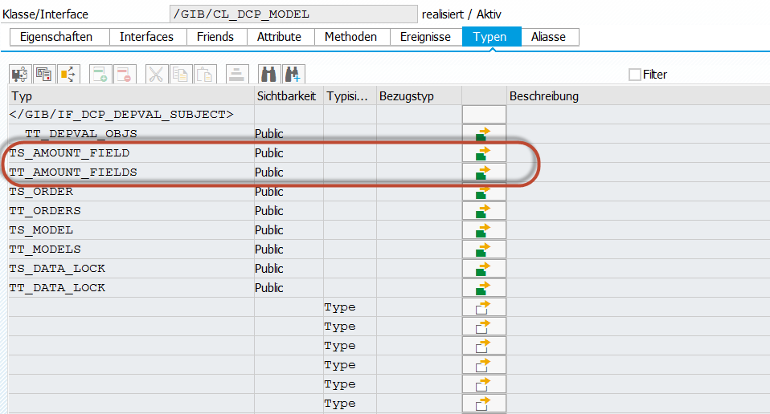

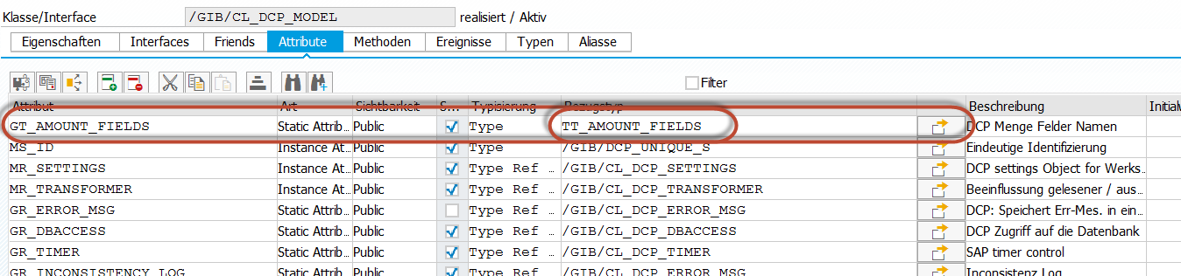

public section.
class /GIB/CL_DCP_TYCO definition load .
interfaces /GIB/IF_DCP_MODEL_EVENTS .
interfaces /GIB/IF_DCP_DEPVAL_SUBJECT .
aliases ATTACH
for /GIB/IF_DCP_DEPVAL_SUBJECT~ATTACH .
aliases DEPLOY
for /GIB/IF_DCP_DEPVAL_SUBJECT~DEPLOY .
aliases DETACH
for /GIB/IF_DCP_DEPVAL_SUBJECT~DETACH .
aliases NOTIFY
for /GIB/IF_DCP_DEPVAL_SUBJECT~NOTIFY .
aliases DATA_CHANGED
for /GIB/IF_DCP_MODEL_EVENTS~DATA_CHANGED .
aliases REQUEST_AREA_CHANGE
for /GIB/IF_DCP_MODEL_EVENTS~REQUEST_AREA_CHANGE .
aliases REQUEST_PLANO_CHANGE
for /GIB/IF_DCP_MODEL_EVENTS~REQUEST_PLANO_CHANGE .
types:
*#HW6800 - Mengenumrechnung (SLI 17.11.2016)
TYPES: BEGIN OF ts_amount_field,
fieldname TYPE fieldname,
meinh TYPE fieldname.
TYPES: END OF ts_amount_field .
TYPES:
tt_amount_fields TYPE STANDARD TABLE OF ts_amount_field .
*##HW6800 - Mengenumrechnung (SLI 17.11.2016 09:24:20)

• • •

Class: | /GIB/CL_DCP_MODEL
Method: | CLASS_CONSTRUCTOR
*#HW6800 - Mengenumrechnung (SLI 17.11.2016 09:26:40)
**#HW4390 - DCP Mengeneinheit Fehlerbehebung (MPL 24.10.2014)
* APPEND 'GAMNG' TO gt_amount_fields.
* APPEND 'GAMNG_NET' TO gt_amount_fields.
* APPEND 'NTMNG' TO gt_amount_fields.
* APPEND 'IGMNG' TO gt_amount_fields.
* APPEND 'IASMG' TO gt_amount_fields.
* APPEND 'MGVRG' TO gt_amount_fields.
* APPEND 'NTMNG_VG' TO gt_amount_fields.
* APPEND 'GMNGA' TO gt_amount_fields.
* APPEND 'XMNGA' TO gt_amount_fields.
* APPEND 'LABST' TO gt_amount_fields.
* APPEND 'INSME' TO gt_amount_fields.
* APPEND 'RVMNG' TO gt_amount_fields.
**##HW4390 - DCP Mengeneinheit Fehlerbehebung (MPL 24.10.2014)
**
DATA: ls_amount_field TYPE ts_amount_field.
ls_amount_field-fieldname = 'GAMNG_NET'. ls_amount_field-meinh = 'GMEIN'.
APPEND ls_amount_field TO gt_amount_fields.
ls_amount_field-fieldname = 'NTMNG'. ls_amount_field-meinh = 'GMEIN'.
APPEND ls_amount_field TO gt_amount_fields.
ls_amount_field-fieldname = 'IGMNG'. ls_amount_field-meinh = 'GMEIN'.
APPEND ls_amount_field TO gt_amount_fields.
ls_amount_field-fieldname = 'IASMG'. ls_amount_field-meinh = 'GMEIN'.
APPEND ls_amount_field TO gt_amount_fields.
ls_amount_field-fieldname = 'MGVRG'. ls_amount_field-meinh = 'MEINH'.
APPEND ls_amount_field TO gt_amount_fields.
ls_amount_field-fieldname = 'NTMNG_VG'. ls_amount_field-meinh = 'MEINH'.
APPEND ls_amount_field TO gt_amount_fields.
ls_amount_field-fieldname = 'GMNGA'. ls_amount_field-meinh = 'MEINH'.
APPEND ls_amount_field TO gt_amount_fields.
ls_amount_field-fieldname = 'XMNGA'. ls_amount_field-meinh = 'MEINH'.
APPEND ls_amount_field TO gt_amount_fields.
ls_amount_field-fieldname = 'LABST'. ls_amount_field-meinh = 'GMEIN'.
APPEND ls_amount_field TO gt_amount_fields.
ls_amount_field-fieldname = 'INSME'. ls_amount_field-meinh = 'GMEIN'.
APPEND ls_amount_field TO gt_amount_fields.
ls_amount_field-fieldname = 'RVMNG'. ls_amount_field-meinh = 'GMEIN'.
APPEND ls_amount_field TO gt_amount_fields.
ls_amount_field-fieldname = 'GAMNG_BRT'. ls_amount_field-meinh = 'GMEIN'.
APPEND ls_amount_field TO gt_amount_fields.
ls_amount_field-fieldname = 'GASMG'. ls_amount_field-meinh = 'GMEIN'.
APPEND ls_amount_field TO gt_amount_fields.
ls_amount_field-fieldname = 'WEMNG'. ls_amount_field-meinh = 'GMEIN'.
APPEND ls_amount_field TO gt_amount_fields.
ls_amount_field-fieldname = 'LMNGA'. ls_amount_field-meinh = 'MEINH'.
APPEND ls_amount_field TO gt_amount_fields.
ls_amount_field-fieldname = 'MGVRG_VOR'. ls_amount_field-meinh = 'MEINH_VOR'.
APPEND ls_amount_field TO gt_amount_fields.
ls_amount_field-fieldname = 'LMNGA_VOR'. ls_amount_field-meinh = 'MEINH_VOR'.
APPEND ls_amount_field TO gt_amount_fields.
ls_amount_field-fieldname = 'OFFEN_VOR'. ls_amount_field-meinh = 'MEINH_VOR'.
APPEND ls_amount_field TO gt_amount_fields.
ls_amount_field-fieldname = 'MGVRG_NACH'. ls_amount_field-meinh = 'MEINH_NACH'.
APPEND ls_amount_field TO gt_amount_fields.
ls_amount_field-fieldname = 'LMNGA_NACH'. ls_amount_field-meinh = 'MEINH_NACH'.
APPEND ls_amount_field TO gt_amount_fields.
ls_amount_field-fieldname = 'OFFEN_NACH'. ls_amount_field-meinh = 'MEINH_NACH'.
APPEND ls_amount_field TO gt_amount_fields.
ls_amount_field-fieldname = 'VOR_AREA_MGVRG'. ls_amount_field-meinh = 'VOR_AREA_MEINH'.
APPEND ls_amount_field TO gt_amount_fields.
ls_amount_field-fieldname = 'VOR_AREA_LMNGA'. ls_amount_field-meinh = 'VOR_AREA_MEINH'.
APPEND ls_amount_field TO gt_amount_fields.
ls_amount_field-fieldname = 'VOR_AREA_OFFEN'. ls_amount_field-meinh = 'VOR_AREA_MEINH'.
APPEND ls_amount_field TO gt_amount_fields.
ls_amount_field-fieldname = 'NACH_AREA_MGVRG'. ls_amount_field-meinh = 'NACH_AREA_MEINH'.
APPEND ls_amount_field TO gt_amount_fields.
ls_amount_field-fieldname = 'NACH_AREA_LMNGA'. ls_amount_field-meinh = 'NACH_AREA_MEINH'.
APPEND ls_amount_field TO gt_amount_fields.
ls_amount_field-fieldname = 'NACH_AREA_OFFEN'. ls_amount_field-meinh = 'NACH_AREA_MEINH'.
APPEND ls_amount_field TO gt_amount_fields.
ls_amount_field-fieldname = 'NTMNG_CALC'. ls_amount_field-meinh = 'MEINH'.
APPEND ls_amount_field TO gt_amount_fields.
ls_amount_field-fieldname = 'NTMNG_VG_CALC'. ls_amount_field-meinh = 'MEINH'.
APPEND ls_amount_field TO gt_amount_fields.
CLEAR: ls_amount_field.
*##HW6800 - Mengenumrechnung (SLI 17.11.2016 09:26:40)
• • •

Class: | /GIB/CL_DCP_V_ALV
Method: | APPLY_AMOUNTUNIT_CONVERSION
METHOD apply_amountunit_conversion.
*#HW4390 - DCP Mengeneinheit Fehlerbehebung (MPL 24.10.2014)
*#HW6800 - Mengenumrechnung (SLI 17.11.2016 09:24:20)
* DATA: lf_gmein TYPE co_gmein,
* lf_meinh_d TYPE meinh,
* lf_fieldname TYPE fieldname,
* lf_fail TYPE flag.
**
DATA: lf_meinh_d TYPE meinh,
lf_fail TYPE flag.
* FIELD-SYMBOLS: <amount> TYPE any.
**
FIELD-SYMBOLS: <lf_amount> TYPE any,
<lf_meinh> TYPE any.
DATA: ls_amount_field TYPE /gib/cl_dcp_model=>ts_amount_field.
DATA: lt_meinh TYPE TABLE OF fieldname,
lf_fieldname TYPE fieldname.
*##HW6800 - Mengenumrechnung (SLI 17.11.2016 09:24:20)
CHECK cs_data_for_view-sart CA /gib/cl_dcp_tyco=>gf_cmpstr_any_orders.
CHECK cs_data_for_view-settings IS BOUND.
*# get display unit
lf_meinh_d = cs_data_for_view-settings->ms_usrarea-meinh.
*#HW
*# get base unit
*#HW6800 - Mengenumrechnung (SLI 17.11.2016 10:04:46)
* lf_gmein = cs_data_for_view-gmein.
* IF lf_gmein IS INITIAL.
* lf_gmein = cs_data_for_view-meinh.
* ENDIF.
**
*# if display unit is initial or is equal to the Order Amount just write
*# write it and exit
* IF lf_meinh_d IS INITIAL OR lf_meinh_d EQ lf_gmein.
* cs_data_for_view-meinh_d = lf_gmein.
* RETURN.
* ENDIF.
**
*# Mengenfelder umrechnen
* LOOP AT /gib/cl_dcp_model=>gt_amount_fields INTO lf_fieldname.
* ASSIGN COMPONENT lf_fieldname OF STRUCTURE cs_data_for_view TO <amount>.
* IF sy-subrc EQ 0.
**# Umrechnung auf Zielmengeneinheit
* CALL FUNCTION 'MATERIAL_UNIT_CONVERSION'
* EXPORTING
* input = <amount>
* matnr = cs_data_for_view-matnr
* meinh = lf_meinh_d
* meins = lf_gmein
* IMPORTING
* output = <amount>
* EXCEPTIONS
* conversion_not_found = 1
* input_invalid = 2
* material_not_found = 3
* meinh_not_found = 4
* meins_missing = 5
* no_meinh = 6
* output_invalid = 7
* overflow = 8
* OTHERS = 9.
* IF sy-subrc <> 0.
* lf_fail = abap_true.
* EXIT.
* ENDIF.
* ENDIF.
* ENDLOOP.
**
CHECK lf_meinh_d IS NOT INITIAL.
LOOP AT /gib/cl_dcp_model=>gt_amount_fields INTO ls_amount_field.
COLLECT ls_amount_field-meinh INTO lt_meinh.
ENDLOOP.
LOOP AT lt_meinh INTO lf_fieldname.
ASSIGN COMPONENT lf_fieldname OF STRUCTURE cs_data_for_view TO <lf_meinh>.
CHECK sy-subrc EQ 0.
CHECK <lf_meinh> IS NOT INITIAL.
CHECK lf_meinh_d NE <lf_meinh>.
LOOP AT /gib/cl_dcp_model=>gt_amount_fields INTO ls_amount_field
WHERE meinh EQ lf_fieldname.
ASSIGN COMPONENT ls_amount_field-fieldname OF STRUCTURE cs_data_for_view TO <lf_amount>.
CHECK sy-subrc EQ 0.
*# Umrechnung auf Zielmengeneinheit
CALL FUNCTION 'MATERIAL_UNIT_CONVERSION'
EXPORTING
input = <lf_amount>
matnr = cs_data_for_view-matnr
meinh = lf_meinh_d
meins = <lf_meinh>
IMPORTING
output = <lf_amount>
EXCEPTIONS
conversion_not_found = 1
input_invalid = 2
material_not_found = 3
meinh_not_found = 4
meins_missing = 5
no_meinh = 6
output_invalid = 7
overflow = 8
OTHERS = 9.
IF sy-subrc <> 0.
CLEAR: cs_data_for_view-meinh_d.
lf_fail = 'X'.
EXIT.
ELSE.
CLEAR: lf_fail.
ENDIF.
ENDLOOP.
CHECK lf_fail IS INITIAL.
<lf_meinh> = cs_data_for_view-meinh_d = lf_meinh_d.
ENDLOOP.
* IF lf_fail IS NOT INITIAL.
* cs_data_for_view-meinh_d = lf_gmein.
* ELSE.
* cs_data_for_view-meinh_d = lf_meinh_d.
* ENDIF.
**
*##HW6800 - Mengenumrechnung (SLI 17.11.2016 09:44:04)
*##HW4390 - DCP Mengeneinheit Fehlerbehebung (MPL 24.10.2014)
ENDMETHOD.
• • •

