BUG: 6648 – Pflege Ausfallzeit bei Arbeitszeiten mit Grund

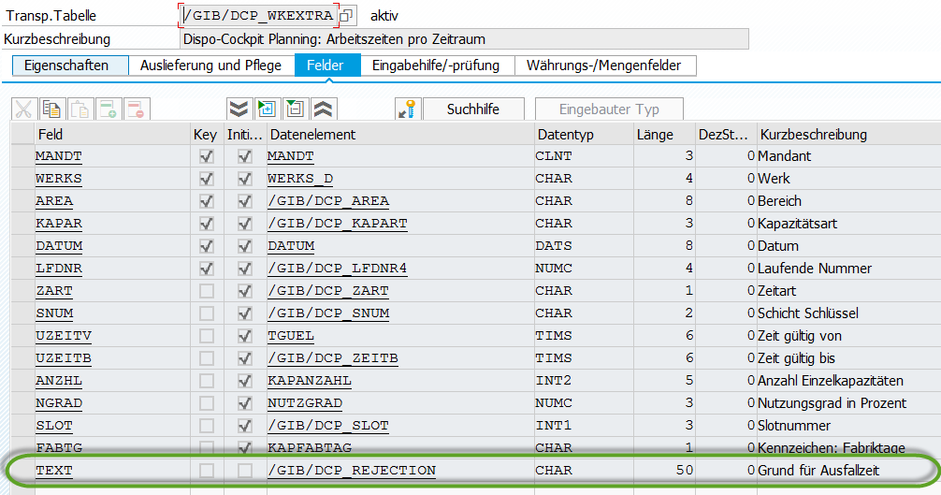
Class: | /GIB/CL_DCP_CAPA_SPEC_DAYS
Method: | BUILD_DATE_SLICES
ENDIF.
ls_slice-spmon = ls_slice-pldat(6).
CALL FUNCTION 'DATE_GET_WEEK'
EXPORTING
date = ls_slice-pldat
IMPORTING
week = ls_slice-spwoc
EXCEPTIONS
date_invalid = 1
OTHERS = 2.
IF sy-subrc <> 0.
* Implement suitable error handling here
ENDIF.
*##HW5040 - Kapa Anpassung ABA/UBA 21.10.2015
*#HW5072 - Kapazitätsänderung führt zu Duration=null (SLI 23.09.2015)
_calculate_ts_and_duration_in ls_slice.
*##HW5072 - Kapazitätsänderung führt zu Duration=null (SLI 23.09.2015)
*#also take the timetype text DCP 740
*#HW6648 - Text für jegliche Zeitart (SLI 04.10.2016 15:44:42)
ls_slice-sttxt_disp = ls_slice-grund = ls_wkex-text.
*##HW6648 - Text für jegliche Zeitart (SLI 04.10.2016 15:44:42)
APPEND ls_slice TO <ls_date_slices>-t_slices.
• • •

Function group: | /GIB/DCP_ANGEBOT
Form: | GET_ZRAUM_PROP_0100
EXCEPTIONS
no_langu = 0
no_date = 0
no_daytxt_for_langu = 0
invalid_date = 0
OTHERS = 0.
lw_zraum-tag = lf_tag.
lw_zraum-werks = /gib/dcp_area_s-werks.
lw_zraum-area = /gib/dcp_area_s-area.
lw_zraum-zart = lw_plantime-zeitart.
lw_zraum-datab = lw_plantime-datum.
lw_zraum-uzeitv = lw_plantime-uzeitv.
lw_zraum-uzeitb = lw_plantime-uzeitb.
lw_zraum-kapar = /gib/dcp_zraum_s-kapar.
lw_zraum-werks = /gib/dcp_werks_s-werks.
lw_zraum-snum = lw_plantime-snum.
*#HW6648 - Grund für Arbeitszeit (SLI 13.10.2016 08:15:24)
*#Allow texts for all time types DCP 740
* IF lw_plantime-zeitart = 'A'.
* lw_zraum-grund = lw_plantime-grund.
* ELSE.
* CLEAR lw_zraum-grund.
* ENDIF.
**
lw_zraum-grund = lw_plantime-grund.
*##HW6648 - Grund für Arbeitszeit (SLI 13.10.2016 08:15:24)
IF lw_plantime-anzhl IS INITIAL.
lw_plantime-anzhl = '1'.
ENDIF.
• • •

Function group: | /GIB/DCP_ANGEBOT
Form: | INSERT_ZRAUM_0100
LOOP AT gt_zraum_tc INTO lw_zraum WHERE datum = lw_datum-datum.
ADD 1 TO lf_lfdnr.
CLEAR: lw_wkextra.
lw_wkextra-lfdnr = lf_lfdnr.
lw_wkextra-datum = lw_zraum-datum.
lw_wkextra-uzeitv = lw_zraum-uzeitv.
lw_wkextra-uzeitb = lw_zraum-uzeitb.
lw_wkextra-kapar = lw_zraum-kapar.
lw_wkextra-zart = lw_zraum-zart.
lw_wkextra-snum = lw_zraum-snum.
lw_wkextra-anzhl = lw_zraum-anzhl.
lw_wkextra-ngrad = lw_zraum-ngrad.
lw_wkextra-werks = /gib/dcp_werks_s-werks.
lw_wkextra-area = /gib/dcp_area_s-area.
lw_wkextra-fabtg = lw_zraum-fabtg.
*#also save the text for the WKEXTRA DCP 740
*#HW6648 - Grund für Arbeitszeit (SLI 13.10.2016 08:12:58)
lw_wkextra-text = lw_zraum-grund.
*##HW6648 - Grund für Arbeitszeit (SLI 13.10.2016 08:12:58)
MOVE-CORRESPONDING lw_wkextra TO lw_wkextra_db.
*#gibt es eine Ausfallzeit
READ TABLE lt_nonwktm INTO lw_nonwktm_db
WITH KEY datumv = lw_wkextra-datum
uzeitv = lw_wkextra-uzeitv.
• • •
Function group: | /GIB/DCP_ANGEBOT
PBO Module: | TC_PBO_0100
MODULE tc_pbo_0100 OUTPUT.
MOVE-CORRESPONDING gw_zraum TO /gib/dcp_week2_s.
SELECT SINGLE brktx FROM /gib/dcp_brsct INTO /gib/dcp_week2_s-brktx
WHERE brkey = /gib/dcp_week2_s-brkey
AND werks = /gib/dcp_week2_s-werks.
IF sy-subrc NE 0.
SELECT SINGLE brktx FROM /gib/dcp_brsct INTO /gib/dcp_week2_s-brktx
WHERE brkey = /gib/dcp_week2_s-brkey.
ENDIF.
*#Allow a text for every time type DCP 740
*#HW6648 - Text für jegliche Zeitart (SLI 04.10.2016 15:45:35)
* IF gw_zraum-zart NE 'A'.
* LOOP AT SCREEN.
* IF screen-group1 = 'AUS'.
* screen-input = '0'.
* MODIFY SCREEN.
* ENDIF.
* ENDLOOP.
* ENDIF.
*##HW6648 - Text für jegliche Zeitart (SLI 04.10.2016 15:45:35)
ENDMODULE. " TC_PBO_0100 OUTPUT
• • •

