Erweiterung der Struktur /GIB/DC_RUADEF
Hinzufügen eines Feldes 'EXECTCODE' TYPE FLAG.
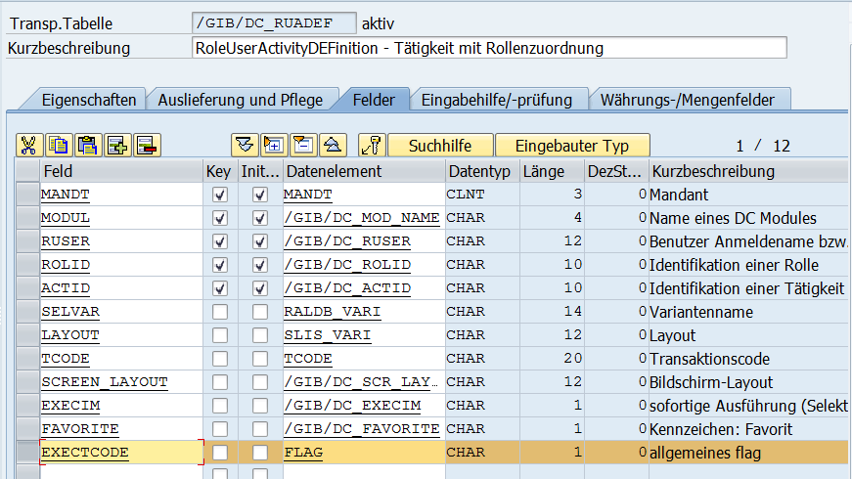

Erweiterung der Struktur /GIB/DC_RAC_FCAT_ACT_LIST_S
Hinzufügen eines Feldes 'EXECTCODE' TYPE FLAG.

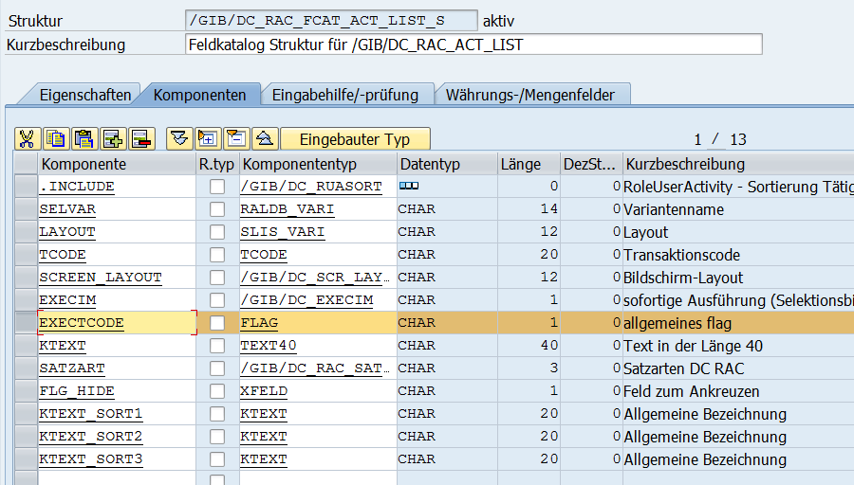

Anpassung FUGR /GIB/DC_RAC_ACT_SETTINGS
Aufnehmen des Feldes EXECTCODE in das DYNPRO 0101 (Überschreiben des Textes)
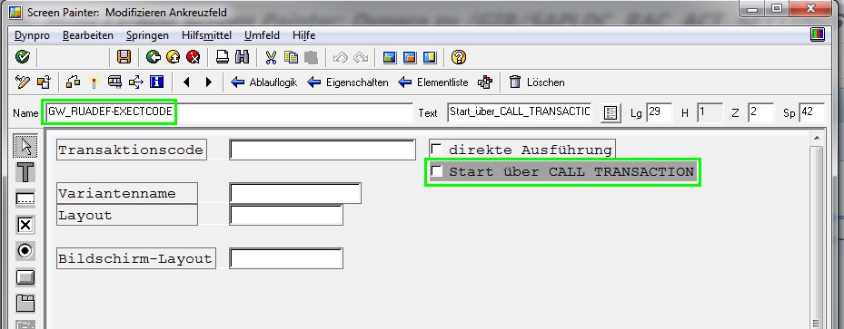

Anpassung Klasse /GIB/CL_DC_RAC
Erweitern der Parameter des Ereignisses DBL_CLK_ACTIVITY um einen Parameter
EF_EXECTCODE TYPE FLAG
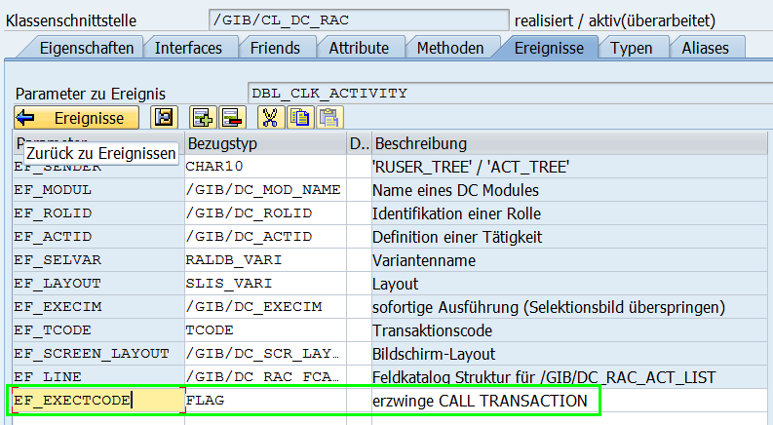
Erweitern der Signatur der Methode RAISE_DBL_CLKACTIVITY um einen Importparameter
IF_EXECTCODE TYPE FLAG
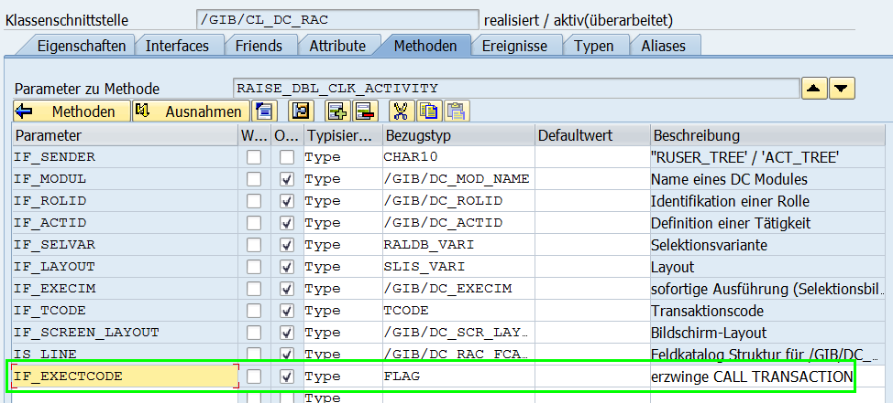

Anpassung im Quellcode der Methode RAISE_DBL_CLKACTIVITY:
METHOD raise_dbl_clk_activity .
RAISE EVENT dbl_clk_activity
EXPORTING
ef_sender = if_sender
ef_modul = if_modul
ef_rolid = if_rolid
ef_actid = if_actid
ef_selvar = if_selvar
ef_layout = if_layout
ef_execim = if_execim
ef_tcode = if_tcode
*# HW 3892, FGR, 29.04.2014 Screen-Layout
ef_screen_layout = if_screen_layout
*## HW 3892
*{ REPLACE M06K900264 1
*\ ef_line = is_line.
*#HW4336 UBA 07.10.2014 CALL TRANSACTION erzwingen
ef_line = is_line
ef_exectcode = if_exectcode.
*##HW4336
*} REPLACE
ENDMETHOD.

Anpassung FUGR /GIB/DC_RAC_ACT_LIST

Include /GIB/LDC_RAC_ACT_LISTF02

FORM CUST_DOUBLE_CLICK
IF gf_f4_call = 'X'.
MOVE-CORRESPONDING cw_tree_tab TO gs_ruasort.
SET SCREEN 0.
LEAVE SCREEN.
ELSE.
CALL METHOD /gib/cl_dc_rac=>raise_dbl_clk_activity
EXPORTING
if_sender = 'ACT_TREE'
if_modul = 'DCO'
if_rolid = cw_tree_tab-rolid
if_actid = cw_tree_tab-actid
if_selvar = cw_tree_tab-selvar
if_layout = cw_tree_tab-layout
if_execim = cw_tree_tab-execim
if_tcode = cw_tree_tab-tcode
*{ REPLACE M06K900263 1
*\*# HW 3892, FGR, 29.04.2014 Screen-Layout
*\ if_screen_layout = cw_tree_tab-screen_layout.
*\*## HW 3892
*#HW4336 UBA 07.10.2014 11:05:39 CALL TRANSACTION erzwingen
if_screen_layout = cw_tree_tab-screen_layout
if_exectcode = cw_tree_tab-exectcode.
*##HW4336
*} REPLACE
ENDIF.

Anpassung Report /GIB/DC_RAC_START

Include /GIB/DC_RAC_START_C01
CLASS lcl_act_list_event_receiver DEFINITION.
PUBLIC SECTION.
*#---------------------------------------------------------------------*
*# Double click on activity
METHODS handle_dbl_clk_activity
FOR EVENT dbl_clk_activity OF /gib/cl_dc_rac
*{ REPLACE M06K900263 1
*\ IMPORTING ef_sender ef_modul ef_rolid ef_actid
*\ ef_selvar ef_layout ef_execim ef_tcode ef_screen_layout.
*#HW4336 UBA 07.10.2014 Start über CALL TRANSACTION
IMPORTING ef_sender ef_modul ef_rolid ef_actid
ef_selvar ef_layout ef_execim ef_tcode
ef_screen_layout ef_exectcode.
*##HW4336
*} REPLACE

*#selection screen parameters are not visible in class method
ls_activity-rolid = ef_rolid.
ls_activity-actid = ef_actid.
ls_activity-execim = ef_execim.
ls_activity-tcode = ef_tcode.
ls_activity-selvar = ef_selvar.
ls_activity-layout = ef_layout.
*# HW 3892, FGR, 29.04.2014 Screen-Layout
ls_activity-screen_layout = ef_screen_layout.
*## HW 3892*#---------------------------------*
*# decide between submit/ call transaction
*{ REPLACE M06K900263 2
*\ IF lf_report EQ 'X'.
*#HW4336 UBA 07.10.2014 Start über CALL TRANSACTION erzwingen
IF lf_report EQ 'X' and ef_exectcode is INITIAL.
*##HW4336
*} REPLACE
PERFORM own_call_report USING ls_activity lw_tstc-pgmna.
ELSE.
PERFORM std_call_transaction USING ef_tcode ef_execim.
ENDIF.
ENDMETHOD. "handle_dbl_clk_activity

